**Topic Title:** Automated Acoustic Monitoring System

**Topic #:** N151-030

**High Rez Consulting, LLC**

67 Beacon Ave

Jamestown, RI 02835-2511

(401) 423-0348

**Contract Information:**

Phase: I

SYSCOM: NAVSEA, PEO IWS 5A

TPOC: Meg Stout, PEO IWS 5ATD2

Contract #: N00024-15-P-456

PoP: August 06, 2015 - February 01, 2016

**Corporate Official:**

Dennis Quelch, President, (401) 423-0348, dquelch@highrezconsulting.com

**Principal Investigator (PI):**

Michael Hughes, (571) 282-8437, mhughes@highrezconsulting.com

**Prepared By:**

Michael Hughes, (571) 282-8437, mhughes@highrezconsulting.com

**SBIR/STTR DATA RIGHTS:**

**Expiration of SBIR/STTR Data Rights Period:** February 6, 2021

The Government's rights to use, modify, reproduce, release, perform, display, or disclose technical data or computer software marked with this legend are restricted during the period shown as provided in paragraph (b)(4) of the Rights in Noncommercial Technical Data and Computer Software - Small Business Innovation Research (SBIR) Program clause contained in the above identified contract. No restrictions apply after the Expiration Date shown above. Any reproductions of technical data, computer software or portions thereof marked with this legend must also reproduce the markings.

**Export Control: WARNING** - This document contains technical data whose export is restricted by the Arms Export Control Act (Title 22, U.S.C., Sec 2751, et seq.) or the Export Administration Act of 1979 (Title 50, U.S.C., App. 2401 et seq.), as amended. Violations of these export laws are subject to severe criminal penalties. Disseminate in accordance with DoD Directive 5230.25.

**Distribution Statement B:** Distribution authorized to U.S. Government agencies only (DFARS- SBIR Data Rights). Other requests for this document shall be referred to the appropriate SYSCOM <address available at: http://www.navysbir.com/pm-poc.htm>.

**Table of Contents**

1 Executive Summary 3

2 Project Objective 4

3 Project Approach 4

4 Analysis 13

5 Results 15

6 Conclusions 31

7 Recommendations 31

8 Proposed Additional SBIR/STTR Funded Research 32

9 Transition and Acquisition Planning 33

10 References 34

Appendix A: Key Terms 35

Appendix B: Supplemental Data 37

B-1 Introduction 37

B-2 Analysis of DI degradation vs. Element outage 55

B-3 Analysis of Coverage Penalty vs. Array Deformation 69

B-4 Expected Detection Range Study 77

# Executive Summary

A robust and effective automated acoustic monitoring system (AAMS) that will alert operators to degraded sensor performance due to platform self-noise and sensor health requires an effective means for gathering, managing, evaluating, associating, thresholding sensor health & performance, and displaying that data in a useful form to the operator for use in determining whether a sensor is too degraded to continue using within the Undersea warfare (USW) Combat system (initiating a Casualty Report – CASREP) or whether to accept the degradation and utilize the associated degraded sensor parameters through the USW system in performance detection, classification, and localization processing.  In the Phase I research, we were able to define and assess operational concepts and automation algorithms that will accomplish the Phase I Technical Objectives.

The key to an effective AAMS operational concept is the ability of the aid (system) to automatically ingest, and evaluate sensor health and degradation data to improve an operator’s ability to make informed tactical decisions.  The operational concept we have developed will achieve these goals by merging flexible architecture and interfaces, functionality, and intelligent algorithms, such that the system, utilizing available Performance Monitoring & Fault Localization (PMFL) and acoustic data from all available sensors, will provide:

* Sensor element health and sensor health-dependent beampatterns and sensor parameters as an aid in determining overall system health and performance,
* Comparison to previous WQM9 reports, and a link to the CASREP generation process
* Updated sensor parameters for use in the Sensor Performance Prediction Functional Segment (SPPFS), to estimate performance based on the actual degraded sensor status

In Phase I, we designed and developed classes of algorithms that support AAMS on multiple sensors in the areas of (a) automated, intelligent control & evaluation of sensor health data based on sensor degradation rules and metrics (b) sensor degradation metric ranking; (c) in-situ calculation of degraded sensor parameters; and (d) automated, real-time sensor self-noise.

Results of our analysis are summarized as follows:

* Sensor element malfunction and sensor deformation affect several terms in the passive and active sonar equations
* We can quantify these effects to estimate degraded sensor performance
* Several displays, or modifications to current tactical decision aid displays, can improve operator situational awareness

Recommended courses of action include re-analysis using actual, rather than canonical, sensor data, refining statistical analysis where behavior of data is non-Gaussian, and modifications to Navy standard performance prediction models to afford efficient computations using degraded sensor information. Future plans include enhancing these intelligent controller algorithms with telemetry wild-pointing & transient detection algorithms and beginning assessment of the integrated classes of algorithms to characterize performance and demonstrate operational benefits.

# Project Objective

The U.S. Navy needs an automated acoustic monitoring system to alert operators to degraded sensor performance due to platform self-noise and sensor health, assist the operator in assessing overall sensor status and recommend corrective actions and make these data available to the combat system for use in calculating detection performance. The system should

* Utilize current Navy PMFL processed data to alert fleet operators, as soon as possible, to degraded sensor performance and enable corrective action through either modifying a sensor processing configuration, reliance more heavily on other sensors, or issue a casualty report (CASREP) when the problem is severe.
* Make recommendations to the operator to maximize overall acoustic performance, including comparison of degraded & optimized sensor beampatterns, while considering operational constraints and fault-tolerance of the current system software
* Provide real-time sensor degradation inputs, based on sensor health and sensor self-noise (based on operational and environmental conditions) due to excessive platform noise, to sensor performance predictions with the objective of optimizing overall combat system performance
* Help detect telemetry processing issues, electronic noise and other intermittent issues

# Project Approach

High Rez Consulting’s (HRC) Phase I work for the identification and development of an operational concept, requirements, and algorithms for a comprehensive automated acoustic monitoring & evaluation (AAME) system is based upon the following critical, but related, technologies:

* Task 1 – Definition and development of the overall AAME operational concept and intelligent controller, architecture, information flow, and processing algorithms.
* Task 2 - Definition and development of base algorithms for a real-time Sensor Self-Noise module, which will provide a general means of calculating real-time hull and towed array self-noise as real-time sensor self-noise inputs for the AAME.
* Task 3 - Definition and development of sensor health and system performance decision aid tools (beampattern generation and visualization) to calculate, alert, and display to operators degraded beampatterns and their associated degraded sensor parameters as a function of selected threat frequencies.

The approach undertaken during the Phase I Base period to address the above tasks and achieve the project objectives was to identify, define/develop, and evaluate flexible architecture, interfaces, and classes of algorithms needed to achieve the project requirements & objectives, as laid out in the initial project RFP. Research into the AAME architecture during the Phase I Base effort identified and addressed six major modules:

1. ASMEC, or the Acoustic Sensor Monitoring External Communications module, handles all the input and output communications for AAME and will be developed to interface to multi-sensor health status data sources, as well as the ACB Common Tactical Displays, CES Alert Framework, IPCP_MFTA, and IPCP_53C. ASMEC handles a variety of inputs and messaging protocols (CORBA, DSW MW, AMPQ, etc.) and provides a uniform output format suitable for sensor health, telemetry, sensor/ownship state (contains TA heading- fore, aft; depth; TA Phone Positions; etc.) and data registration and processing by Intelligent Controller from the various AAME modules
2. ASMIC, or the Acoustic Sensor Monitoring Intelligent Controller, is the primary component of the AAME concept. ASMIC will collate incoming sensor and health data as well as calculation products from its various modules and compare results against historical values, highlight the differences, make decisions based on sensor degradation rules on possible sensor health issues, provide real-time alerts to CES concerning degraded sensor health and performance for needed operator action. Utilizing in-situ sensor health and self-noise data within the ASMIC and its associated components, a Threat of Interest (TOI)-based performance & evaluation of sensor health using frequencies of interest, or Primary Threat Tonals (PSTs), obtained from an operator-selected Threat may be accomplished to calculate degraded active and passive beampatterns for PST’s and F1-F5 active transmit bands.
3. ASMDB, or the Acoustic Sensor Monitoring Data Base function, provides underlying supporting database and the Display Processor (ASMDP) provides the operator validation interface to the SPPFS/STDA-controlled Env tab (APB15 for STDA; ACB17 for SPPFS) within Common Tactical Displays for our proposed Sensor Health & Monitoring subtab that allows operators to visualize sensor health, comparisons of historical and in-situ WQM9 data, and optimized vs degraded sensor beampatterns to make a determination of reconfiguration or initiation of CASREP issuance process
4. ASMSN, or the Acoustic Sensor Monitoring Self Noise module, provides real-time sensor self-noise algorithms that may be suitable or adapted for providing a general means of calculating real-time hull and towed array self-noise based on operational and environmental conditions (stave & hydrophone health, ownship speed, sea state, shipping noise, etc.) for use in determining overall degraded sensor and system performance in AAME.
5. ASMBG, or the Acoustic Sensor Monitoring Beampattern Generation & Visualization module, is an adaption of the Navy standard model GBEAM. ASMBG generates the actual in-situ frequency-dependent active and passive sensor beampatterns and parameters based on in-situ sensor dead phone/stave data and to be used in sensor and system performance predictions.
6. ASMDP, or the Acoustic Sensor Monitoring Display Processing & Visualization module, provides the in-situ, frequency-dependent ASMBG-calculated theoretical and degraded sensor beampattern and parameter products to the Common Tactical Displays for use by the operator in evaluating of sensor health and performance against a relevant threat.

Figure 1 below addresses the module flow for the AAME architecture and concept.

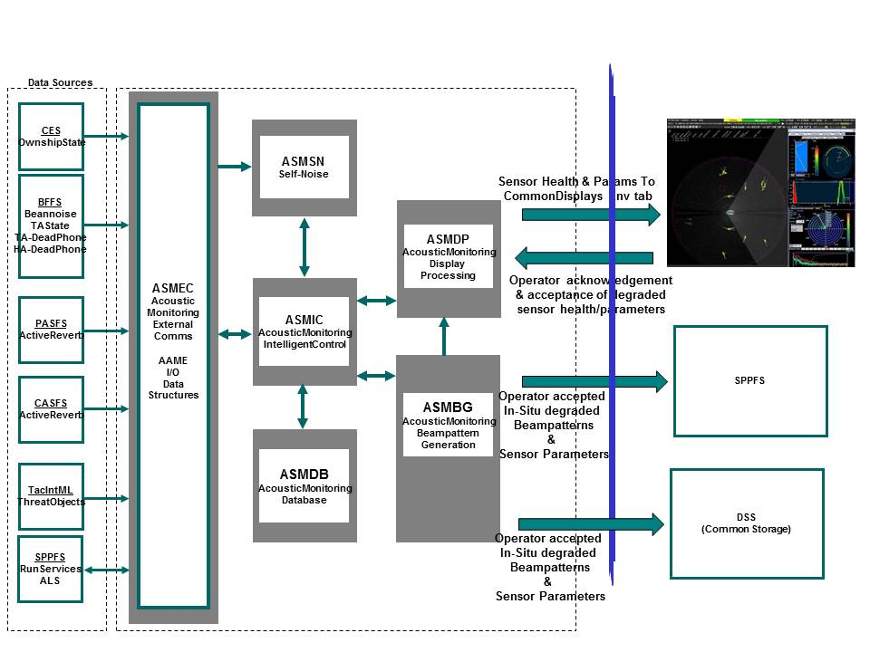

Figure . AAME Architectural Module Flow

During the Base period of the project, development and evaluation of algorithms was undertaken under the direction that all work done during the Base period was to be unclassified. The unclassified directive dictated the general flow of work and unfortunately eliminated possibilities of fully evaluating and assessing algorithm efficacy and performance. As part of this assumption, HRC did not utilize WQM9 or MFTA Self-Noise curve data, SQQ-89 sonar data, and utilized idealized cylindrical & horizontal arrays for algorithm development, evaluation, and assessment. Therefore, our Phase I Base work approach was to

1. Write a basic testbed framework & simulator to generate beam weights for idealized cylindrical & horizontal arrays and simulate random failure of sensor elements and segments of both cylindrical and horizontal line array (HLA) to perform evaluation of ASMBG
2. Utilize Monte Carlo simulations for sensor degradation metrics analysis and exercising the Intelligent Controller architecture

## Automated Acoustic Monitoring & Evaluation (AAME) Concept

For Task 1, the definition and development of the automated acoustic monitoring & evaluation (AAME) operational concept, architecture, information flow, and algorithms was split into three major subtasks

* + - * Task1-1: Identification of Data Requirements for ASMIC, ASMBG, & ASMSN algorithms and definition of External/Internal Interfaces, Messaging, & Data Structures
      * Task1-2: Identification/Definition of Core ASMIC algorithms
      * Task1-3: Evaluation & analysis of the Decision Degradation Rule Set, sensor degradation metrics & thresholds needed by ASMIC in making determination of sensor degradation and operator alertment

For Task 2, the definition and development of base algorithms for a real-time Sensor Self-Noise module concentrated on leveraging current AN/SQQ-89 Self-Noise Survey core algorithms, SAMANTHA, and identifying needed algorithm changes to support additional sensor arrays and real-time sensor self-noise calculations.

For Task3, definition and development of sensor health and system performance decision aid tools was broken down into two major subtasks: beampattern generation and visualization. Task 3-1 concentrated on modification and adaptation of the Navy standard model GBEAM to calculate in-situ beampatterns and their associated sensor parameters based on sensor array health

1. Number & percentage of sensor array deadphones
2. Number & percentage of sensor array deadphones with respect to historical values
3. Deadphone locations with respect to array geometry, array apertures, and operator-defined threat frequency-of-interest (FOIs)
4. Array deformation (for HLAs only)

Task3-2 concentrated on visualizing degraded sensor health & sensor performance to present to the operator for evaluation and determination on whether sensors and their associated detection performance are too degraded to continue use (initiating a CASREP) or, if degradation is not too severe, accept the new degraded sensor parameters and transmit to the rest of the ASW system for use in detection, classification, and localization processing.

### Acoustic Sensor Monitoring External Communications

Task 1-1 concentrated on the definition of the External Communications module, or ASMEC. ASMEC is responsible for interfacing directly to relevant SQQ-89 Acoustic Segment (AS) Functional Segments and converting AN/SQQ89 AS-unique messaging & data into the Sonar Tactical Decision Aid (STDA) common data format (SPCMN) for AAME internal use. The SPCMN data format was selected for internal messaging for STDA compatibility. The initial RFP indicated that the AAMS could be either a stand-alone component of the USW system or could be integrated into SPPFS-STDA. ASMEC consists of the Sonar-IF, Threat Processor, and Sensor Metrics interface modules. Provided below in Figure 2 are the ASMEC module’s components, messaging, & message ID’s.

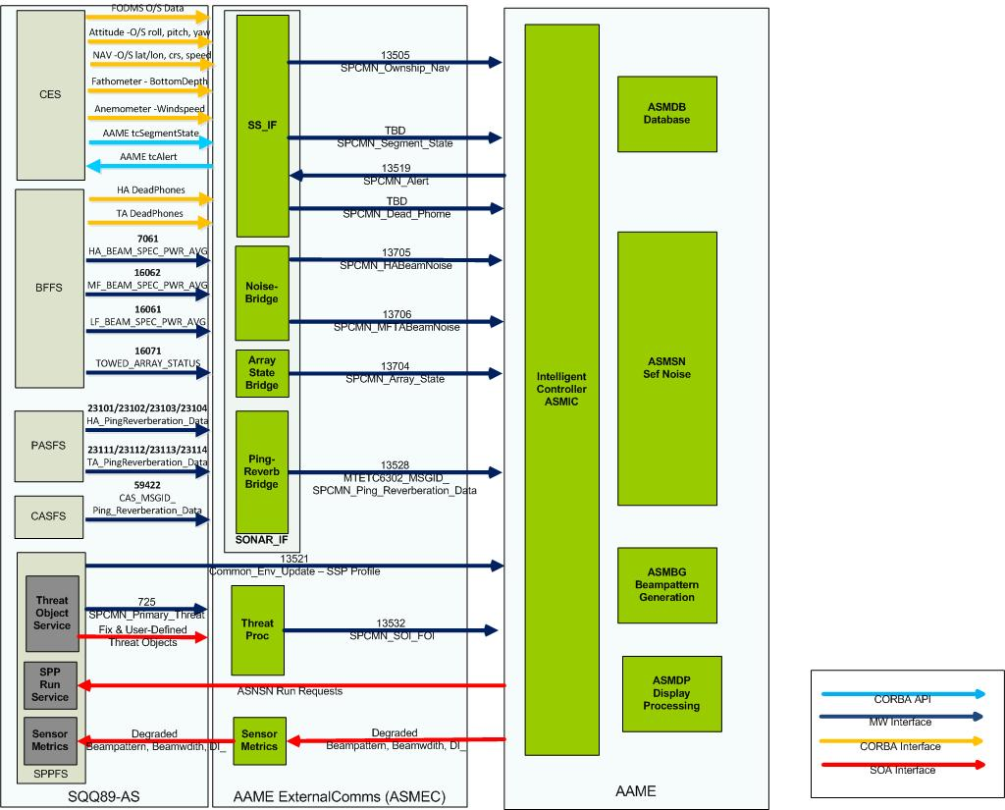

Figure : AAME ASMEC Interfaces & Message Flow

The Sonar-IF module interfaces to the AN/SQQ-89 AS system and is comprised of the following submodules:

1. ShipServices Interface (SS-IF) provides the CORBA Interface to ShipServices. SS-IF interfaces to:
2. Ship Services & converts Ownship data into SPCMN navigation data
3. SRMD/SONSYM to obtain & set AAME SegmentState (Training, Playback, or Tactical) & propagates to ASMIC
4. CES tcAlertServices to provide ASMIC Operator alerts to CES Command Bar on Sensor Health & Degradation status & required Operator Actions
5. BFFS HA & TA DeadPhone Notification Channels to obtain dead or degraded hydrophone status for use by ASMIC & ASMBG
6. ArrayState-IF (MW Bridge & Sensor State Conversion) which extracts required data from MFTA-State messages (phone positions, cable scope, heading sensors, etc) and other sensor state messages and converts the data into the SPCMN format
7. Noise-IF (Beamnoise Interface: MW Bridge & Conversion) which converts Hull & Towed LF, MF, HF Beamnoise into the SPCMN format
8. PingReverb-IF (Ping & Reverberation Interface: MW Bridge & Conversion) which converts Hull & Towed PAS SDT/ODT and CAS Ping/Reverberation data into SPCMN format

The Threat Processor (ThreatProc) module interface interfaces to SPPFS Threat Object Service. ThreatProc receives Operator-Defined Fixed & User-Defined Threat Objects via the SPPFS Threat Service and converts to object data & associated frequencies into FOIs for use by AAME internal

The Sensor Metrics Interface Module interfaces to SPPFS’ Platform Sensor Database (PSDB) which is needed to inject updated and/or degraded beampatterns & sensor parameters for use by SPPFS in calculating sensor health-based HA/TA In-situ SE Performance Prediction Overlays

The DSS-IF or TDR-IF will be the entry point for providing updated Active Transmit Patterns and sensor parameters to HATFS and other interested Segments (PASFS, etc for updated Receive patterns). If AAME is to follow current ACB architectural paradigm, the preferred entry point for all common data is to insert into DSS (Common Data Storage) or TDR (Tactical Data Repository) and let other Segments retrieve the needed data instead of AAME trying to interface to all relevant Segments.

The Phase I Base effort for this subtask defined the architecture, data translation algorithms, message flow, messaging, message ID’s, & data structures needed for ingesting in-situ sensor state, health data, beamnoise, etc for use by the Intelligent Controller, Sensor Self-Noise, and Beampattern Generation modules. Phase I products for this module include design documentation, external and internal interface diagrams, and message tables with associated source, destination, message protocols, and message ID’s for all needed data. These classes of algorithms need real data to be properly evaluated for efficacy and performance and are their evaluation is part of the proposed follow-on work in the Phase II.

### Acoustic Sensor Monitoring Intelligent Controller

Task 1-2 concerning the Intelligent Controller, or ASMIC, is the core of AAME architecture and the Phase I Base development effort. The Phase I effort identified several different classes of algorithms needed by the Intelligent Controller to ingest, process, manage, calculate, and evaluate sensor health & degraded performance as well as trigger an operator alert and evaluation. The ASMIC architecture and algorithm flow is provided below in Figure 3. ASMIC is comprised of several different processing algorithms:

1. Deadphone Analysis & State Assessment (DASA)
2. Performance Degradation Manager (PDM)
3. Critical Factor Ranking (CFR)

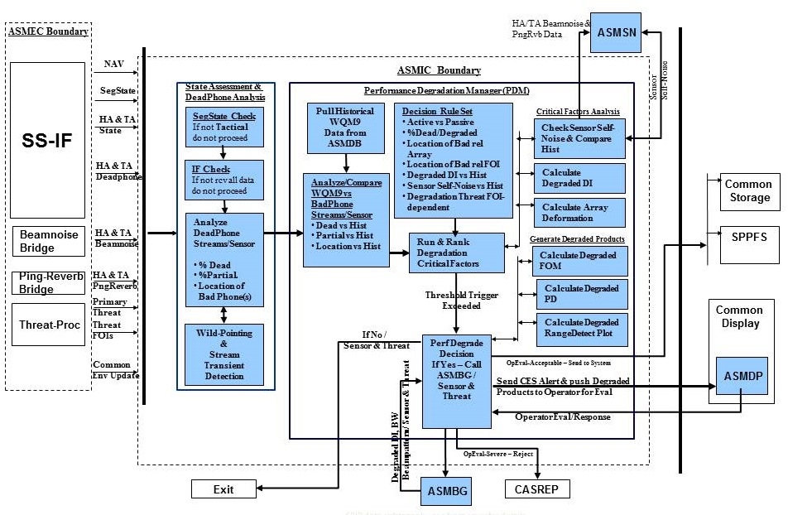

Figure . AAME ASMIC Algorithm Flow

The Deadphone Analysis & State Assessment (DASA) algorithm can be further broken down into separate algorithms:

1. SegmentState Control,
2. Interface/Data Channel Control,
3. DeadPhone Stream Identification/Pre-Analysis,
4. Telemetry Wild-pointing & Transient Detection

These classes of algorithms need real data to be properly evaluated for efficacy and performance and are their evaluation is part of the proposed follow-on work in the Phase I Option.

The Performance Degradation Manager (PDM) is the heart of the Intelligent Controller and manages the sensor health state with respect to Ownship state (is Ownship in a maneuver that renders the HLA useless for some period of time due to array deformation, etc), initiating & evaluating degradation calculations based on FOI’s from ingested operator-selected threats, and deciding whether an operator alert is warranted based on the degradation decision tree with its corresponding degradation decision rule set, metrics, and estimated degradation metric thresholds. These algorithms were evaluated in the Phase I Base period using the testbed framework developed within this Base period and Monte Carlo simulations. The Critical Factors that were investigated in the Phase I Base period within Degradation Decision Tree include:

* + Active vs Passive (Does more dead phones mean more to Passive than Active?)
  + % Dead & Degraded Hydrophones compared to historical data
  + % Non-Contiguous vs Contiguous Dead & Degraded Hydrophones
  + Location & Percent of Dead & Degraded Hydrophones relative to Array Geometry
  + Location of Dead & Degraded Hydrophones relative Array Geometry/Aperture (LF, MF, HF) for each Threat FOI
  + Degraded DI vs Historical
  + Sensor Self-Noise vs Historical
  + Degradation Threat FOI-dependent
  + Effect/ Thresholding of Array Deformation on Sensor Beampatterns/Parameters

The Critical Factor Ranking algorithm ranks the identified degradation metrics based on Sensor Degradation Decision rule set. CFR performs a comparison of critical factors for use in determining need of reconfiguration or initiation of CASREP issuance process. During the Phase I Base evaluation of ASMIC, we used Monte Carlo-based simulations to perform a Critical Factors Analysis to identify and determine the best metrics, by sensor, for use in determining need of recalculation and determine most important critical factors for use in the degradation decision tree

## Acoustic Sensor Monitoring Self Noise

For Task 2, the Phase I effort was concentrated on isolating and evaluating the core SAMANTHA algorithm, currently used within the AN/SQQ-89 Self-Noise Survey. The Base I effort focused on identifying the needed algorithm inputs and modifications needed to SAMANTHA to calculate real-time sensor self-noise for both the AN/SQQ-89 hull and towed sensors. Currently in AN/SQQ-89, SAMANTHA is an offline self-noise survey tool that only calculates hull self-noise based on real-time hull beamnoise inputs and operator inputted parameters to complete the survey for the Planned Maintenance System (PMS) Noise Survey Run documented by the PMS Check 4688/R-76Q.

Data Requirements for the SAMANTHA algorithm were identified to be the following Needed Input Parameters/Data will need to include

* + - * 1. Hull Array (HA) & Towed Array (TA) state,
        2. HA & TA Beamnoise
        3. HA & TA Ping_Reverberation data (Pulsed & Continuous Active)
        4. Environmental data (lat/lon, Date Time Group (DTG), Wind, Noise)
        5. Tactical Data including whether Prairie/Masker is on or off
        6. Operator-ordered Ownship speeds (5, 10, 15, & 20 knots)

Currently, Prairie/Masker status is an operator inputted value for SAMANTHA, as is Ownship speed and several environmental inputs such as wind and DTG. As part of the Phase I Base effort, in addition to investigating modifications needed multiple array support, we investigated automated ingestion from the Tactical DLAN and/or Sensor LAN of these manual inputs. The needed Environmental and Ownship data is readily available as part of the Sensor LAN and will be incorporated into the ASMEC interfaces to provide AAME the needed data for automated, real-time calculations. For the Prairie/Masker status data, we have recently obtained the DLAN specification and are researching whether this available for automated ingestion.

## Acoustic Sensor Monitoring Beampattern & Sensor Parameter Generation

For Task3-1, Phase I Base effort made significant strides in modifying and adapting the Navy standard model GBEAM for the AAME purposes. As part of the effort,

1. Testbed framework was developed to generate needed sensor array beamforming weights and sensor array phone position, etc needed for cylindrical & horizontal line arrays for both active & passive processing.
2. Identified and defined needed internal input and output ASMBG/GBEAM Data Requirements
3. Developed & modified ASMBG/GBEAM Algorithms to compute beampatterns and fully-populated DI vs. individual FOIs, for fully functional & degraded sensor arrays.
4. The algorithms were unit tested with multiple sensor types (Active & Passive), multiple sensor arrays (HLA & Cylindrical), and multiple Threats & Threat FOIsto verify their efficacy and performance.

Using a Threat-based (Generic Diesel 1 & 2) analysis & evaluation, we were able to calculate the theoretical and degraded beampatterns and their associated sensor parameters for an ideal cylindrical and horizontal line array for both active & passive processing utilizing our testbed framework developed as part of the Base effort. For the ASMBG algorithm analysis & evaluation, the number, location, and percentage of array dead phones with respect to the fully operational, ideal sensor arrays were varied based upon

1. Random non-contiguous element failures
2. Random contiguous element failures (segment or stave failures)
3. Strategically-placed non-contiguous & contiguous element failures

with respect to array geometry, array apertures (Low Frequency (LF), Mid-Frequency (MF) & High-Frequency (HF)), and operator-defined threat frequency-of-interest (FOIs).

As a follow-on assessment of the efficacy of the ASMBG algorithms developed in the Phase I Base period, we imported the sensor degradation datasets from the algorithm evaluation into an Operational TDA to verify active & passive performance for both the cylindrical and HLA against the Generic Diesel 1 & 2 in multiple relevant tactical ocean environments (Atlantic, Indian Ocean, Arctic Ocean, and Pacific basin).

Task 3-2 concentrated on definition and development of processing algorithms, messaging, & operator evaluation products to push & display Sensor Degradation data to Common Display Env tab for Operator Evaluation & Decision during the Phase II work. These algorithms visualize & display for the operator the degraded beampatterns & sensor performance outputted by beampattern generation algorithms of Task3-1. Code was developed to ingest the outputted ASMBG beampattern and associated sensor parameter data and creates

1. 1-D, 2-D, 3-D frequency-dependent Active & Passive theoretical & degraded beampatterns
2. Probability of Detection Degradation Displays
3. Degraded Sensor Performance Prediction Displays (Best detection range available with degraded beampatterns & DI)

# Analysis

In Phase I Base effort, we designed, developed, and evaluated classes of algorithms that support a flexible AAMS concept and architecture, interfaces, and functionality on multiple sensors in the areas of

(a) Automated, intelligent control & evaluation of sensor health data based on sensor degradation rules and metrics

(b) Sensor degradation metric ranking;

(c) In-situ calculation of degraded sensor parameters;

(d) Automated, real-time sensor self-noise.

We also identified and analyzed new degradation metrics that will be used to develop a Critical Factor Ranking algorithm that will be used within the Intelligent Controller to make determinations and decisions on sensor degradation and alert an operator to degraded sensor health. Finally, we generated exemplars of degraded sensor beampatterns and sensor parameters.

Phase I Base period analyses, evaluations, & assessments of these algorithms and degradation metrics using our testbed framework, Monte Carlo simulations, and operational TDA environment successfully demonstrated that these algorithms and degradation metrics satisfy the Phase I Objectives of

* Defining and developing a robust AAME operational concept and intelligent controller, architecture, information flow, and processing algorithms.
* Defining and developing of base algorithms for a real-time Sensor Self-Noise module,
* Defining and developing of sensor health and system performance decision aid tools to calculate and display to operators degraded beampatterns and their associated degraded sensor parameters of selected threat frequencies.

Monte-Carlo analyses of Sensor Degradation metrics and resulting evaluation of the Degradation Decision Ruleset showed that there is a clear dependency on and ranking of the factors/metrics we identified as probable contributing factors to degradation in the initial analysis to be part of the ruleset. Using the identified metric rankings, we have been able to assign initial weighting of the metrics and develop a Degradation Metric Ranking algorithm to incorporate into the overall Performance Degradation manager of the Intelligent Controller.

Additionally, exercising the core Intelligent Controller algorithms within our Testbed Framework, we were able to demonstrate the efficacy of the algorithm classes needed to calculate degraded beampatterns, beamwidth, DI, FOM, & ROC curves as a function of sensor and threat. We were then able to import the ASMIC & ASMBG sensor degradation products, resulting from the Testbed Framework analysis & evaluation, into an operational Navy TDA to perform a wide area assessment of the end result of the algorithms in an operationally-relevant environment.

In this wide area TDA assessment, we noted non-Gaussian characteristics for many of the distributions of expected detection ranges (and by extension, range degradations).  This meant that the previous displays of the 1-sigma-down detection ranges did not necessarily capture 85% of the range sample data.  On the other hand, the “worst case” display captures 100% of the range samples, which is probably too strict.  Given the non-Gaussian nature of the detection range distributions, we wrote code to determine the range degradation that captures 85% of the range sample data, and showed that the results are consistent with those we generated when assuming Gaussian behavior.

Models used in our analysis include three preexisting models: 1) NUWC’s GBEAM model, which generates beampatterns from sensor element data, 2) The Navy standard Parabolic Equation (PE) model, which estimates passive propagation loss, 3) The Navy Standard Comprehensive Acoustic Simulation System (CASS), which estimates passive and active sensor performance. We also wrote, for this analysis, models for the estimation of Directivity Index (DI), and for statistical estimates of skew and kurtosis.

Through the analyses and assessments performed during the Phase I Base period, we were able to assess the proposed AAME operational concepts and automation algorithms that to characterize performance and successfully demonstrate the operational benefits of the AAMS concept.

# Results

Understanding the effects of array degradation requires more than just knowing which elements are malfunctioning, and how an array may be spatially distorted. The information about the array itself needs to be translated into usable information. In this section, we present three different kinds of results:

1. Expected Penalties associated with sensor degradation
2. Recommended Thresholds, and recommended actions
3. Recommended modifications to Tactical Decision Aids

In each of these areas, a full explanation with additional detail is provided in Appendix B.

## Expected Penalties associated with Sensor Degradation

Figure 4 is a simplified flow diagram conveying the idea of the “downstream” effect of sensor degradation on threat detection. A degraded sensor’s beam pattern, for example, will change shape. Its main lobe may be decreased in level and/or point in directions we don’t anticipate, while sidelobes may increase in size. Increased sidelobe levels adversely affect noise and reverberation, and decreased main lobe levels decrease threat signal. One result is that threats will be detected at shorter ranges when a sensor is degraded. In this section, we address the effects of array degradation on:

1. Beam noise and Self Noise evels
2. Reverberation
3. Signal
4. Threat Detection Ranges

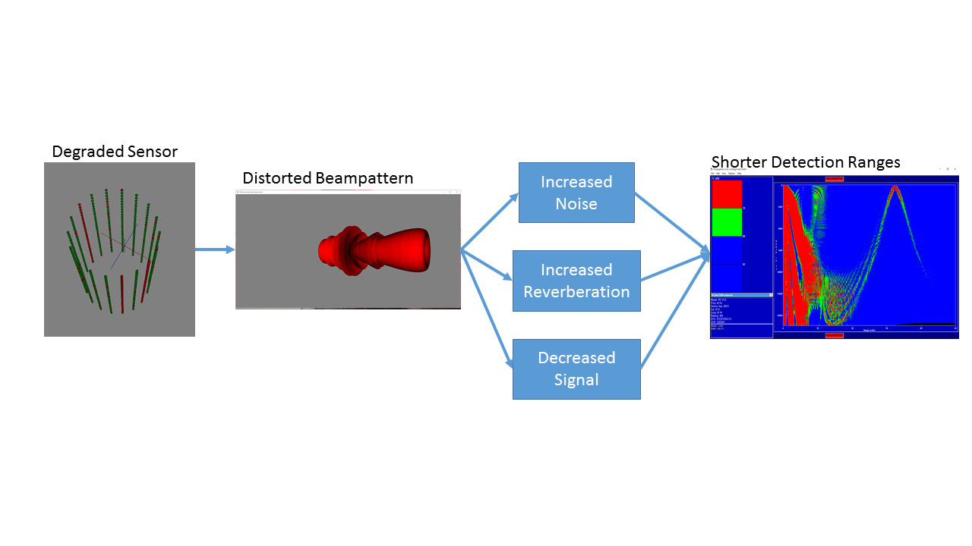

Figure . Degradation Flow, from Sensor to Target Detection

### Effect of Array Degradation on Beam Noise and Self Noise

Arrays are designed with several considerations in mind, but one that is critical to the reduction of ambient noise is minimization of aliasing and sidelobes. When arrays are distorted, as is the case when a towed array is dragged through a ship maneuver, or when elements fail, sidelobe levels can increase, main lobe beamwidths can increase, and aliasing can occur, degrading the system’s ability to suppress ambient noise. In the passive and active sonar equations, the suppression of ambient noise is called Directivity Index (DI); the difference between ambient noise level and beam noise level is DI.

In our analysis, we estimated DI for an ideal array, and for thousands of array degradations, considering cases where element outages were random and also where element outages were grouped. Contiguous element outages turned out to cause a larger change in DI than did randomly placed outages. Figure 5 shows DI degradation (1- and 2- sigma levels) as a function of the percentage of disabled elements. This has a direct effect on beam noise in sonar systems. For example, if 12% of the elements in a sensor are malfunctioning, we can expect, on average, a half-dB increase in beam noise. If we want to be conservative and capture 95% of the data, then we need to look at the 2-sigma curve and assume a little more than 1 dB of increased beam noise.

One of the assumptions we have made so far is that self noise is not a significant contributor to the interference terms in the passive and active sonar equations; that ships can drive at such a speed that self noise is not a factor for its sensors. While self noise is extremely important, especially to active sonar systems, the question here is whether it affects our recommendation for a malfunctioning-element threshold.

The DI degradation computations we have made always assume that self noise is not a factor. When ownship speeds are high enough, however, this assumption is incorrect, and we need to treat the overall lower response of a receiver array as an additional degradation in the sonar equation. While this can be accomplished in a straightforward implementation in any sensor performance prediction, it may not be as simple to use this information to tighten tolerances on malfunctioning elements unless we know the average beam-to-self noise ratios, for which we probably need actual array data. It can be noted, however, that it would take a lot of malfunctioning elements to lower the beam noise levels even a few dB. For example, if 50% of the elements in an array are completely dead, the noise levels are lowered by only 3 dB (and presumably raised by the DI degradation, which mitigates the self-noise problem even further).

Active Transmitter Source Level reduction due to malfunctioning elements should not affect the self-noise, beam-noise balance, so is not a consideration in determining tolerances on malfunctioning elements.

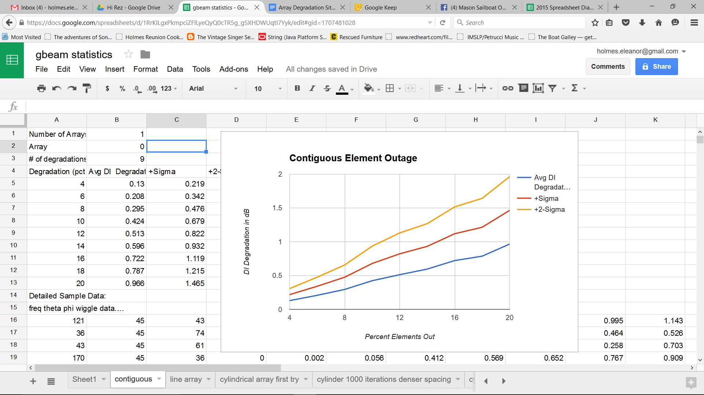

Figure . DI Degradation as a function of % of Malfunctioning Elements

### Effect of Array Degradation on Reverberation

Reverberation is a problem unique to active systems. It occurs when the active signal reflects from anything *other* than the target, and propagates back to the receiver. The same changes to the beam pattern that affect noise suppression also affect reverberation suppression, and to approximately the same extent.

### Effect of Array Degradation on Signal

Figure 6 shows an example of an ideal line array and its beam pattern, alongside the same array with severe distortion. The sidelobe levels have increased significantly in the distorted-array beam pattern, and the main lobe has become fatter and lower in level. A picture of multiple beams of a towed array, shown in Figure 7, illustrates now a portion of the search space can be adversely affected by array distortion.

We have created a new term to describe the portion of the search space affected by beam pattern distortion: Coverage Penalty. Rather than describe just the dB degradation in a single direction, Coverage Penalty estimates the portion of the search space in which threat signal may be severely degraded. Figure 8 shows two displays of coverage penalty as a function of frequency and also as a function of beam steer angle. In both cases, coverage penalty behaves as we’d expect. Higher frequencies, with narrower beams, are affected more than lower frequencies, where beams are fat. Broadside beams are affected more than endfire beams for the same reason.

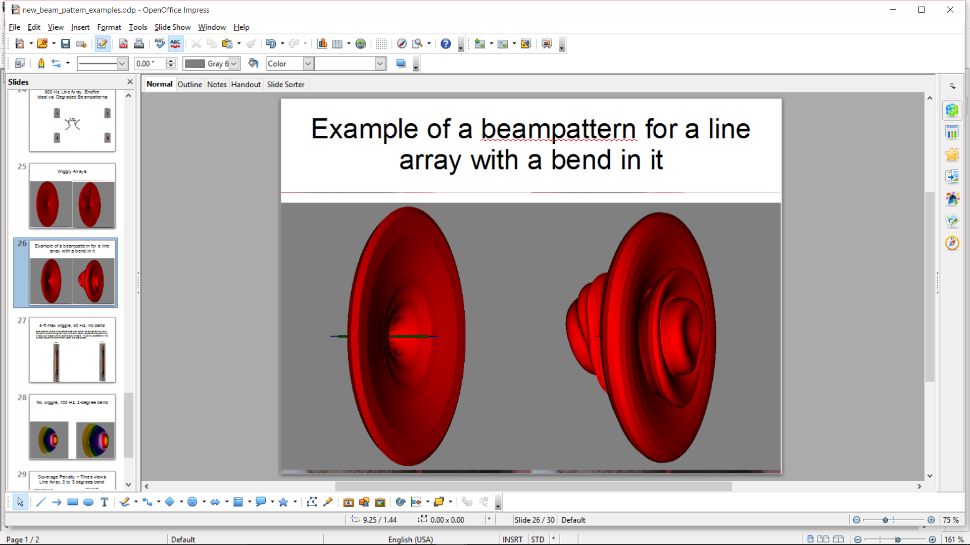

Figure . Ideal and distorted array beam patterns

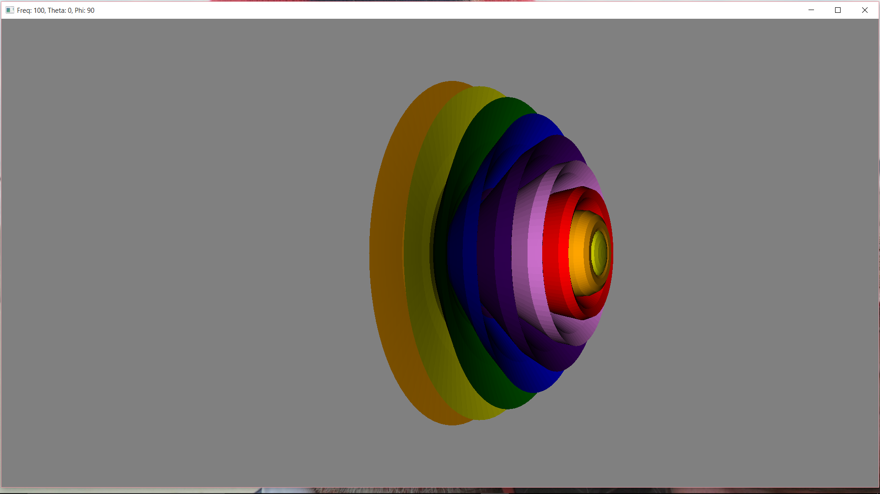

Figure . Several Distorted Line Array Beam Patterns

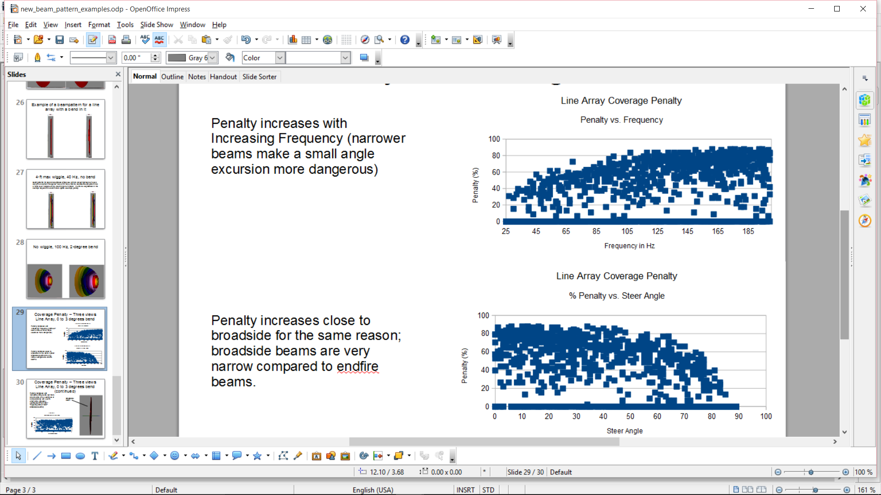

Figure . Coverage Penalty as a Function of Frequency and Steer Direction

### Effect of Array Degradation on Threat Detection Ranges

In order to determine the effect of Array Degradation on Threat detection ranges, we used unclassified descriptions of typical threats, sensors, and environmental conditions, and ran the Navy’s standard Propagation and Active Performance models in tens of thousands of cases around the world, for different seasons and threat/sensor geometries. Figure 9 shows active sensor performance against a shallow target in January. Given several sensor configurations, etwo degradations (mild, severe), three threat depths and three threat tonals, four seasons, and four ocean basins, providing a display for every combination of parameters is unwieldy. We therefore summarize these results in a display that compares the ideal array to the degraded array, as shown in Figure 10. Here we have divided all of the range data into bins associated with the ideal array. The three lines represent the ideal, a sensor missing 10% of its elements, and a sensor missing 40% of its elements. At 15 nautical miles on the “X” axis, for example, we see that the “Y” value for the ideal sensor is also 15. This is a result of the binning process being keyed to the ideal sensor. The 10% degraded sensor line is at about 13 or 14 nm, which means that for about 70% of the cases[1] where the ideal sensor made detections between 14.5 and 15.5 nm, the degraded sensor made detections *no longer than 13.5 nm*. For the 40% degraded sensor, 70% of the degraded sensor detections were at least 7 nm.

Analysis of spatial trends yielded results shown in Figure 11, yield a rather interesting consistency, considering the dramatically different climates of the various ocean basins, especially in the Arctic Ocean, where half-channel conditions dominate. We found the same to be true of seasonal dependencies: there are none. In fact, the only strong trend we found was when we compared sensor types. Figure 12 is a comparison between active and passive sensors, in which the passive sensor is clearly affected more severely by array degradation than is the active sensor.

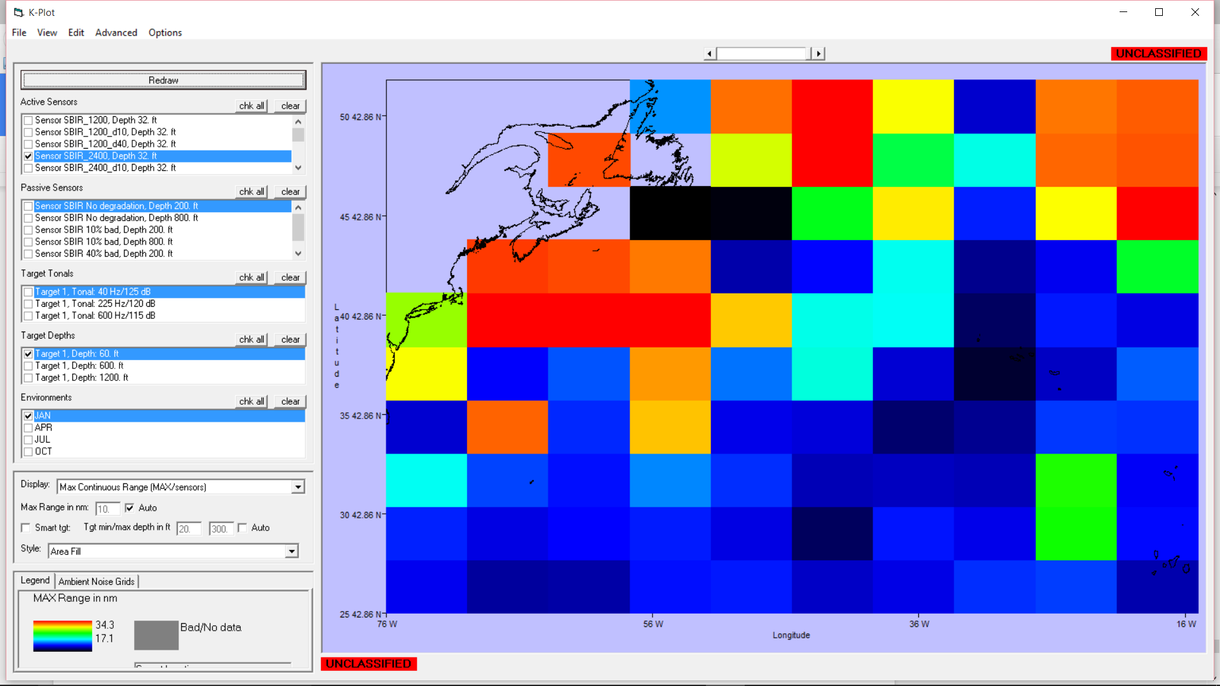

Figure . Average Performance in the Atlantic Ocean

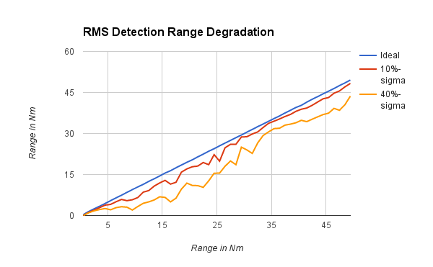

Figure . Atlantic Performance Degradation

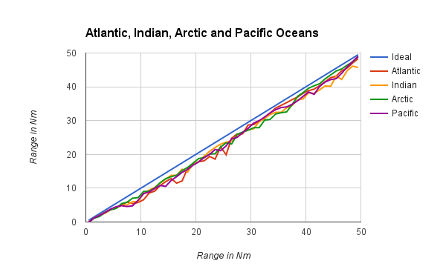

Figure . Degradation as a function of Ocean Basin

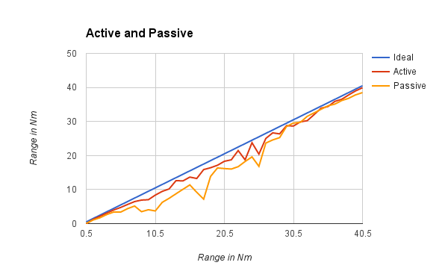

Figure . Active vs. Passive Range Degradation - All Oceans

## Thresholds

In the phase I Base period, we identified an initial Sensor Degradation Decision Ruleset and degradation metrics that we believe parametrize the critical factors that govern and threshold the determination of when a sensor is too degraded to be utilized and trigger an operator evaluation & decision. We then generalized the results of a large number of examples (Initial Critical Factors Analysis) to generate statistics on each metric to begin establishing thresholds for alertment triggers. To accomplish this, a Monte Carlo simulation was developed to model DI for a large number of random array degradations, frequencies, and steer angles, and generate statistics on the DI degradation and its variance. We can then use these statistics to investigate ranking algorithms to determine the primary metric(s) in triggering an operator alert. As stated earlier, the initial factors to be considered in Degradation Decision Tree and for the Critical Factors Analysis are:

* + Active vs Passive (Does more dead phones mean more to Passive than Active?)
  + % Dead & Degraded Hydrophones compared to historical data
  + % Non-Contiguous vs Contiguous Dead & Degraded Hydrophones
  + Location & Percent of Dead & Degraded Hydrophones relative to Array Geometry
  + Location of Dead & Degraded Hydrophones relative Array Geometry/Aperture (LF, MF, HF) for each Threat FOI
  + Degraded DI vs Historical
  + Sensor Self-Noise vs Historical
  + Degradation Threat FOI-dependent
  + Effect/ Thresholding of Array Deformation on Sensor Beampatterns/Parameters

Based on our analysis of sensor performance and comparative trends, we have developed recommended thresholds for some of the critical factors listed above. We have also identified areas that need additional research, in some cases with actual sensor data. This ranking is shown in Table 1.

Table . Critical Factor Ranking and Thresholds

|  |  |  |  |
| --- | --- | --- | --- |
| Critical Factor | Ranking | Threshold | Comments |
| Passive Array, % contiguous dead phones | High | 8% |  |
| Active Array, % contiguous dead phones | High | 8% |  |
| Passive and active arrays, % random dead phones | High | 12% |  |
| Degraded DI vs. Historical | High | N/A | This has a direct effect on performance, but needs to be baselined with actual data |
| Array Deformation | Medium | 1-3 degrees array bend | Need further study with actual array distortion data to develop method for determining “array bend” from hydrophone locations |
| Location of dead phones | Unknown |  | Need further study and access to real array data to determine |
| Sensor Self Noise vs. Historical | Unknown |  | Need access to self noise data |

## Recommended Tactical Decision Aid Modifications

Figure 10 shows a conceptual chart of several important elements of the Navy’s tactical decision aids for sonar. Yellow boxes indicate data that is supplied to the process, either from automated sensor data retrieval, or from databases, or from the system operator. Green boxes represent major computations, and blue boxes represent displays. The arrows show the flow of data.

Using this as a guide, and results of the analyses, we make the following recommendations for modifications to today’s TDAs, to accommodate new information on the status of acoustic sensors:

1. Provide pre-computation products
2. Compute and use degraded sonar equation parameters
3. Provide output displays that readily distinguish between ideal and actual performance

These three classes of recommendations are defined in

Sensor Data:

Element (x,y,z,shading)

Steer angles

Type (active, passive, bistatic)

Tactical Data:

Threat frequencies

Threat source levels

Environment:

location

dtg

wind

noise

Beamforming

3D Beampattern

DI

Beamwidth

Beam Pattern Displays

2-d, ideal vs. actual

3-d, ideal *and* actual

DI comparisons

PD comparisons

Propagation Modeling

Passive and Active

Sensor Performance Displays

Current array only

Current array vs. ideal array

Figure . Incorporation of sensor data into TDAs

### Pre-performance-Prediction Products

Our first suggestion for a display of PD degradation is shown below. It is similar to the display above, but has two curves: Ideal and Actual. To understand the effect on sensor performance, the operation can note from viewing this display that, for example, when the ideal PD is 50%, his actual PD is around 35%. Clicking within the display could also provide numbers for any selected PD/SE, as shown here as well by the vertical cursor and the cursor read-out. when PD is 76% for an ideal array, the degraded array has a 66% PD.

Another possibility for a PD display would eliminate altogether the need to observe signal excess. In the display below, the X axis is PD for the ideal array, and the Y axis is PD for the actual array. The green line is used to readily see the difference between ideal and actual PD. The distance between the green and red lines is the PD degradation. Again, a cursor readout can show users the degradation at any particular PD. The trade-offs between this display and the previous are as follows:

An advantage of the previous SE vs. PD display is that operators may be familiar with ROC curves, and therefore may be comfortable with this display.

An advantage of the PD vs. PD display is that signal excess is removed as a (possibly) distracting parameter.

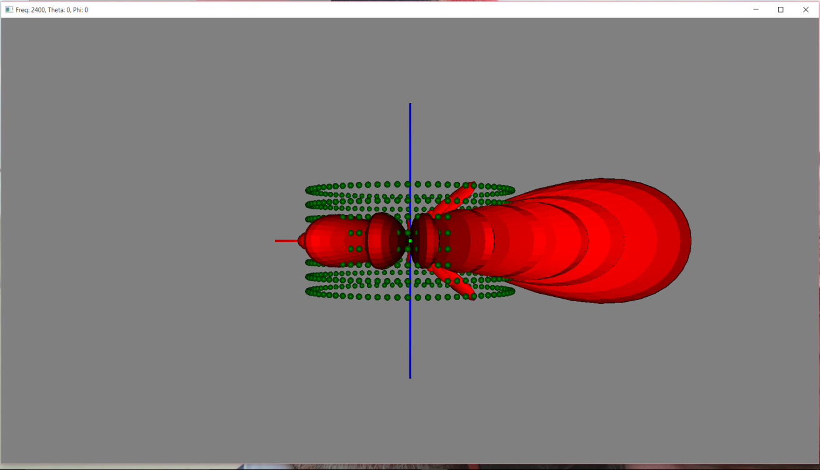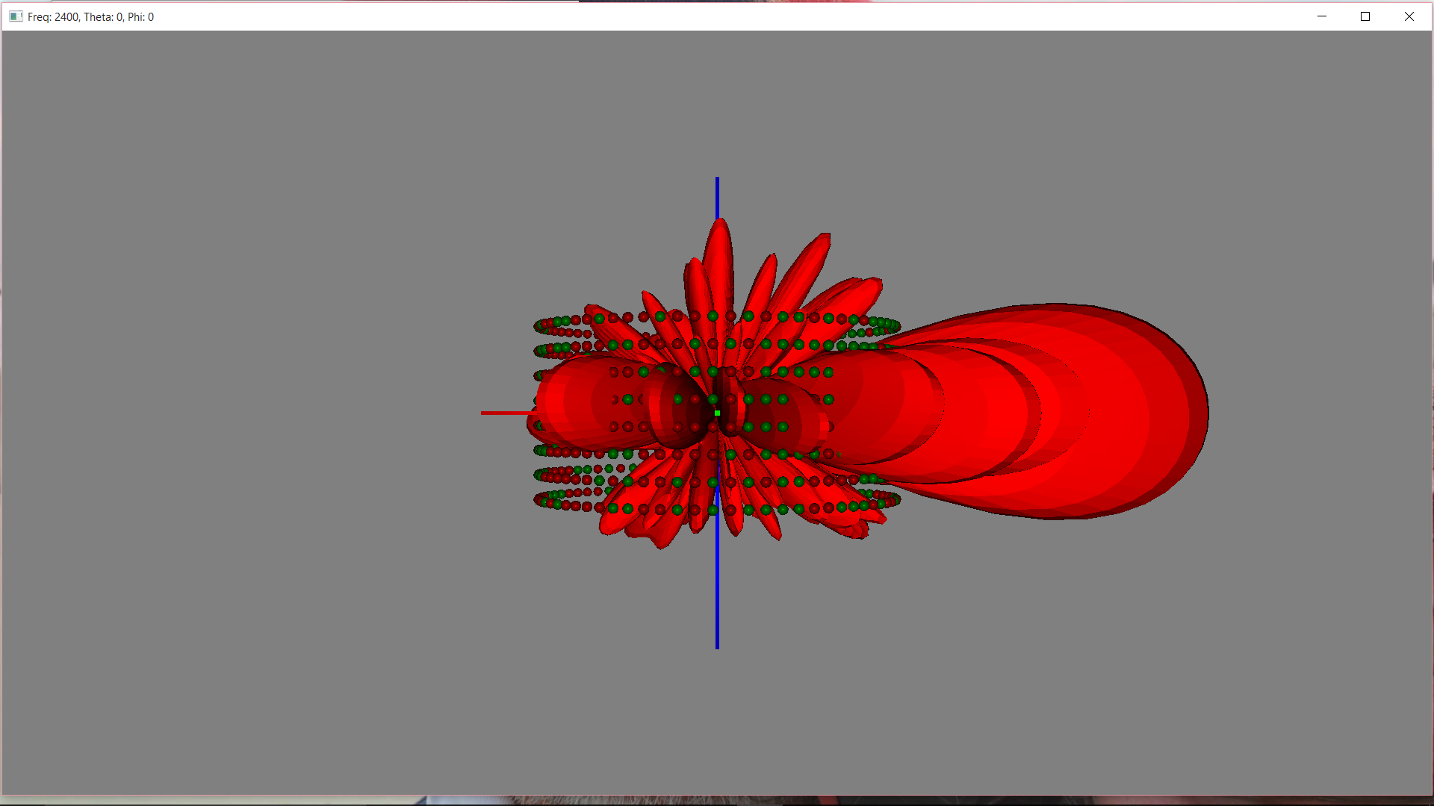

**Figure 14. 3-d Beam Patterns for Ideal and Degraded Arrays**

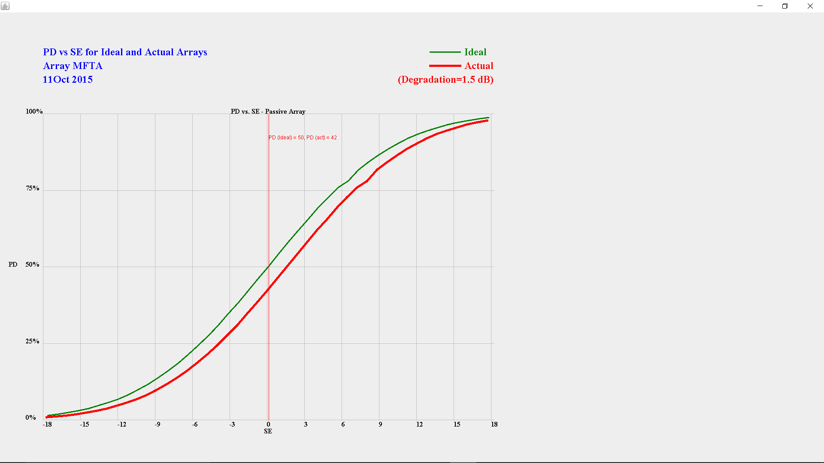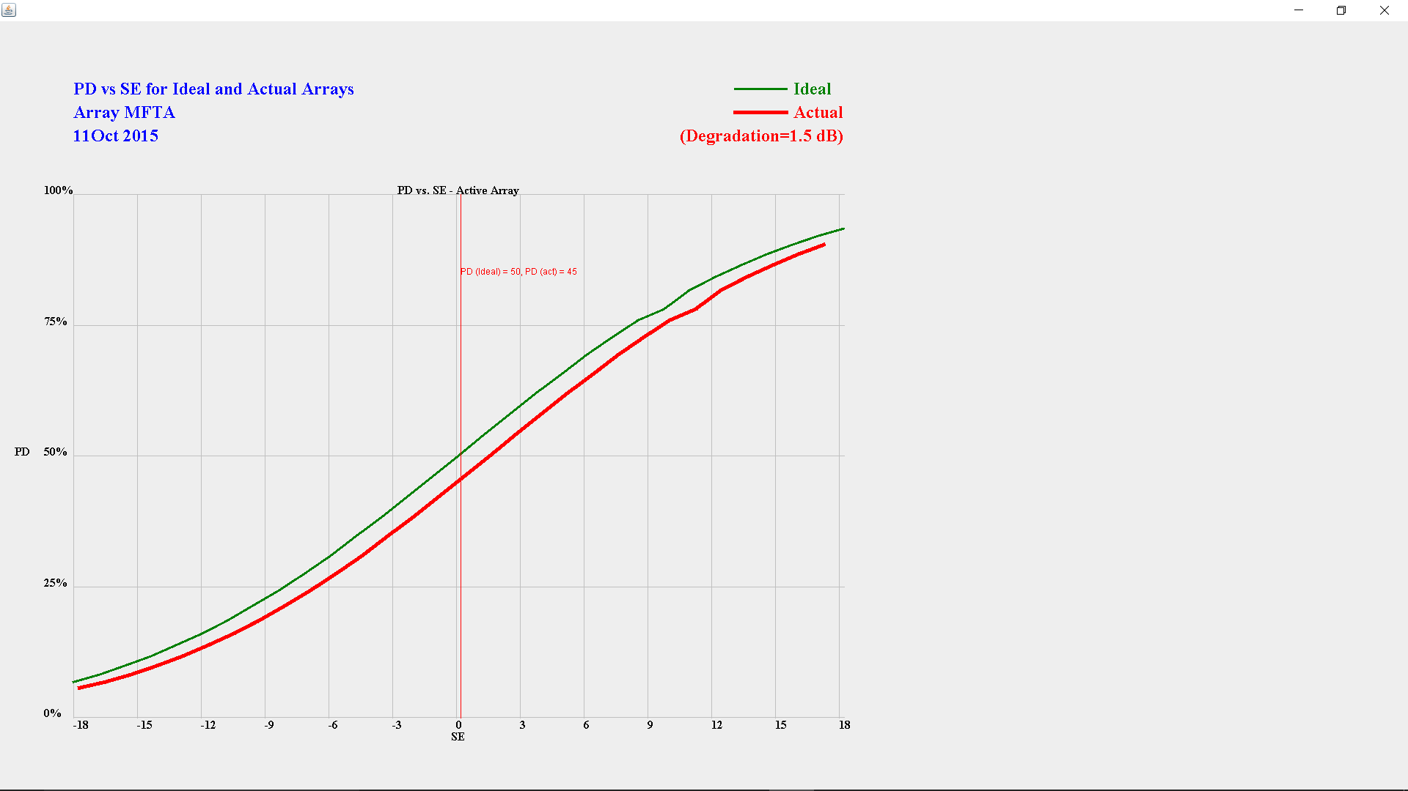

Figure . Probability of Detection for Ideal and Degraded Arrays

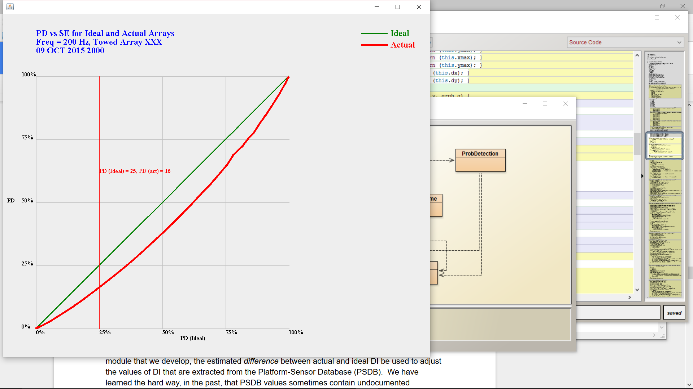

Figure . PD Display without Signal Excess

### Incorporation of Sonar Equation Parameters

To estimate sensor performance, the Navy’s TDAs solve the passive and active sonar equations:

Passive SE = Source Level – TL – (Noise – DI) – Recognition Differential

Active SE = (Source Level – TL(out) – Target Strength – TL(back)) – (Reverb ϴ (Ambient Noise – DI) ϴ selfNoise) – Recognition Differential

We recommend computing and using the following modified sensor parameters, appropriate to the degraded array:

* DI – Directivity Index, computed by integrating around the 3-d Beam pattern. To implement this modification, we recommend computing both the degraded and ideal sensor DI values, and modifying the PSDB by the *difference* between these two values. This can be used for both passive and active sonar performance predictions.
* Active sonar source level, computed as a simple function of the fraction of malfunctioning elements
* Active reverberation. This is estimated using modified vertical and horizontal beamwidth values computed directly from the DI estimates.

We will want to be able, on request, to show the users actual numbers: the differences in DI and Effective Beamwidth between ideal and degraded arrays. The most straightforward way to do this may be with a table, such as the examples in Table 2, for passive runs.

For active runs, there is generally a single frequency (at a time, anyway). Its table might be even simpler, and could accommodate more than one frequency when complex active wave forms involving more than one frequency are used. An example of this table is shown in Table 3.

Table . Passive DI Degradation Example

|  |  |
| --- | --- |
| **Threat Frequency** | **DI degradation** |
| 40 Hz | 1.9 dB |
| 220 Hz | 2.2 dB |
| 600 Hz | 2.6 dB |

Table . Active Parameter Degradation Example

|  |  |  |  |  |
| --- | --- | --- | --- | --- |
| **Transmit/Receive Frequency** | **Source Level Degradation** | **DI degradation** | **Ideal Beamwidth** | **Degraded Beamwidth** |
| 3000. | .8 dB | 3.3 dB | 4 degrees | 7.2 degrees |

### Sensor Performance Displays

There are three easy ways most operators currently view sensor performance: TL (or SE in the active case) vs. Range, Plan View, and Full-Field. In each case, we recommend a single display that will show the operator his current expected performance, as well as the performance of a non-degraded array.

Looking at the simplest first, shown in Figure 17, a TL vs. Range display shows transmission loss on the vertical axis, range on the horizontal, and, in this case, horizontal lines at the values of FOM for the ideal and degraded arrays. The degraded FOM is smaller, leading to shorter expected detection ranges. This display shows results, however, for only a *single* target depth, and a *single* bearing.

The next display (Figure 18) shows data for a single target depth, but for all bearings along which propagation has been computed. It may not be obvious initially, but this display, with a little practice, is just as easy to understand as the previous display, and contains a lot more information. Instead of using a line to represent an FOM, we now use color. With a sensor in the center of the display, every pixel on the screen is colored according to threat vulnerability at the range and bearing associated with that pixel, assuming a single threat depth. The colors are:

* Bright red, if there is more than a 50% probability that a target at this location will be detected by the degraded or ideal array
* Dark red, if there is more than 50% probability that a target at this location will be detected by the ideal array, but less than 50% chance the target will be detected by the degraded array
* Dark or light blue if neither the degraded or ideal array has at least a 50% chance of detecting the target

For the Full-Field display shown in Figure 19, a performance vs. range and depth plot, we chose a color scheme that we feel does a better job highlighting performance degradation:

* Red indicates regions where oth the ideal and degraded arrays should be able to detect the threat,
* Green indicates regions where only the ideal array should be able to detect the threat, and
* Blue indicates regions where the target is probably undetectable by either the ideal or the degraded array.

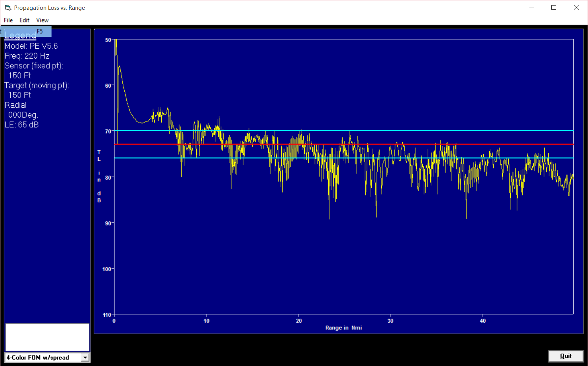

Figure . Example of Sensor Performance Health Product (TL vs. Range)

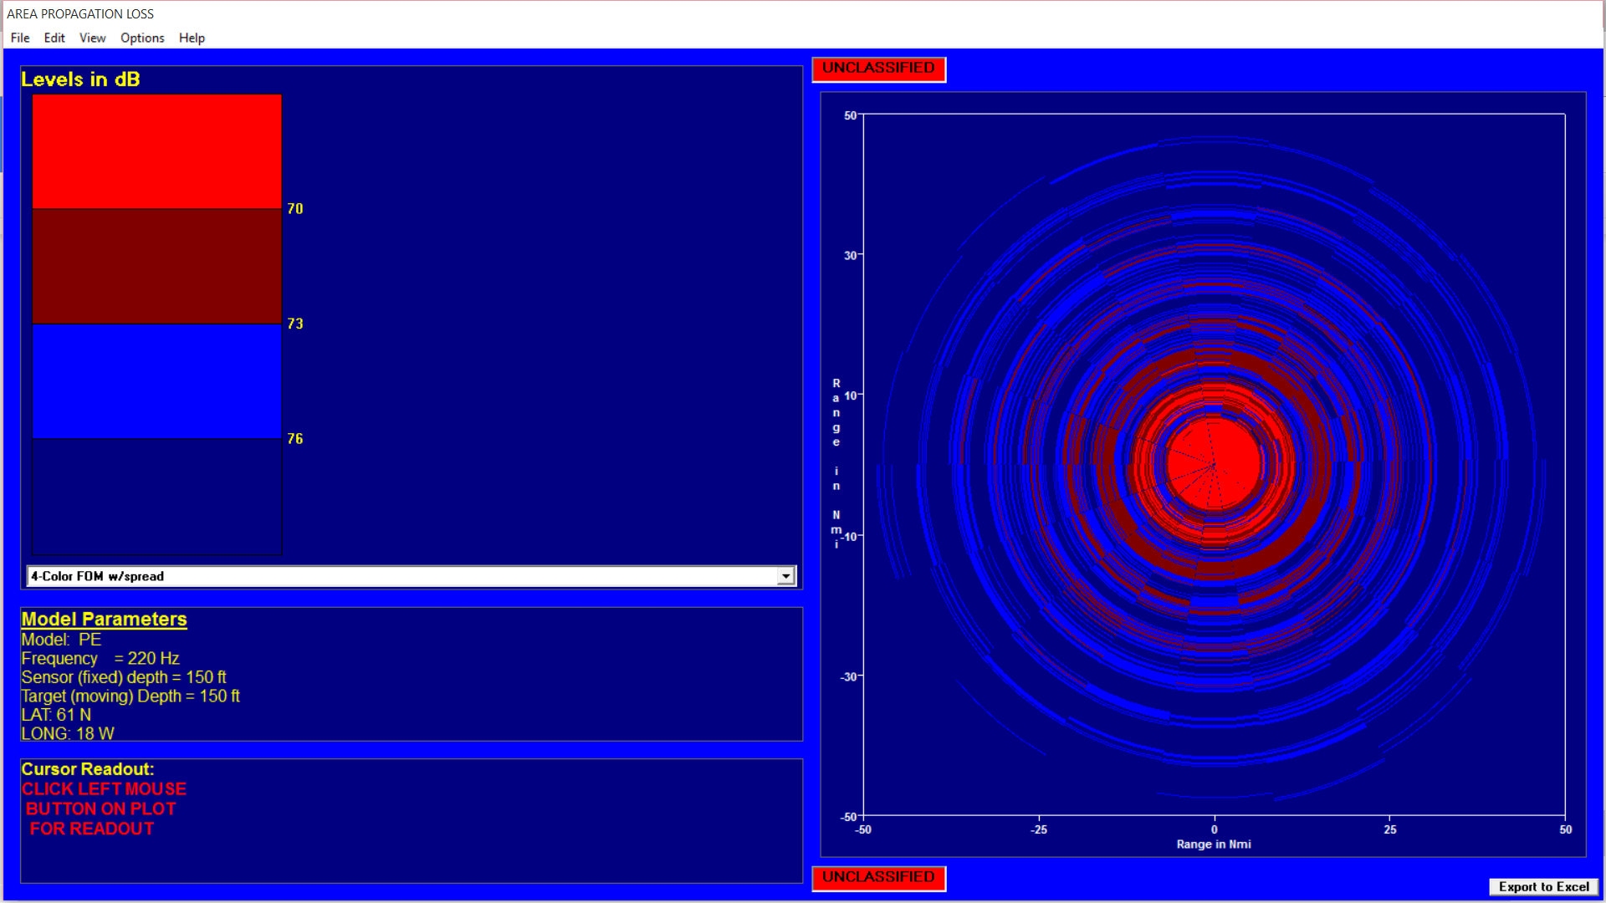

Figure . Example of Sensor Performance Health Product (Plan-View)

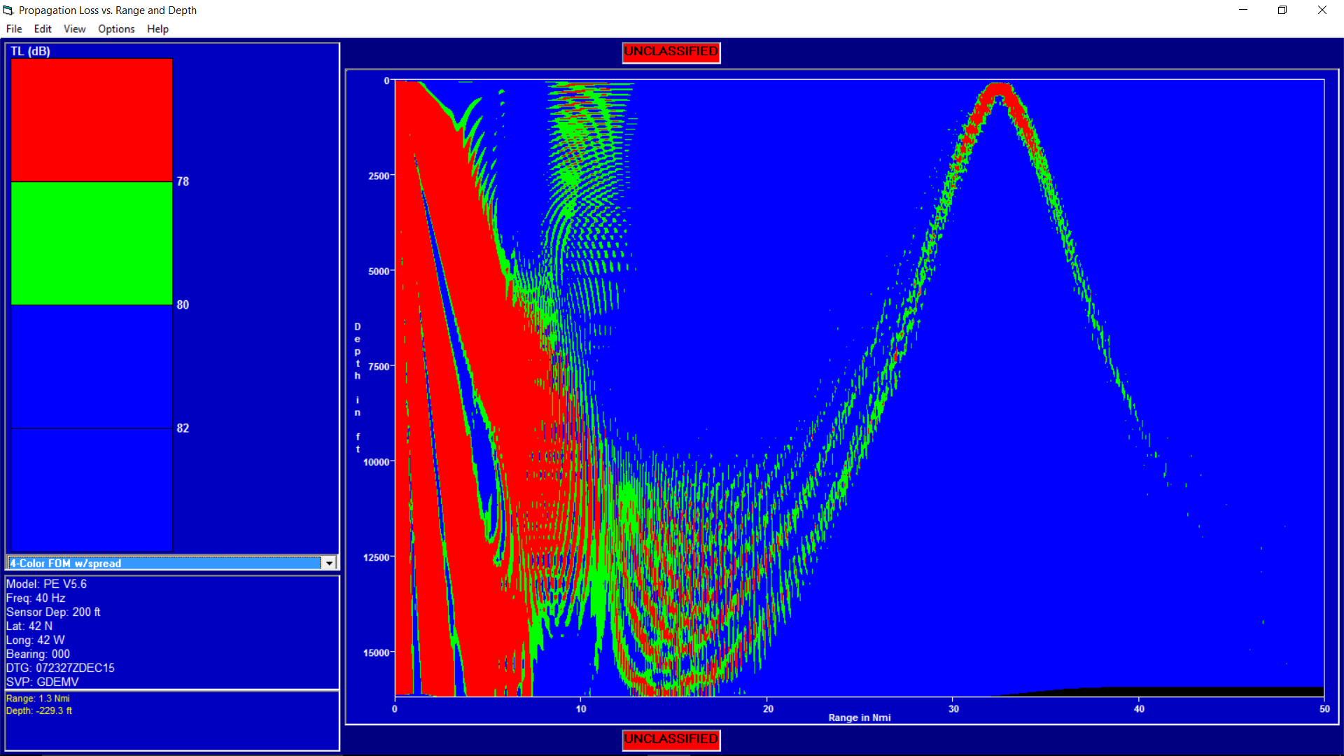

Figure . Full-Field Plot with Red-Green-Blue Color Coding

# Conclusions

During the Phase I Base effort, we designed, developed, and evaluated classes of algorithms that support a flexible AAMS concept, architecture, interfaces, and functionality on multiple sensors in the areas of

(a) Automated, intelligent control & evaluation of sensor health data based on sensor degradation rules and metrics

(b) Sensor degradation metric ranking;

(c) In-situ calculation of degraded sensor parameters;

(d) Automated, real-time sensor self-noise.

We also identified and analyzed new degradation metrics that will be used to make the decision to alert an operator to degraded sensor health, generated exemplars of degraded sensor beampatterns and sensor parameters.

Phase I Base period analyses, evaluations, & assessments of these algorithms and degradation metrics using our testbed framework, Monte Carlo simulations, and operational TDA environment successfully demonstrated that these algorithms and degradation metrics satisfy the Phase I Base period goals of

* Defining and developing a robust AAME operational concept and intelligent controller, architecture, information flow, and processing algorithms.
* Defining and developing of base algorithms for a real-time Sensor Self-Noise module,
* Defining and developing of sensor health and system performance decision aid tools to calculate and display to operators degraded beampatterns and their associated degraded sensor parameters as a function of selected threat frequencies.

Successful integration of these classes of algorithms in the Phase I Option period and proposed integrated algorithm assessment to characterize performance will allow us to fully demonstrate the automated acoustic monitoring concept and demonstrate the operational benefits of the concept.

# Recommendations

Through the Phase I Base effort and analyses, HRC has successfully demonstrated that individual algorithms and partial integration of these algorithms form a solid backbone and performance baseline for the proposed AAME architecture & concept. Successful integration of these classes of algorithms in the Phase I Option period and proposed integrated algorithm assessment to characterize performance will allow us to fully demonstrate the automated acoustic monitoring concept and demonstrate the operational benefits of the concept. We recommend funding the additional proposed Phase I Option tasks of

* Enhancing the Phase I Base intelligent controller algorithms with telemetry wild-pointing & transient detection algorithms
* Expanding our Testbed Framework, developed in Phase I Base period, to encompass & stim the entire operation AAME concept
* Modify our current recorder technology to record and playback at-sea data recordings of the relevant data needed in the ACB System Integration environment to use in development of the Phase II Prototype

Approval and funding of these Option tasks will provide us a good start to developing the Phase II AAME Prototype and the fulfilling the overall Project goals of developing & providing a robust and effective automated acoustic monitoring system (AAMS) that will alert operators to degraded sensor performance due to platform self-noise and sensor health.

# Proposed Additional SBIR/STTR Funded Research

The proposed Phase II tasks for continued AAME development are the following:

1. Development of an integrated AAME Prototype for Phase II laboratory demonstration in a relevant tactical environment (TRL6)
2. Acquisition and modification of GFI SPPFS Sonar & SS-IF Bridges and Sensor Metrics for use by AAME Prototype
3. Modify GFI Sensor Metrics to insert degraded sensor beampatterns and associated sensor parameters into SPPFS PSDB for use in SPPFS performance predictions
4. Modify GFI active performance prediction models to efficiently compute both ideal and degraded performance in a single pass, without having to run models twice.
5. Integrate displays that were prototyped during Phase I into performance prediction system architecture.
6. Modify GFI SS-IF and Sonar Bridges for use in AAME architecture to interface to AN/SQQ-89 ACB.
7. Development of the Acoustic Sensor Monitoring External Communications (SS-IF, Sonar Bridges, Threat Processor, and Sensor Metrics) module
8. Acquisition of WQM9 data and MFTA Self-Noise curves as GFI for continued ASMIC algorithm development & evaluation
9. Development of the Acoustic Sensor Monitoring Database module
10. Development, evaluation, and integration of ASMIC DASA algorithms into overall AAME architecture & prototype
11. Continued refinement of Acoustic Sensor Monitoring Intelligent Controller algorithms and development of prototype module for integration into the overall integrated AAME architecture & prototype
12. Definition and development of sensor health operator alerts and interface to CES Alert service
13. Modifications identified in Phase I Base algorithm investigation to SAMANTHA algorithms for incorporation into integrated AAME architecture

# Transition and Acquisition Planning

The Phase II Transition Plan will concentrate on the development of an integration risk mitigation and transition plan for the AAME Prototype into the AN/SQQ-89 ACB baseline. As part of this risk mitigation plan, we have already identified, investigated, defined and evaluated available AN/SQQ89 ACB interfaces, messaging, message ID’s, and data structures as part of our design specification for the ASM External Communication module in the Phase I Base period. As a continuing effort to mitigate integration risk into ACB, we will

* Identify interface changes and tactical updates to improve performance, which the Navy can schedule into later ACBs.
* Modify our current recorder technology to record and playback at-sea data recordings of the relevant data needed in the ACB System Integration environment to use in development of the Phase II Prototype.

To further reduce integration risk into ACB, we will produce a technical approach for integration and demonstration of the AAME technologies to be at Test Readiness

* Level 6 (System prototype demonstration in a relevant environment) by the end of the Phase II Base period
* Level 7 (System prototype demonstration in operational environment) by the end of the Phase II Option period

The risk mitigation approach will reuse interfaces to the AN/SQQ-89 ACB Acoustic Sensor (AS) baseline developed by HRC/Leidos personnel as part of AN/SQQ-89 ACB SPPFS program to minimize the impact of the Phase III transition since the initial RFP indicated possible integration of AAMS technology into STDA-SPPFS.

We will target the AN/SQQ-89 ACB19 as the transition target, in which we will submit Phase II results (Prototype at TRL6) in second quarter of FY18, refine the prototype through FY19 during the Phase II Option, and submit the AAMS Prototype (TRL7) for ACB19 Step2 evaluation and acceptance in the third quarter of FY20. The Seminal Transition Point (STP) of the AAME technologies will be successful acceptance of the Prototype and the end of the ACB19 Step2 evaluation in later part of the third quarter of FY20.

After Step 2 acceptance, the system will go through ACB19 String & Systems Integration leading up to Step3 evaluation in the last quarter of FY21 at which time the system will be at TRL8 (Ssystem completion and qualified through test and evaluation). The system will achieve the highest level of readiness (TRL9 – Actual system proven through successful missions operation) after ACB19 Step4 (Sea Test Evaluation) is completed.

# References

**[*Book Format:*** Author's last name, first name. *Book title*. Additional information. City of publication: Publishing company, publication date.

1. Boorstin, Daniel J. The Creators: *A History of the Heroes of the Imagination*. New York: Random, 1992.

***Encyclopedia & Dictionary Format:*** Author's last name, first name. "Title of Article." *Title of Encyclopedia*. Date.

1. Pettingill, Olin Sewall, Jr. "Falcon and Falconry." World Book Encyclopedia. 1980.

***Magazine & Newspaper Articles Format:*** Author's last name, first name. "Article title." *Periodical title* Volume # Date: inclusive pages.

1. Kalette, Denise. "California Town Counts Down to Big Quake." USA Today 9 21 July 1986: sec. A: 1.

***Website or Webpage Format:*** Author's last name, first name (if available). "Title of work within a project or database." *Title of site, project, or database*. Editor (if available). Electronic publication information (Date of publication or of the latest update, and name of any sponsoring institution or organization). Date of access and <full URL>.

1. Dove, Rita. "Lady Freedom among Us." The Electronic Text Center. Ed. David Seaman. 1998. Alderman Lib., U of Virginia. 19 June 1998 <http://etext.lib.virginia.edu/subjects/afam.html>]

# Appendix A: Key Terms

|  |  |
| --- | --- |
| **A** |  |
| AAME | Automated Acoustic Monitoring & Evaluation system |
| AAMS | Automated Acoustic Monitoring System |
| ACB | Advanced Capability Build |
| ACC | Attack Control Console |
| APB | Advanced Processor Build |
| ASW | Anti-Submarine Warfare |
| ASMBG | Acoustic Sensor Monitoring Beampattern Generation |
| ASMDB | Acoustic Sensor Monitoring Database |
| ASMDP | Acoustic Sensor Monitoring Display Processing |
| ASMEC | Acoustic Sensor Monitoring External Communications |
| ASMIC | Acoustic Sensor Monitoring Intelligent Controller |
| **B** |  |
| BFFS | Beamforming Functioanl Segment |
| BW | Beam Width |
| **C** |  |
| CASREP | Casualty Report |
| CASS | Comprehensive Acoustic Simulation System |
| CZ | Convergence Zone |
| **D** |  |
| dB | Decibel |
| DI | Directivity Index |
| DoD | Department of Defense |
| DSS | Data Storage Servies |
| **F** |  |
| FOI | Frequency of Interest |
| FOM | Figure of Merit |
| **G** |  |
| GFI | Government Furnished Information |
| **H** |  |
| HF | High Frequency |
| HLA | High Level Architecture |
| HRC | High Rez Consulting, LLC |
| Hz | Hertz |
| **I** |  |
| IPCP | Interface Protocol Computer Program |
| **L** |  |
| LAT | Latitude |
| LAT/LONG | Latitude/Longitude |
| LONG | Longitude |
| **M** |  |
| MRA | Maximum Response Axis |
| MW | Sonar Middleware |
| **N** |  |
| NAVSEA | Naval Sea Systems Command |
| NAVSEASYSCOM | Naval Sea Systems Command |
| NUWC | Naval Undersea Warfare Center |
| **P** |  |
| PASFS | Pulsed Active Sonar Functional Segment |
| PD | Probability of Detection |
| PE | Parabolic Equation |
| PEO | Program Executive Officer |
| PMFL | Performance Monitoring Fault Localization |
| PMS | Planned Maintenance System |
| PSDB | Platform-Sensor Database |
| **R** |  |
| ROC | Receiver Operating Characteristics |
| **S** |  |
| SBIR | Small Business Innovation Research |
| SE | Signal Excess |
| SONAR | Sound Navigation and Ranging |
| SPCMN | STDA Common Data Format |
| SPPFS | Sonar Performance Prediction Functional Segment |
| STDA | Sonar Tactical Decision Aid |
| SYSCOM | Systems Command |
| **T** |  |
| TA | Towed Array |
| TDR | Tactical Data Repository |
| TL | Transmission Loss |
| TOI | Threat of Interest |
| **U** |  |
| USW | Undersea Warfare |

# Appendix B: Supplemental Data

# Introduction

Understanding the effects of array degradation requires more than just knowing which elements are malfunctioning, and how an array may be spatially distorted. The information about the array itself needs to be translated into usable information. We propose the following two uses for this array element information:

* Generation and display of 3-D beam patterns for both ideal and degraded arrays, and their associated tactical parameters, Directivity Index and Beamwidth (array degradation situational awareness), and
* Use of Directivity Index and Beamwidth in passive and active sensor performance predictions, with modifications to the performance prediction displays so that users can contrast actual/degraded and ideal sensor performance.

Figure B- 1 shows the elements of an end-to-end sensor performance prediction process using degraded array data. Yellow boxes indicate data that is supplied to the process, either from automated sensor data retrieval, or from databases, or from the system operator.

Green boxes represent major computations, and blue boxes represent displays. The arrows show the flow of data. Each of these boxes will be described in the following subsections, followed by Analyses of typical array element degradation (Section B-2), array distortion (Section B-3), and their effect on expected sensor performance in real-world environments (Section B-4).

Sensor Data:

Element (x,y,z,shading)

Steer angles

Type (active, passive, bistatic)

Tactical Data:

Threat frequencies

Threat source levels

Environment:

location

dtg

wind

noise

Beamforming

3D Beampattern

DI

Beamwidth

Beam Pattern Displays

2-d, ideal vs. actual

3-d, ideal *and* actual

DI comparisons

PD comparisons

Propagation Modeling

Passive and Active

Sensor Performance Displays

Current array only

Current array vs. ideal array

Figure B- . General Data Flow and Computation in Recommended Architecture

## Sensor data

A horizontal line array, a passive hull array, and an active hull transmitter will be used as exemplars in this project.

The towed array will be a multi-aperture array, 1250 ft long, with the apertures shown in Table B- 1. The Cylindrical Array consists of 72 vertical staves with 8 hydrophones on each stave, for a total of 576 array elements. The diameter of the cylinder is 100 inches (about 8 ft), and the height of each stave is 48 inches (4 ft). The frequencies of interest for this array are listed in Table B- 2.

Table B- . Towed Array Sensor Parameters

|  |  |  |  |
| --- | --- | --- | --- |
| **Aperture** | **Min Frequency** | **Max Frequency** | **Aperture Length (ft)** |
| LF | 1 | 200 | 1250 |
| MF | 200 | 400 | 625 |
| HF | 400 | 1200 | 312.5 |

Table B- . Cylindrical Array Frequencies

|  |
| --- |
| Cylindrical Array Transmit/Receive Frequencies |
| 1200  2400  4005  6000  7995  9990 |

### Array Visualization

We have developed a three-dimensional display of array elements, showing both functional and malfunctioning array elements. For towed arrays, it can also show the actual (vice ideal) array element locations. Examples of a multi-aperture towed array, a cylindrical array, and a submarine hull array are shown below in Figure B- 2 and Figure B- 3. In each case, we have randomly disabled some of the elements. In the case of the cylindrical, we randomly disabled not only some elements, but some of the staves. Fully functional elements are shown in green; malfunctioning elements are shown in red. The user of this display has control over the view angle and zoom level, so that he can inspect any portion of an arbitrary array.

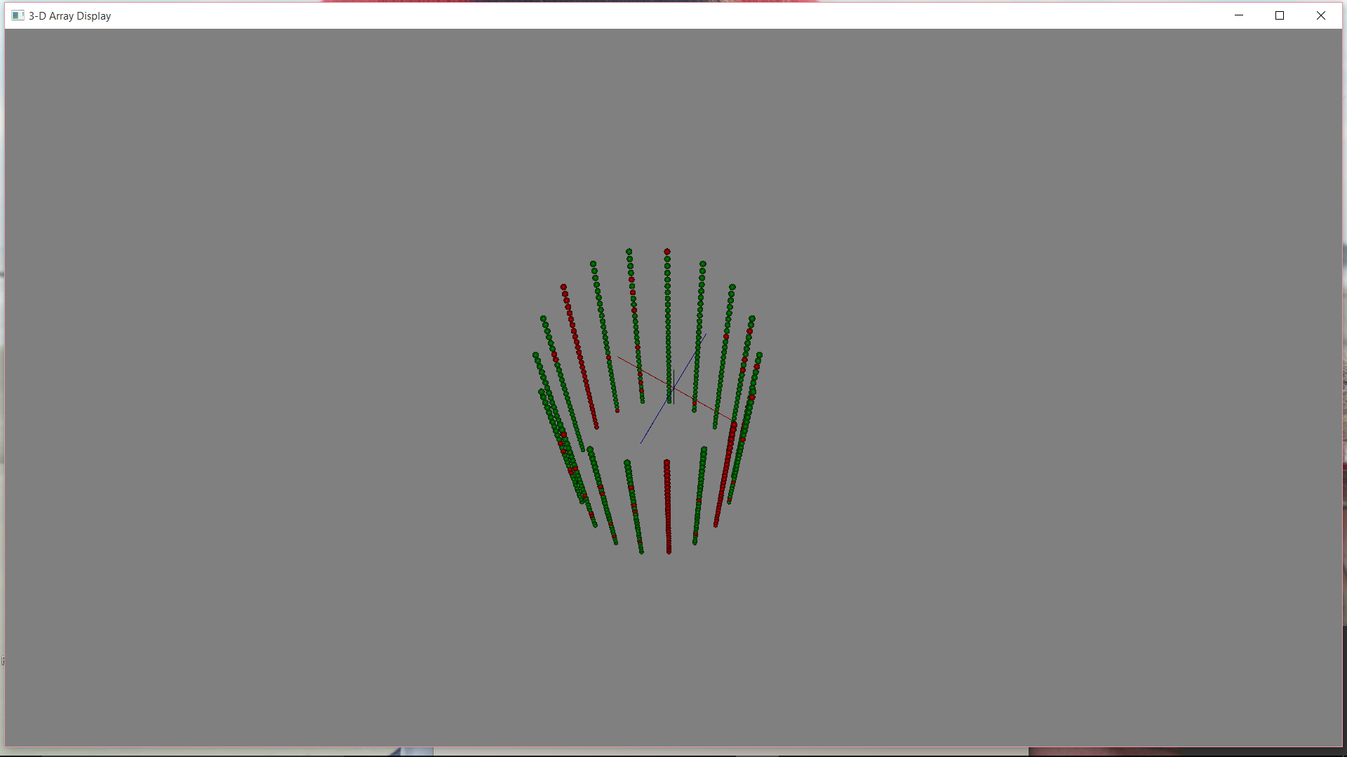 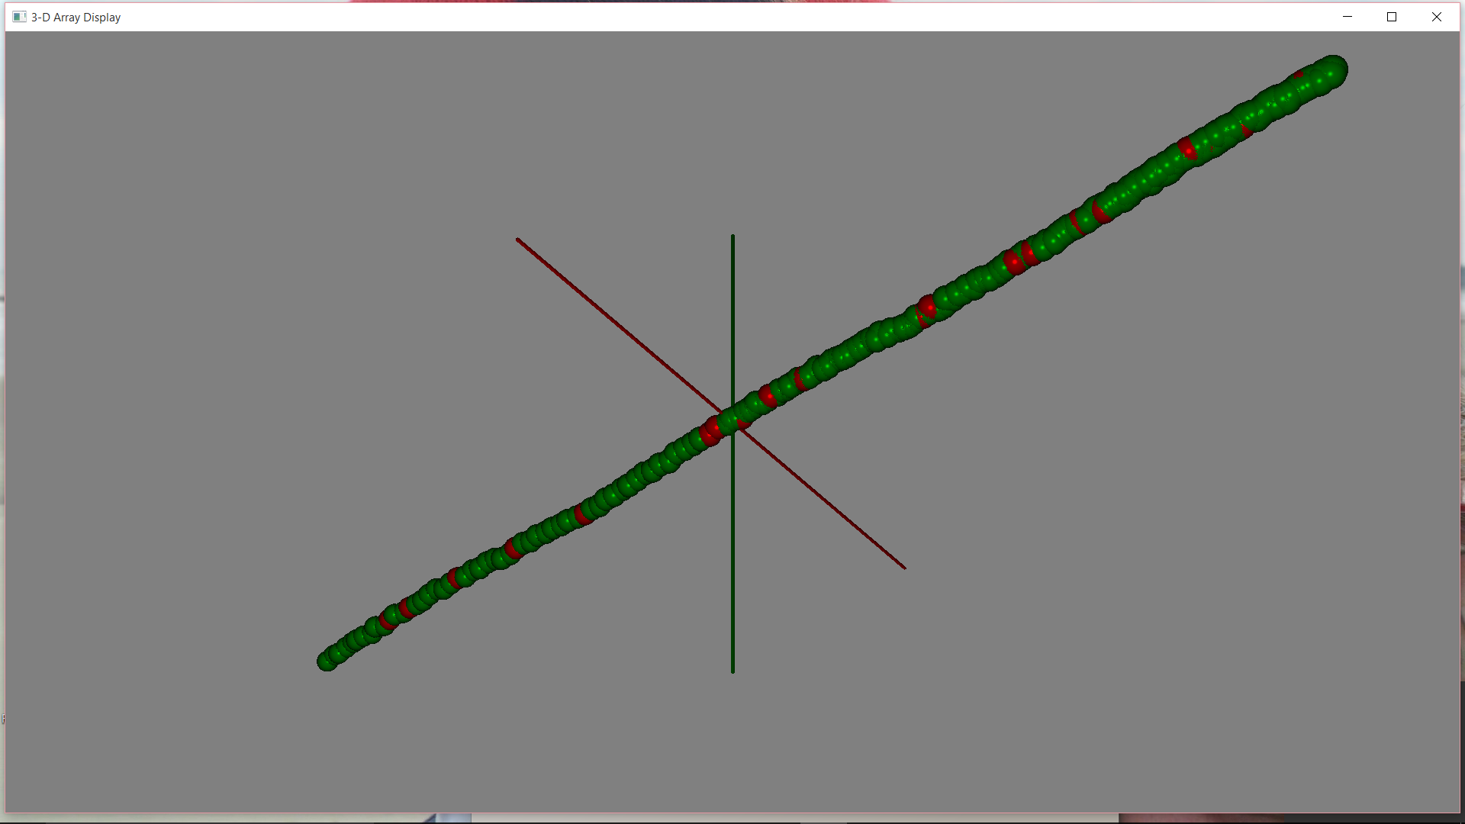

Figure B- . Cylindrical and line array 3-d Visualization

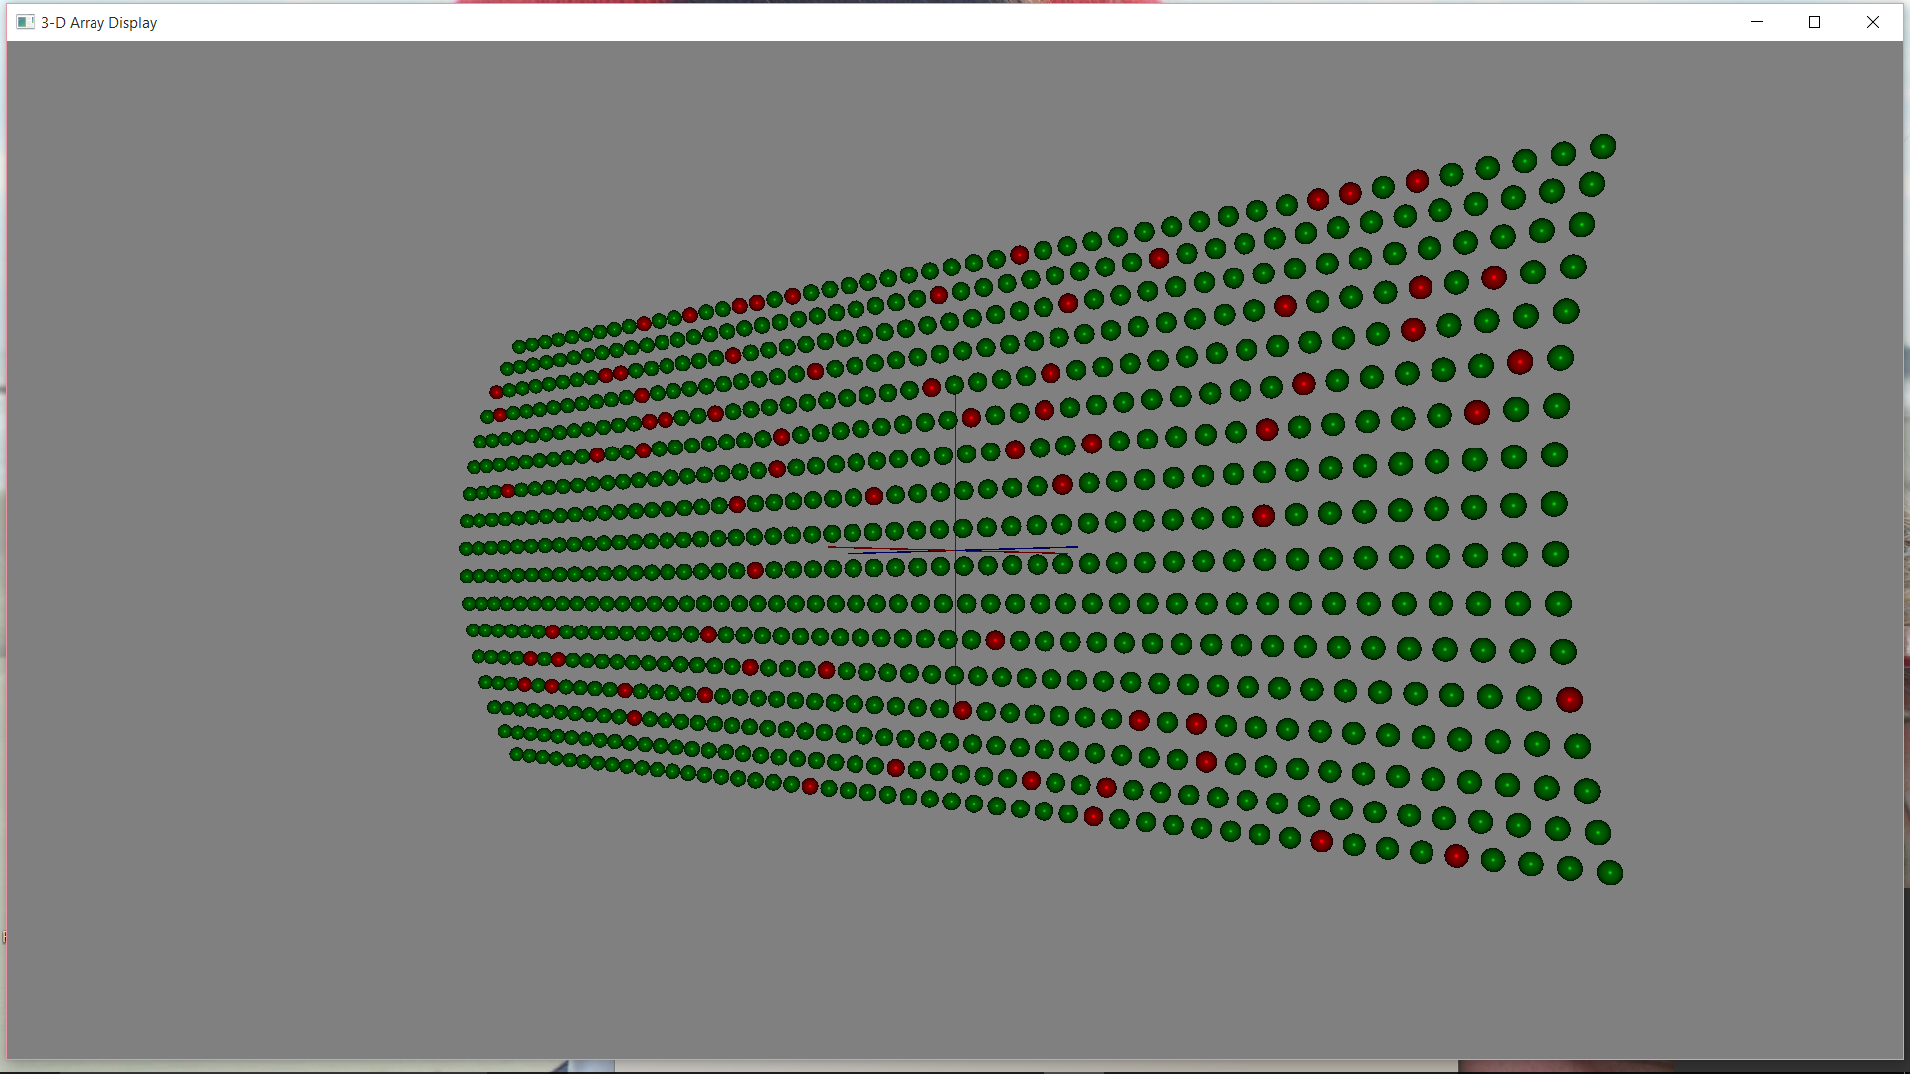

Figure B- . Hull Array Visualization

## Tactical Data

A canonical threat has been generated for use in our development. It is a generic diesel, with a target strength of 15 dB, a depth range from 0 to 1200 ft with periscope depth at 60 ft. Three threat frequencies are provided, along with their source levels, in Table B- 3. These frequencies are below the frequency regime of the cylindrical array, but will be used with the line array.

Table B- . Threat Tonals

|  |  |
| --- | --- |
| **Frequency (Hz)** | **Source Level (dB)** |
| 40 | 125 |
| 225 | 120 |
| 600 | 115 |

Frequency information is provided to the beamforming software so that beam patterns for the specific frequencies of interest can be generated.

Frequency, source level, target strength and threat depths are provided to the propagation modeling software for generation of passive and active propagation loss, echo level, and reverberation. The development has already been accomplished within the Navy’s tactical decision aids to pass threat data between its source (PSDB or operator-entered in general) and the propagation models, so this part of the process requires no additional developmental effort.

## Environment

In the Navy’s tactical decision aids, environmental information comes from a combination of climatological databases and in-situ inputs from sensors (i.e., noise), messages (3-d nowcast sound speed), or operators (i.e., wind speed, time of day for predictions). There should be no change needed in the environmental data management to accommodate the recommendations for degraded sensor performance predictions.

## Beamforming

For this project, we have taken a Visual Basic version of NUWC’s gbeam model, and converted it to Java, adding wrappers and other utilities for easy access to the model and graphical representations of its outputs. The beamforming software we have developed does three things:

1. It generates 3-D beam patterns for arbitrary arrays
2. It integrates over the 3-D beam patterns to estimate Directivity Index, DI, which is used directly in the passive and active sonar equations in tactical decision aids
3. It takes the DI information and generates an effective beamwidth which can be used directly in active sensor performance predictions

## Beam Pattern Displays

Figure B- 4 shows the beam pattern levels for a horizontal line array steered at 45 degrees up (or left, or right, as the beam pattern is symmetric around the axis of the line array), for both ideal and degraded conditions. Since the beam patterns are symmetric around the horizontal axis, this display contains all of the information in a 3-D display, and allows users to see exactly where array degradation affects the beam pattern. In this case, for example, the main lobes of the ideal and degraded beampatterns are almost identical, but we can see that the sidelobes of the degraded beampattern are slightly higher, allowing for more noise to interfere with the signal.

Even for line arrays, additional situational awareness can be accomplished from viewing 3-d beam patterns. Figure B- 5 shows beam patterns for a degraded array and an ideal array. The degraded array sidelobes are visibly higher than those for the ideal array, allowing noise to overwhelm signal in low signal-to-noise situations. In fact, the ideal array shows *no* reception at angles beyond broadside (which is the desire for this beam), while the degraded array shows significant reception at these angles.

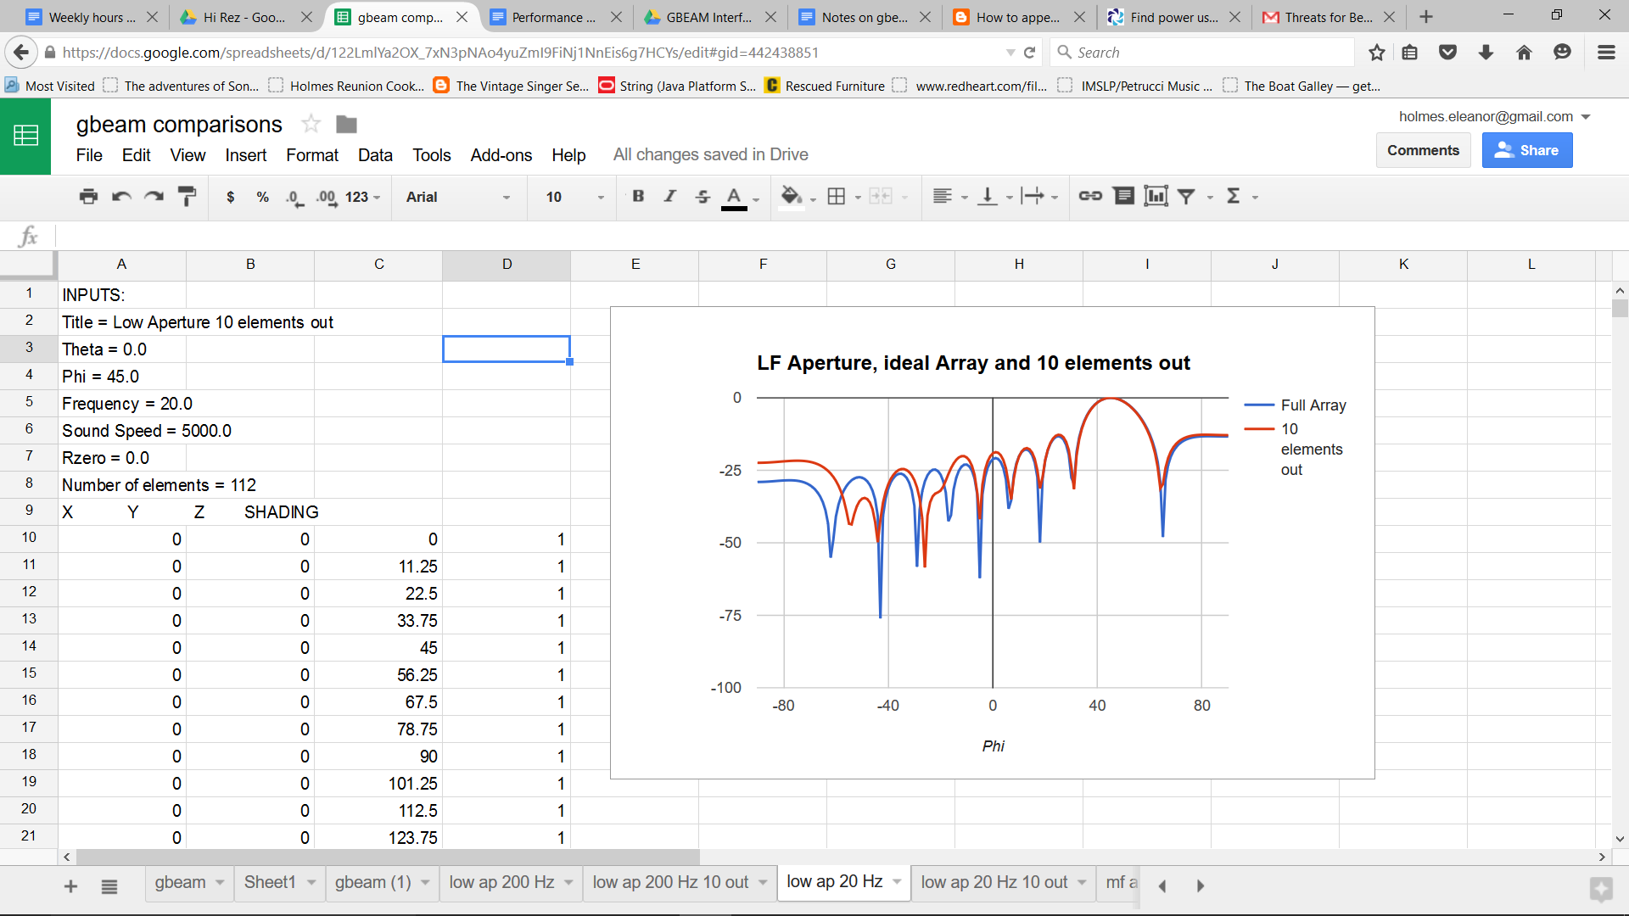

Figure B- Example of 2-D Beampattern Displays

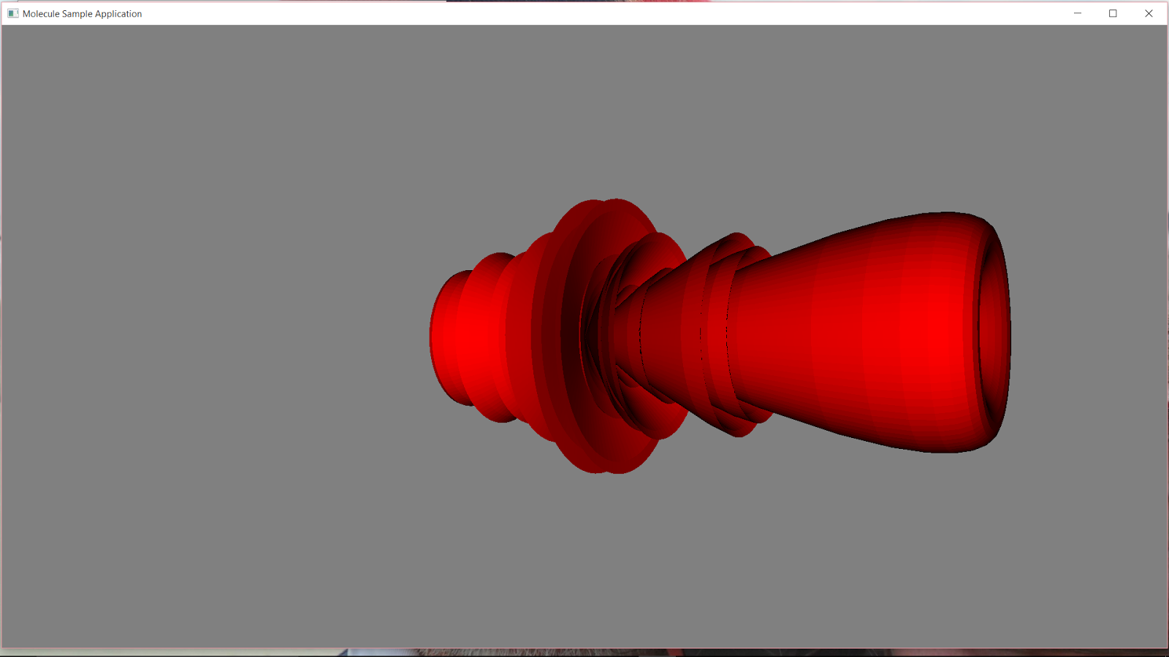 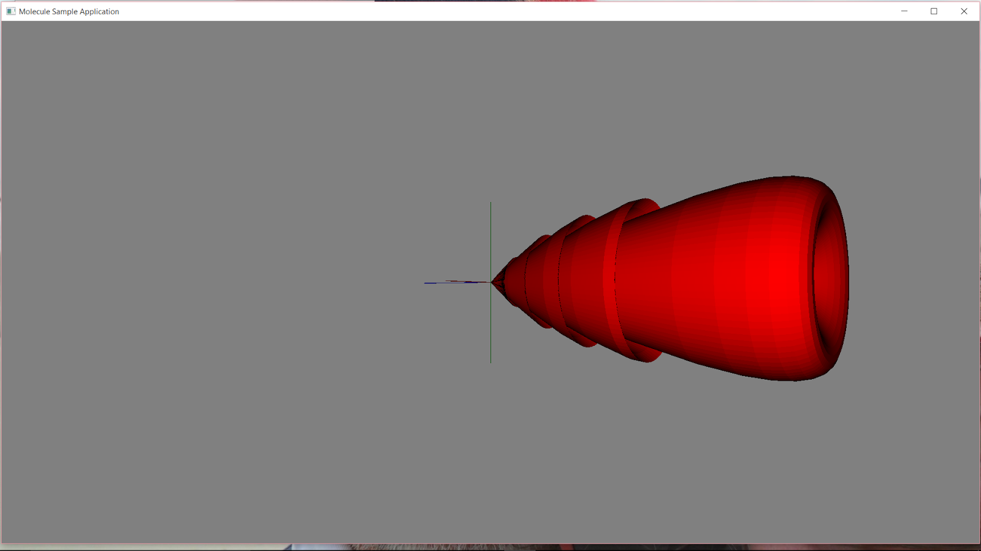

Figure B- . Degraded (left) and Ideal (right) Line Array 3-d Beampatterns

### DI Computation and Displays

Directivity Index (DI) of an array is used to determine the suppression of noise relative to signal when a beam is steered in the direction of a target's signal. The Navy's Platform Sensor Database (PSDB) contains the approved values of DI for US and other sensors. For this project, therefore, we will compute the difference between the DI values for an ideal sensor, and one with some missing elements. To do this, we compute the beam patterns of both the ideal array and the actual array, and then the DI for each array. The degradation associated with the actual array is then the difference between the two computed DI values. For any array, DI, in units of intensity, is the ratio of the volume of a unit sphere to the volume of the solid beam pattern, normalized so that at the steer direction, the beam pattern level is 1.

#### How we compute DI for Horizontal Line Arrays

Computation of DI for a horizontal line array is much simpler than for an arbitrary array, because the beam pattern is symmetrical around the horizontal axis, allowing the implicit rotation and a single-loop integration:







where

V1 is the volume inside the array beam pattern,

V2 is the volume inside a unit sphere,

$bp\left(φ\right)$ is the beam pattern level at angle $φ$, which is measured from broadside,

$A$ is the area on the surface of the sphere, which turns out to be the most complicated part of this equation to solve, although for the line array it is straightforward: while integrating, each $delta-A$ is the area of a thin “belt” around the sphere between the two bracketing values of $φ$, and is therefore the difference between the areas of two spherical caps, as shown in Figure B- 7 and discussed below.

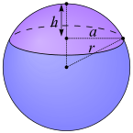

Figure B- . Area of a spherical cap

The area of the purple spherical cap, for a unit sphere (r=1) is $A=2πh$, and therefore the surface area of a strip between two adjacent samples of the beam pattern is



The computation of DI for a cylindrical or any other non-line array is a straightforward, although much more computationally intensive, extension of the computation of DI for a line array. For each angle in the “-90 to 90” integration, we integrate over 360 degrees of horizontal steer direction, applying the beam pattern and appropriate fraction of surface area of a sphere, depending on the angular resolution of the generated beampattern.

One sanity check for the full-array DI computation is a back-of-the-envelope calculation that estimates the array beamwidth (in radians) as λ/L where λ is the wavelength of sound and L is the length of the array. We can then estimate DI by dividing 180 degrees by the beamwidth and doing the appropriate conversion to dB:



#### Orientation

At this point, we should make sure that we provide clarity on how we define array element positions and steer angles in a 3-d coordinate system. The array element locations for an arbitrary 3-dimensional array are defined as (x,y,z) triplets as shown in Figure B- 8. As an example, for a typical horizontal array, ignoring array distortion and assuming it is perfectly horizontal in the water, the y and z components of the element locations will be zero, and only the x values will be nonzero.

Cross-sectional View (x is coming out of the picture):

z

y

View from above (y coming out of the picture):

z

x

Figure B- . Array Element Orientation

#### Steer Angles

The two steer angles provided to gbeam are theta and phi. Phi is the angle relative to the z axis, where 0 is broadside and 90 is endfire, or steered along the z axis. If all of the elements are along the z axis (i.e, the x and y components are 0), then theta doesn’t affect the gbeam computations, and the beam pattern is representative of a line array.

#### Presentation of DI

Finally, we will want to show the users actual numbers: the differences in DI and Effective Beamwidth between ideal and degraded arrays. The most straightforward way to do this may be with a table, an example of which is shown in Table B- 4, for passive runs.

For active runs, there is generally a single frequency (at a time, anyway). Its table might be even simpler, and could accommodate more than one frequency when complex active wave forms involving more than one frequency are used. Table B- 5 shows an example of a possible active sensor degradation table.

Table B- . Passive Array DI Degradation as a Function of Frequency

|  |  |
| --- | --- |
| **Threat Frequency** | **DI degradation** |
| 40 Hz | 1.9 dB |
| 220 Hz | 2.2 dB |
| 600 Hz | 2.6 dB |

Table B- .. Active Sensor Degradation Table

|  |  |  |  |
| --- | --- | --- | --- |
| **Transmit/Receive Frequency** | **DI degradation** | **Ideal Beamwidth** | **Degraded Beamwidth** |
| 3000. | 3.3 dB | 4 degrees | 7.2 degrees |
| 3800. | 3.7 dB | 3.7 degrees | 5.4 degrees |

### Probability of Detection Displays

Probability of detection (PD) is one of the most useful metrics in sensor performance predictions. While it is directly related to signal excess (SE), it is intuitively easier to understand. Figure B- 9 shows this relationship for a passive sensor; Signal Excess in dB is shown on the X axis, and probability of detection, in percent, is shown on the Y axis. At 0 dB SE, the Probability of detection is 50%, as we expect and as is defined by the passive sonar equation, which uses the recognition differential to anchor the 50% PD to 0 dB SE. When we gain a few dB of SE, the PD increases rapidly so that with 6 dB signal excess, we have about a 75% probability of detection. When the array is degraded so that Directivity Index, DI, suffers by some number of dB, the passive signal excess is degraded by the same amount. Therefore, we can relate the previously-discussed DI degradation to SE, at least for the passive sensor.[2]

Our first suggestion for a display of PD degradation is shown in Figure B- 10. It is similar to the previous FIgure, but has two curves: Ideal and Actual. To understand the effect on sensor performance, the operation can note from viewing this display that, for example, when the ideal PD is 50%, his actual PD is around 35%. Clicking within the display provides a numeric cursor readout for the selected PD/SE. The example shown here indicates that when PD is 76% for an ideal array, the degraded array has a 66% PD.

Another possibility for a PD display would eliminate altogether the need to observe signal excess. In Figure B- 11, the X axis is PD for the ideal array, and the Y axis is PD for the actual array. The green line is used to readily see the difference between ideal and actual PD. The distance between the green and red lines is the PD degradation. Again, a cursor readout can show users the degradation at any particular PD. In this Figure, the cursor sits at 25% for the ideal array, and the cursor readout indicates that when PD is 25% for the ideal array, it is 16% for the degraded, actual array.

The trade-offs between this display and the PD vs. SE display are as follows:

* An advantage of the previous PD vs. SE display is that operators may be familiar with ROC curves, and therefore may be comfortable with this display.
* An advantage of the PD vs. PD display is that signal excess is removed as a (possibly) distracting parameter

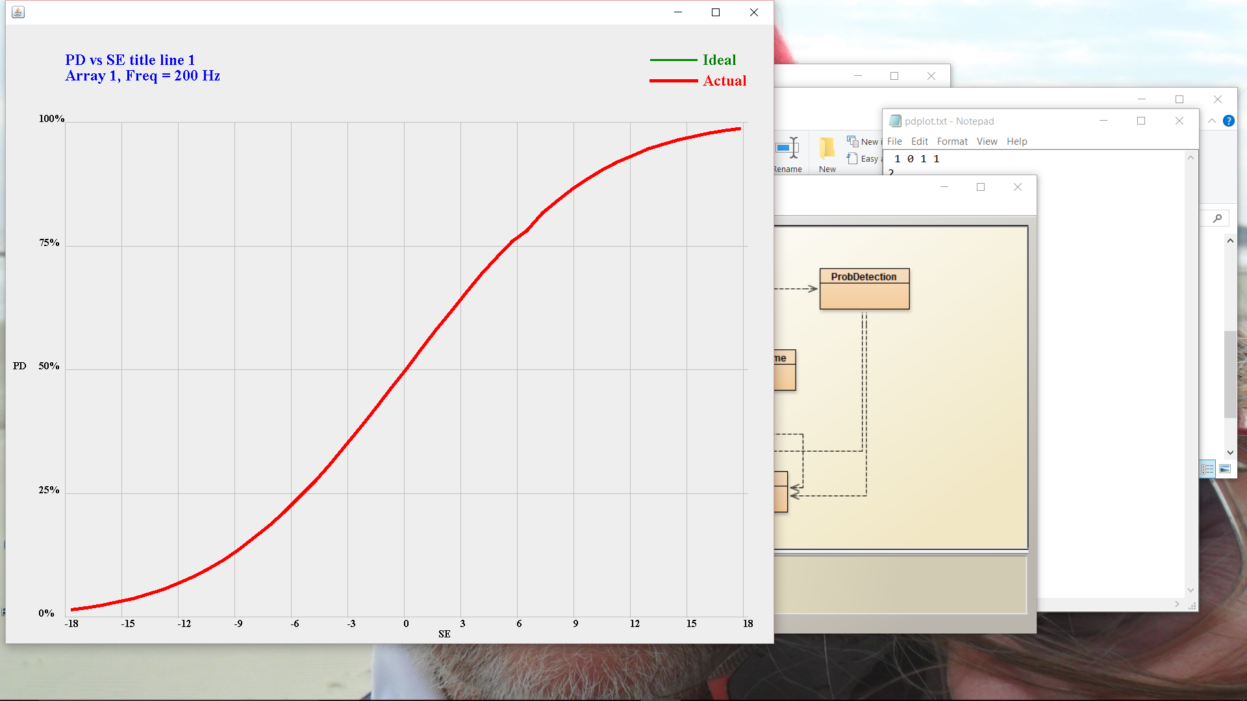

Figure B- . Probability of Detection as a function of Signal Excess

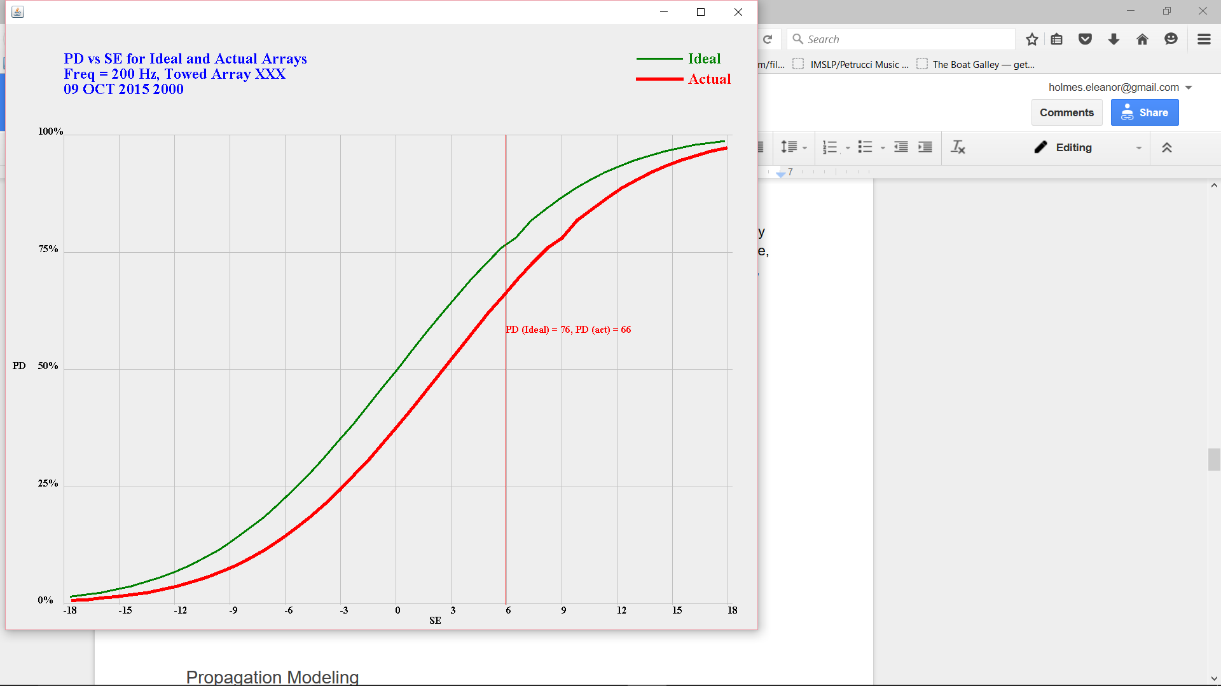

Figure B- . PD vs. SE for Ideal and Actual Arrays



Figure B- . PD vs. PD for Ideal and Actual Arrays

## Propagation Modeling

Passive propagation modeling algorithms within the tactical decision aids will need little or no modification to handle new degraded array information. Instead, DI information is used after the modeling is completed to generate the Figure of Merit (FOM) for passive performance estimates. It is our recommendation that instead of using DI directly from the beamforming module that we develop, the estimated *difference* between actual and ideal DI be used to adjust the values of DI that are extracted from the Platform-Sensor Database (PSDB). We have learned the hard way, in the past, that PSDB values sometimes contain undocumented “adjustments” and “fudge factors” that are critical to accurate performance predictions. Therefore, simply adjusting by the *degradation* for the actual array is a much safer approach to taking array degradation into account.

For active modeling, it will be possible to use an actual (i.e., degraded) beampattern, or we may use effective beamwidths derived from the DI generated by gbeam, along with array steer angles. Using effective beamwidth and steer angles will keep the new modeling as similar as possible to what we have now, and will allow a PSDB-formatted approach to the implementation.

## Sensor Performance Predictions

There are three easy ways to view passive sensor performance: TL vs. Range, Plan View, and Full-Field. Looking at the simplest first, a TL vs. Range display (Figure B- 12) shows transmission loss on the vertical axis, range on the horizontal, and, in this case, horizontal lines at the values of FOM for the ideal (red line) and degraded (upper blue line) arrays[3]. The degraded FOM is smaller, leading to shortened expected detection ranges. This display shows results, however, for only a *single* target depth, and a *single* bearing.

Figure B- 13 shows data for a single target depth, but for all bearings along which propagation has been computed. It may not be obvious initially, but this display, with a little practice, is just as easy to understand as the previous display, and contains a lot more information. Instead of using a line to represent an FOM, we now use color. With a sensor in the center of the display, every pixel on the screen is colored according to threat vulnerability at the range and bearing associated with that pixel, assuming a single threat depth. The colors are:

* Bright red, if there is more than a 50% probability that a target at this location will be detected by the degraded or ideal array
* Dark red, if there is more than 50% probability that a target at this location will be detected by the ideal array, but less than 50% chance the target will be detected by the degraded array
* Dark or light blue if neither the degraded or ideal array has at least a 50% chance of detecting the target

The third kind of display uses the same color scheme, but assumes we know more about the target bearing than its depth. This is shown in Figure B- 14 is and called a full-field display; its two axes are depth and range. The difference between Figure B- 14 and Figure B- 15 is the extent of the Y axis. In the first picture, we show the entire water column. This is useful for understanding the types of paths an operator might expect; direct path, bottom bounce, ducted, and convergence zone (CZ) are some examples. The second picture shows only the top 1500 feet of the water column, allowing the user to concentrate on depth regimes where the target and sensor are likely to be.

Note: in both the plan view and full-field pictures, there are two shades of blue. This is because we have reused existing software. These could easily be made into a single shade of blue for the purpose of comparing ideal and degraded sensor performance. Also, to make it clearer, we recommend changing the remaining three colors to red/green/blue (or a green/yellow/red stoplight display), where

* red indicates regions where both the ideal and degraded arrays should be able to detect the threat,
* green indicates regions where only the ideal array should be able to detect the threat, and
* blue indicates regions where the target is probably undetectable by either the ideal or the degraded array.

A mock-up of this is shown below in Figure B- 16. An example, in which we changed existing display code to reflect these three colors, is shown in Figure B- 17.



Figure B- . TL vs. Range Display with two FOM values (blue = degraded, red = ideal)

**

Figure B- . Plan-View Display (bright red = degraded sensor coverage, dark red = ideal sensor coverage)

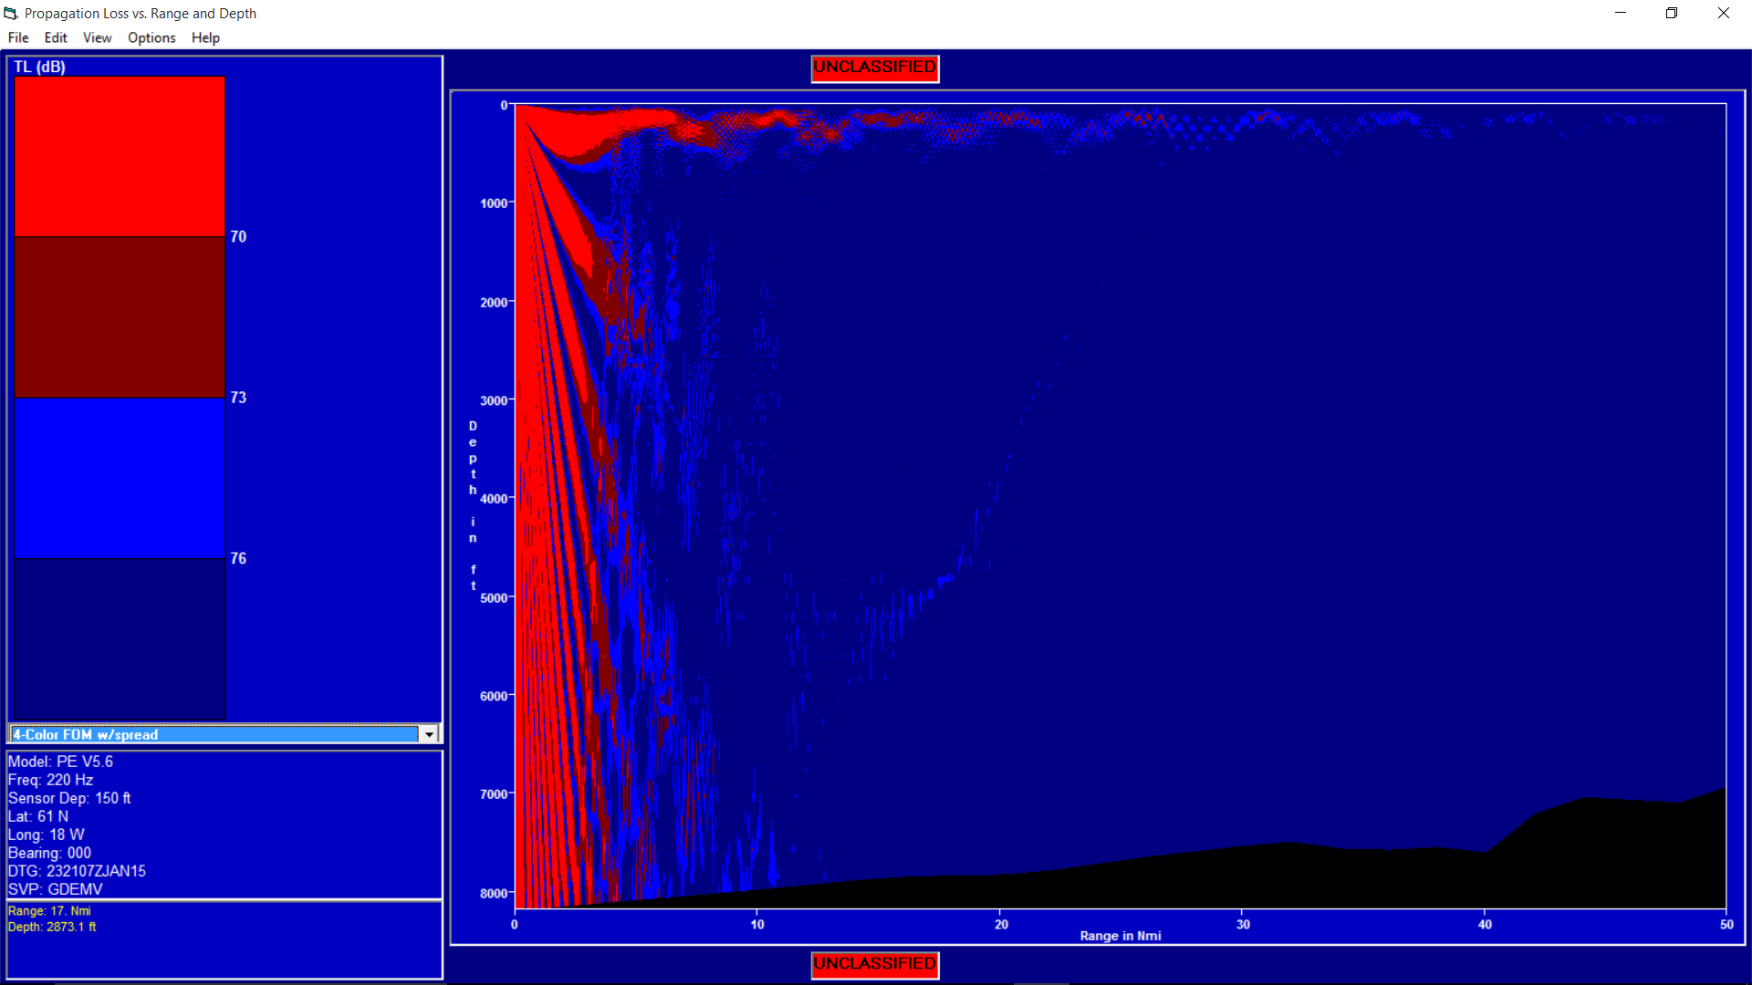

Figure B- . Example of Full-Field Display

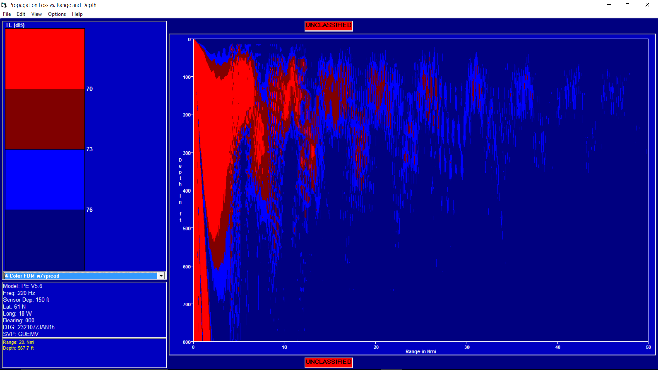

Figure B- . Example of Full-field Display zoomed in depth

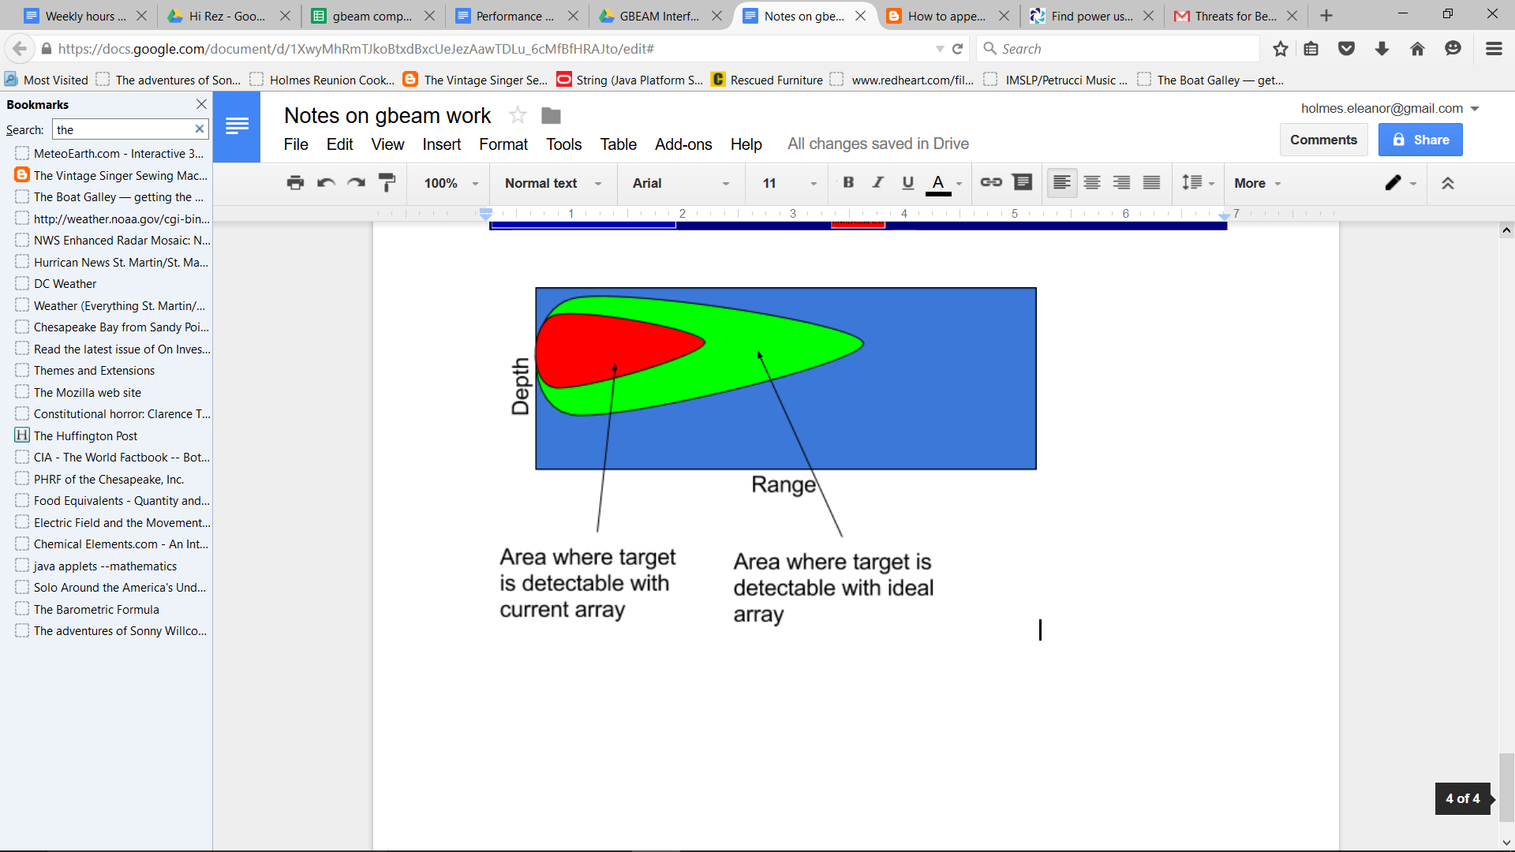

Figure B- . Mock-up of 3-color Full-Field Plot



Figure B- . Full-field Modified for 3-Color Ideal vs. Degraded Performance

# Analysis of DI degradation vs. Element outage

While providing beam patterns and tactical displays of actual and idealized sensor performance is important, we would like to know if we can generalize the results of a large number of examples to determine when an *array’s* degradation will translate to *performance* degradation.

To accomplish this, a Monte Carlo simulation was developed to model DI for a large number of random array degradations, frequencies, and steer angles, and generate statistics on the DI degradation and its variance.

Figure B- 18 and Figure B- 19, representing a line array and a cylindrical array respectively, show DI degradation as a function of the percentage of malfunctioning elements in the array. The second and third lines in these displays represent DI degradation plus 1 sigma, and DI degradation plus 2 sigma, where sigma is the standard deviation of all of the values of DI. For this test case, we ran 300 iterations for each level of array degradation. For each iteration, we selected a random frequency and steer angle.

Two additional display types confirm the validity of this approach. The first, shown in Figure B- 20, is a scatter plot of all of the frequencies and steer angles selected. It can be seen in this display for the line array, that while the steer angles (phi) look uniformly spaced, the frequencies do not. This is because we first randomly select an aperture, and then a random frequency within the aperture. The lower-frequency apertures are narrower than the higher-frequency apertures, so this leads to non-uniform frequency selection. However, there is still a good frequency selection in the set of samples. The selections for the single-aperture cylindrical array are more uniform, as shown in Figure B- 21.

The second display type is a histogram of the 25%-bad-element DI degradation values. In order to use the standard deviation with confidence, we would like this curve to appear “normal” or “Gaussian”, which it does for the line array (Figure B- 22), but not so much for the cylinder (Figure B- 23). This may be because more samples are needed. 300 samples, when we vary frequency *and* vertical steer angle *and* horizontal steer angle may not be enough. Increasing the number of samples, however, does not result in a normal distribution; there is a clear bimodal distribution to the DI values when shown in a histogram (Figure B- 24). Looking at the lower end of the frequency range of the array (1200 - 2500 Hz), the distribution is clearly Gaussian (Figure B- 25). The selection of random frequencies and steer angles is also uniform, as we would hope, having increased the sample size to 1000 (Figure B- 26), and the bottom line, shown in Figure B- 27, is the average, sigma and 2-sigma DI degradation as a function of the percent of malfunctioning elements.

Now that we think we understand DI degradation as a function of array degradation, the next question to answer is “how bad is too bad?”. Given the rule of thumb that applies to cylindrical spreading in a surface duct or half-channel, for example, we assume that 3 dB doubles, or halves, the detection range. For example, if a target is detectable by an ideal array at 15 KYds, and enough elements are out to cause a 3 dB DI degradation, then the actual expected detection range would be 7.5 KYds. This makes 3 dB, clearly, a little too large to allow. .7 dB (a 15% range reduction) is probably a better number. Taking a conservative look at the display below, we see that with about 12% of the elements out, the DI degradation can reach about .7 dB. We’re using the conservative 2-sigma curve for this analysis.

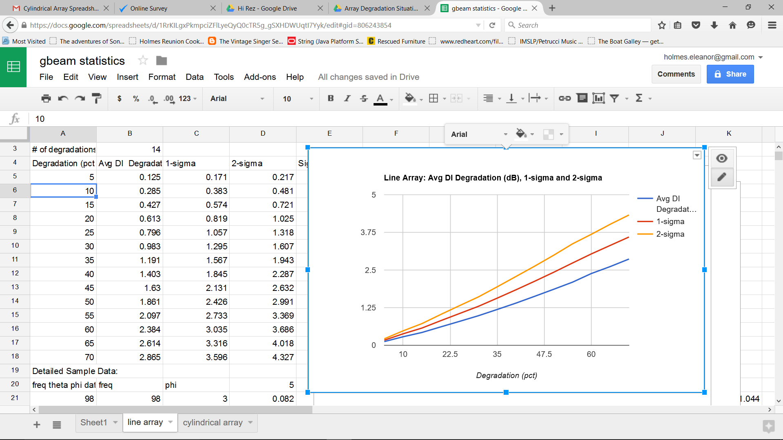

Figure B- . Line Array DI Degradation caused by Malfunctioning Elements

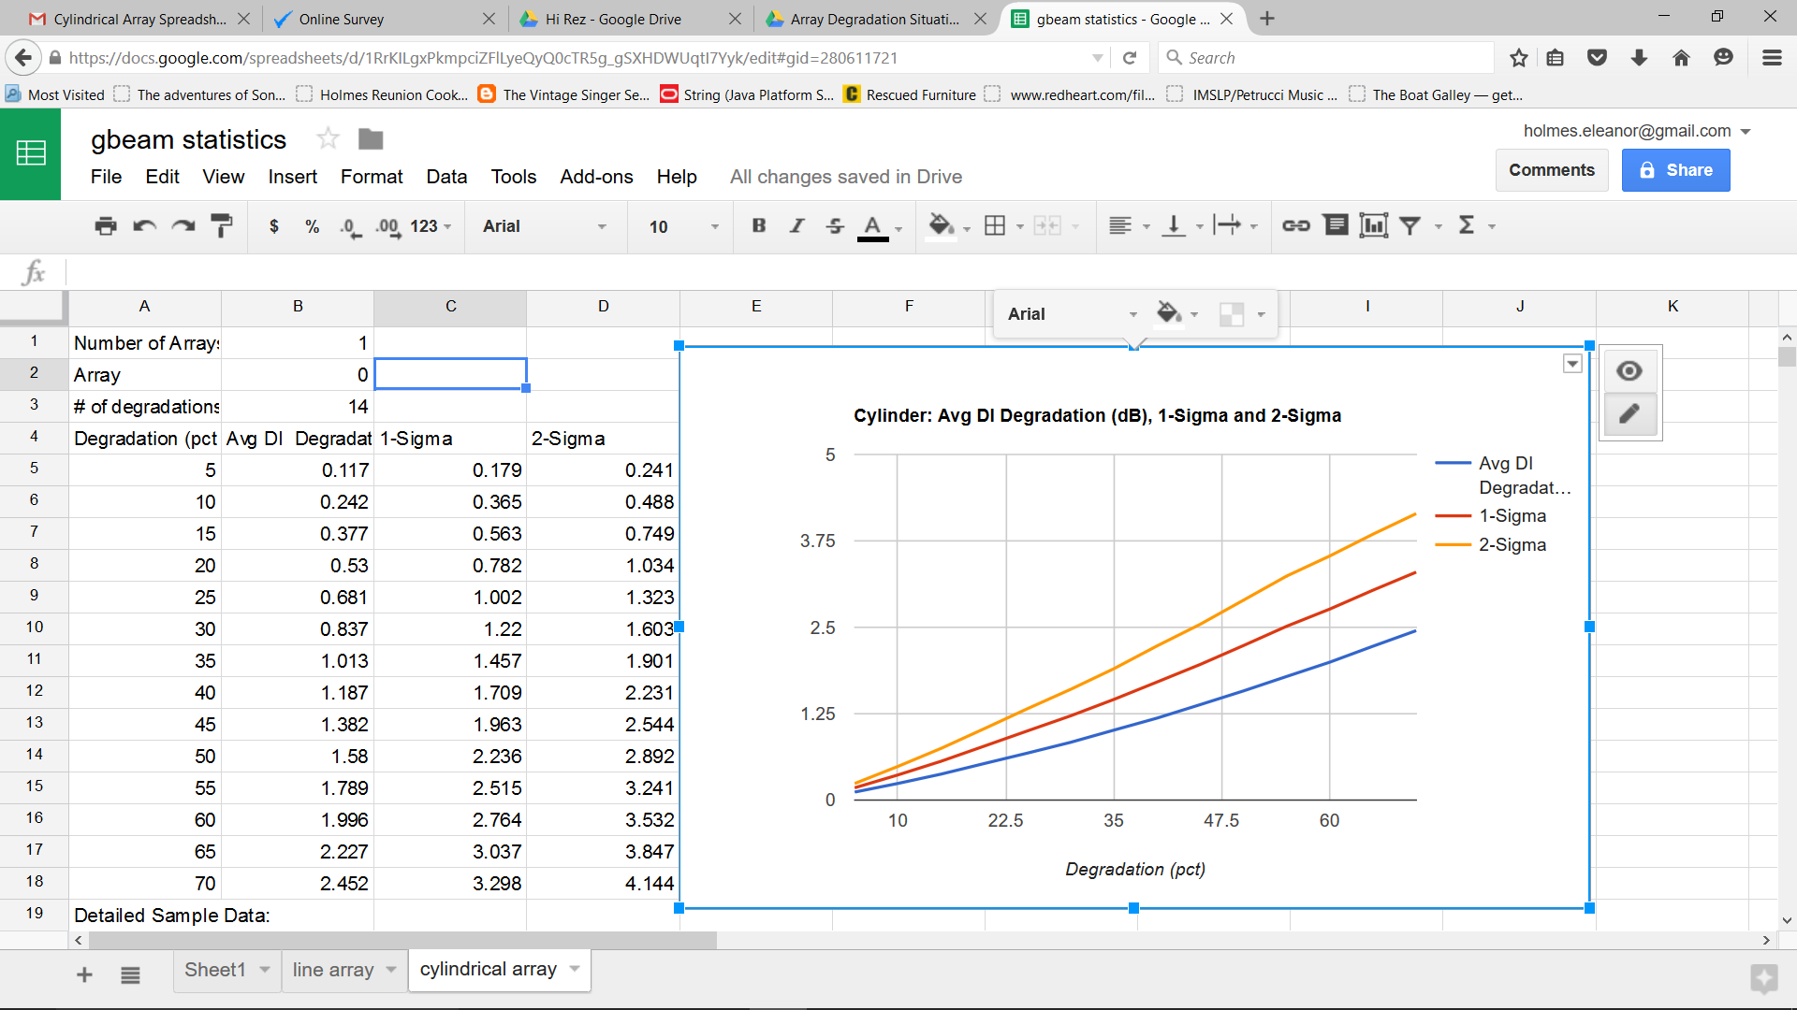

Figure B- . Cylindrical Array DI Degradation caused by Malfunctioning Elements

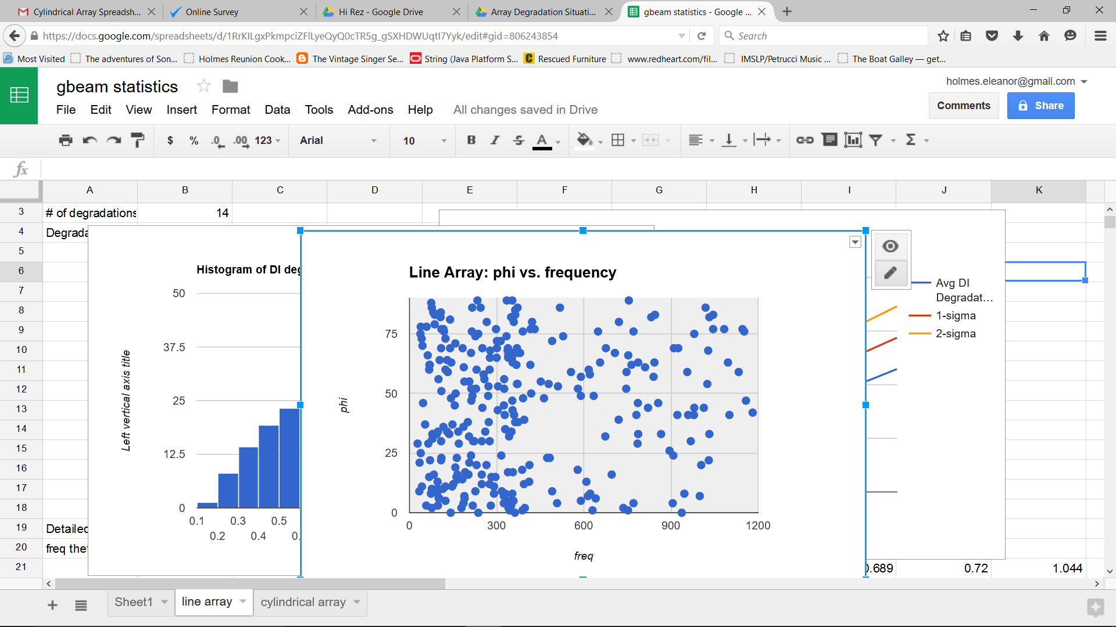

Figure B- . Random selection of frequency and steer angle for Multi-Aperture Line Array

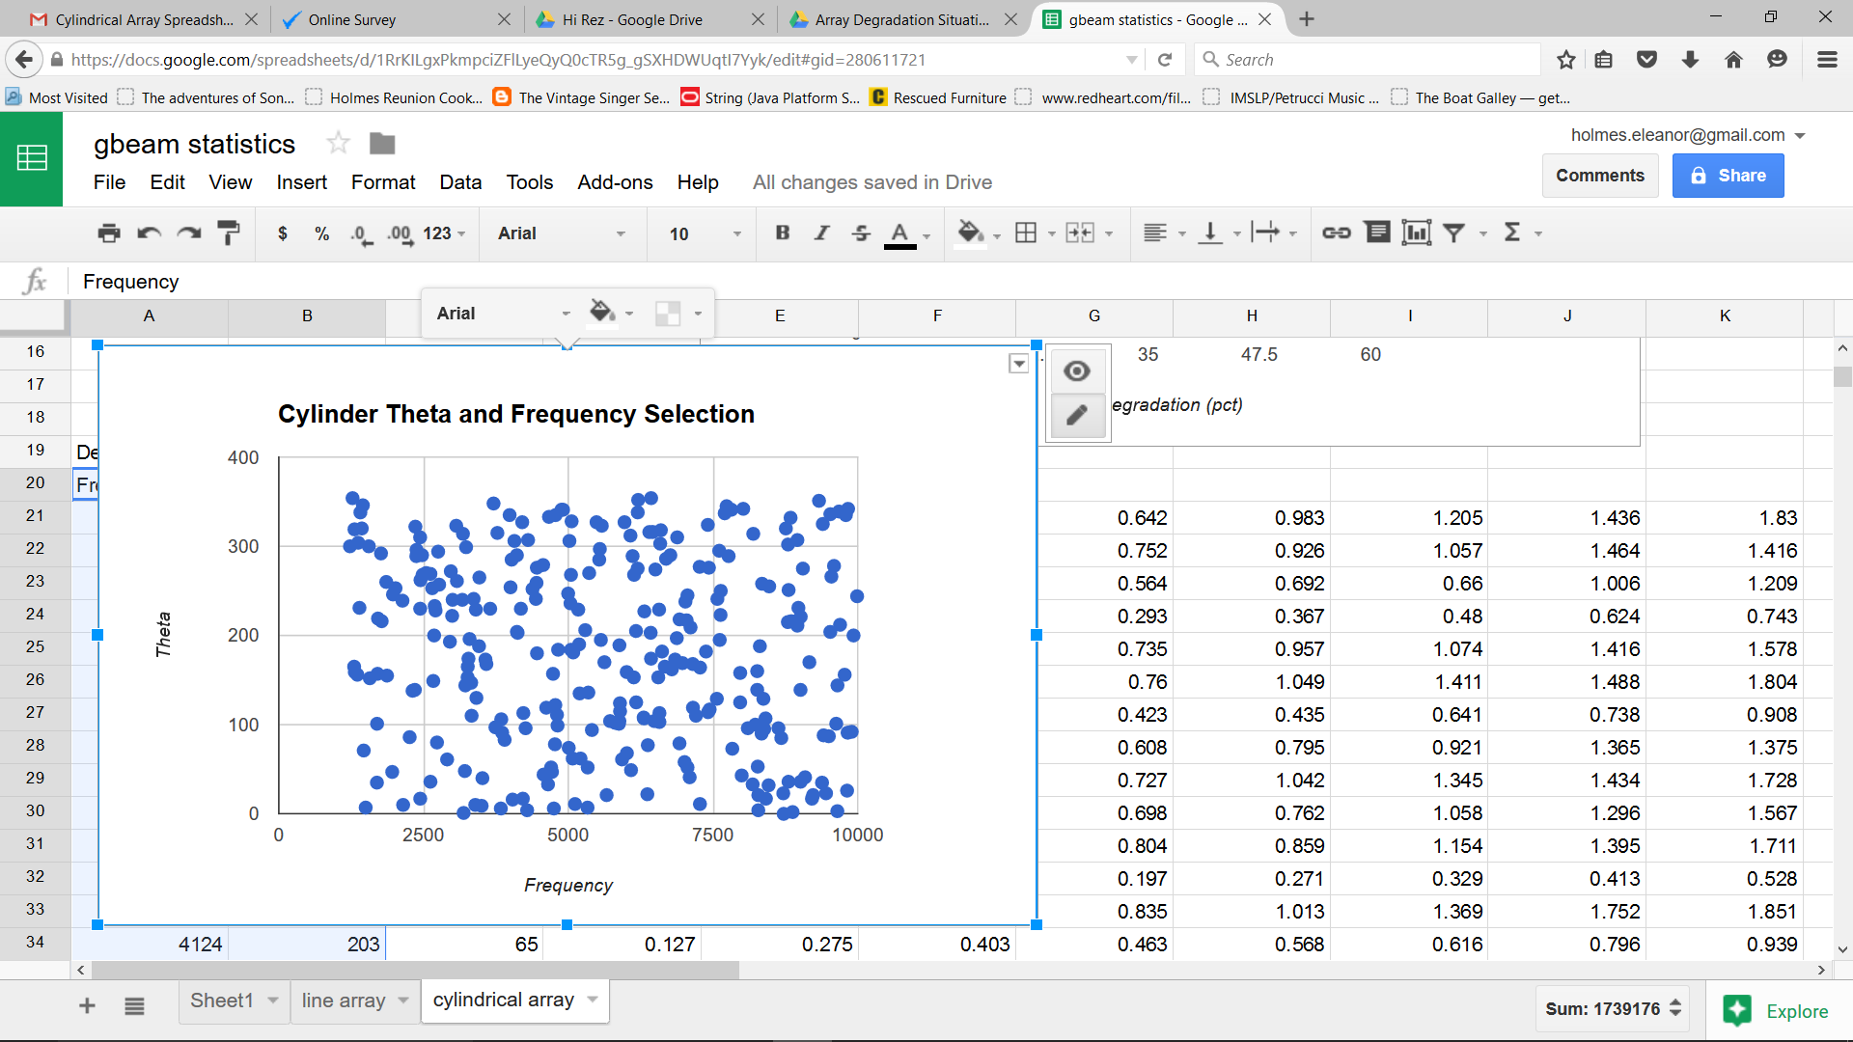

Figure B- . Random selection of frequency and steer angle for Cylindrical Array

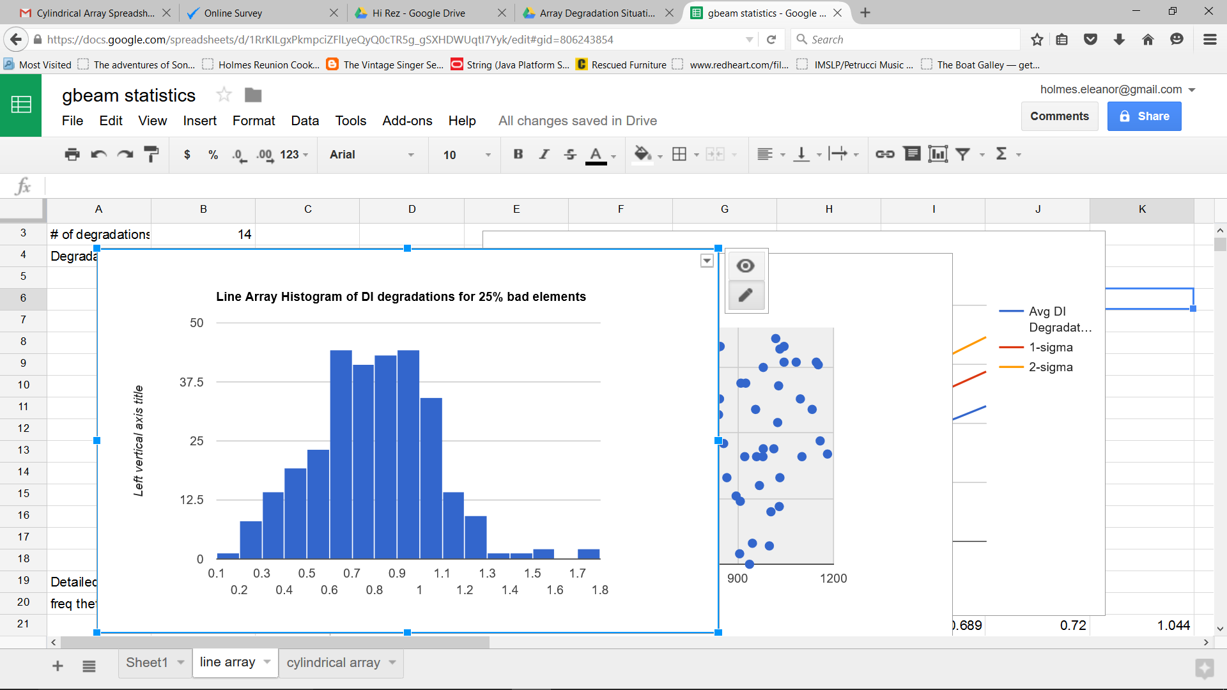

Figure B- . Histogram of DI degradation for Line Array

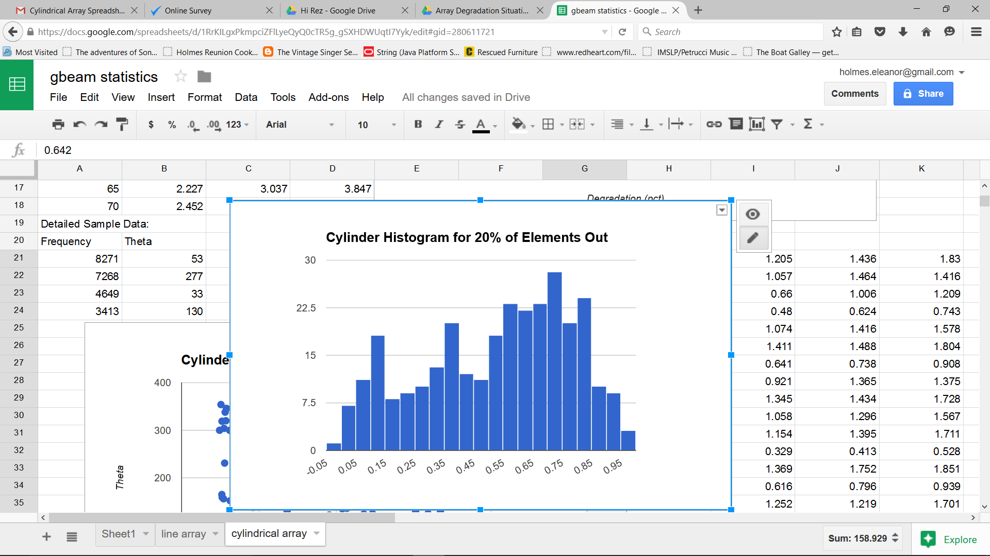

Figure B- . Histogram of DI degradation for Cylinder

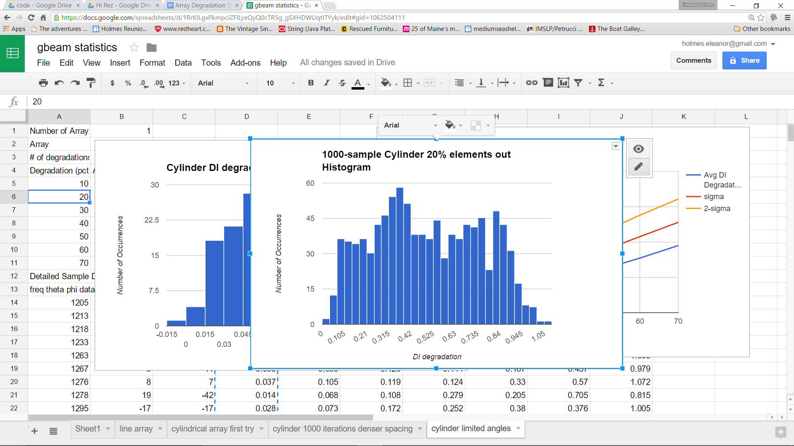

Figure B- . Bimodal DI degradation distribution on sphere

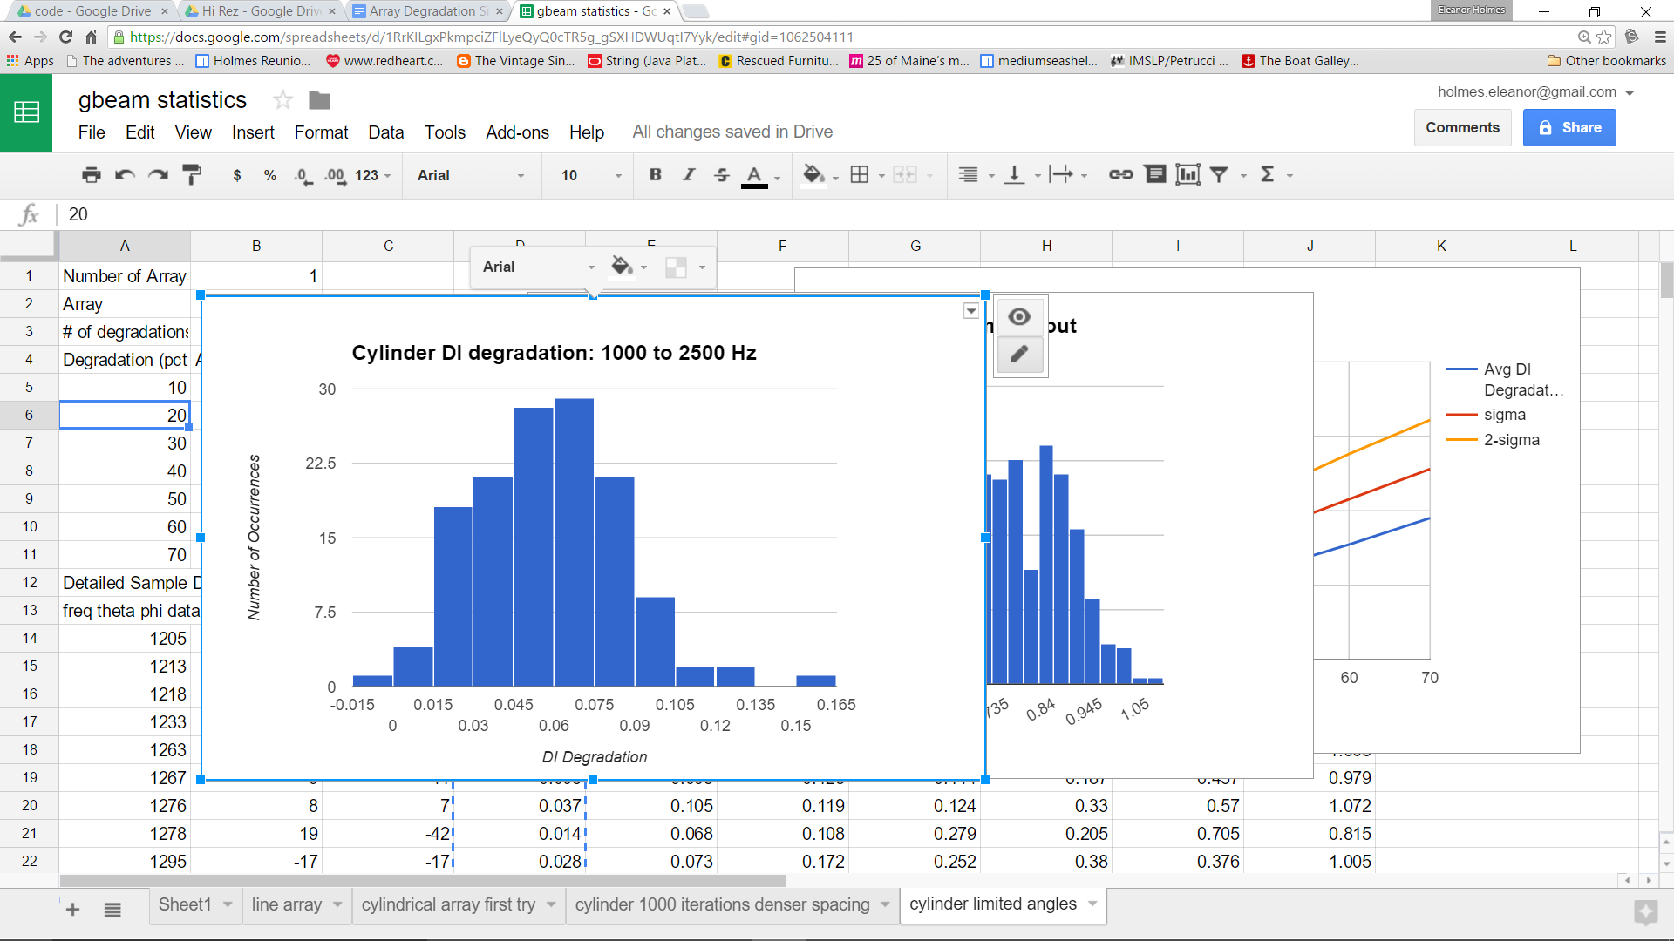

Figure B- . Lower end of frequencies

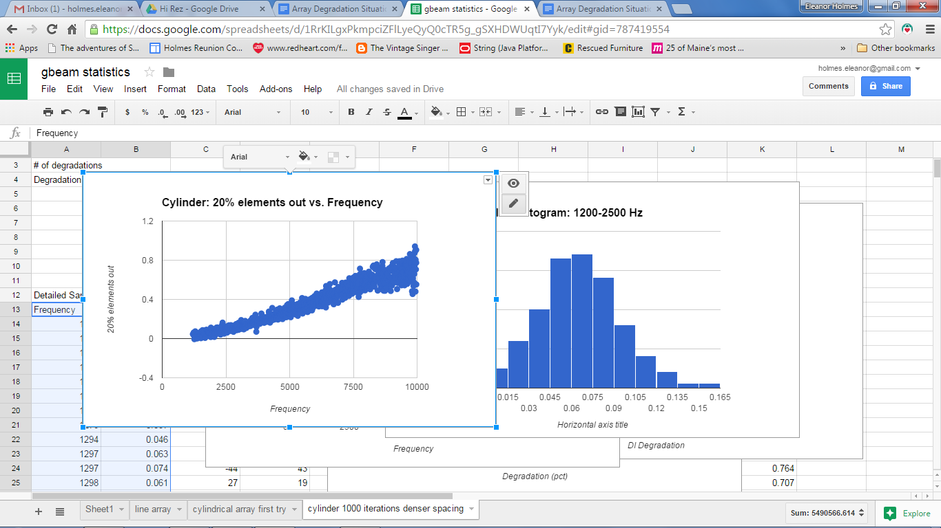

Figure B- . Frequency trend of DI degradation in Cylinder

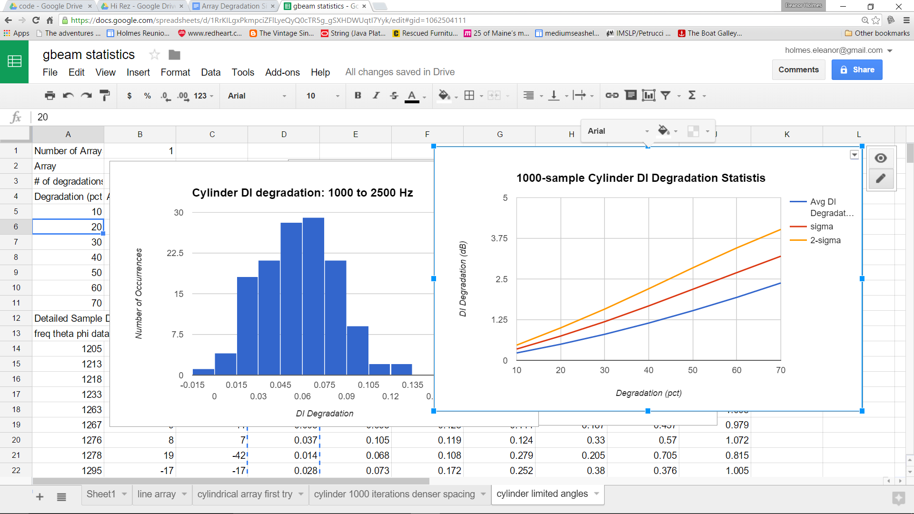

Figure B- . DI degradation vs. Array Degradation

## Active vs. Passive Arrays

Computation of DI degradation is independent of whether a receiver is part of an active or passive system. However, in deciding how much array deformation or DI degradation is acceptable for passive and active arrays, the following questions need to be answered:

1. We have stated that a .7-dB (15% range penalty) degradation in DI is acceptable for passive arrays. How does this translate to active?
2. Are there considerations for active transmitters, such as the variable “Source Level” that depends on the health of the active transmitter in the active sonar equation?
3. Given the different formulas for active and passive Probability of Detection (PD), should we reconsider using the passive .7-dB rule of thumb for active sensors?

To answer the first two questions, we look at the passive and active sonar equations:

Passive SE = Source Level – TL – (Noise – DI) – Recognition Differential

Active SE = (Source Level – TL(out) – Target Strength – TL(back)) – (Reverb ϴ (Ambient Noise – DI) ϴ selfNoise) – Recognition Differential

The highlighted terms are those affected by the transmitter and receiver beampatterns. For the purposes of this explanation, we will consider ambient-noise-limited, reverberation-limited and self-noise-limited cases separately. This is because the two power sums (ϴ) in the interference term cause one of these three mechanisms to dominate while the other two are marginalized:

1. In ambient-noise-limited environments, a 1 dB change in DI has the same effect as it does in the passive sonar equation. The same signal excess penalty will result from a 1-dB degradation in DI regardless of whether the array is active or passive. However, lowering the source level, a logical result of array element failure, will case additional degradation in signal excess: one dB SE penalty for each one dB in source level degradation.
2. In reverberation-limited environments, DI has only a minor influence on SE. So the conservative assumption is that DI will affect signal excess equally for passive and active sonar equations. It should be noted that source level is *not* a factor, although it is not clear from the active sonar equation. This is because reverberation is a function of source level; a one-dB increase in source level increases reverberation one dB as well, so there is no net effect on signal excess in a reverberation-limited environment.
3. In a self-noise-limited environment, DI again has only a minor influence on SE. Source level, however, has the same effect, a one-for-one SE dependence, as in the ambient-noise-limited case.

But what about range? Here is where active and passive sonar equations diverge. Transmission loss (TL) is the only range-dependent term in the passive and noise-limited-active sonar equations, and it appears twice in the active sonar equation, only once in the passive. In conditions where TL is proportional to 10*log10R, such as ducted (CZ or surface) environments, a 1-dB change in SE is equivalent to a 10% change in detection range. Now, considering the noise-limited part of the active sonar equation, we can see that both TL(out), representing transmission loss from the active source to the target, and TL(back) have equal weighting. This means that a 1 dB change in SE is equivalent to only about a 5% change in detection range; half a dB is allocated to each transmission loss term in coming to this conclusion.

Turning to source level, we need to focus on a different part of the beampattern than we did for DI computation: the maximum response axis (MRA). When estimating DI, we paid attention to sidelobes and their levels – spatial components of the beampatterns we wanted to keep as small as possible to reject as much noise as possible. For source level, we look at the pressure level of the sound we put into the direction we want to transmit, and this is proportional to the number of elements. Therefore, the 11% malfunctioning elements we recommend as a threshold for passive would result in a .7-dB reduction in source level, or about a 15% range reduction. This reduction in source level has a one-for-one dB effect on signal excess in noise-limited environments, as noted above. In reverb-limited environments, reverberation is reduced by exactly the same number of dB as is the signal, so source level has no effect on signal excess.

Before addressing the last question (is .7 dB a good threshold?), we will combine the results of the first two questions and make the following observations:

* Most environments contain noise-limited portions of a signal-excess vs. range plot, so we can conservatively focus on noise-limited areas.
* A degradation in DI results in approximately *half* the range-degradation for active systems than for passive systems.
* A degradation in source level results in approximately the *same* range-degradation for active systems as for passive systems.

So if we want to attempt to limit ourselves to the same range reduction for active and passive systems, we need a stricter tolerance on the number of malfunctioning. A .5 dB DI degradation will result in a similar range reduction overall due to loss of both noise rejection and source level. This corresponds to 8% malfunctioning elements.

Finally, considering probability of detection, we note that the receiver operating characteristics (ROC) curves are different for passive and active sonars, as shown in Figure B- 28 and Figure B- 29. With a 1.5 dB SE degradation, at 50% PD for an ideal active sensor, the PD for a degraded array is 45%. The penalty is harsher for passive sensors, where for the same ideal PD, the degraded PD is 42%. However, since our threshold determination has been based on range, and not PD for a target at a specific range, this observation does not translate into a recommendation to change the threshold on malfunctioning elements.



Figure B- . Passive ROC Curves



Figure B- . Active ROC Curves

## Contiguous Element Outages

So far, all of our statistical analysis has assumed that the element outages will be random and uniformly distributed. There may be cases, however, when element outages come in groups, and to understand these cases, we reran the statistics for the line array disabling contiguous strings of elements placed randomly along the array, instead of randomizing individual element outages. The results were surprising at first; DI degradation was a little worse when element outages were grouped. However, considering that removing a long contiguous string of elements effectively shortens the array, which fattens the main lobe of any beam patterns, it makes sense that this fatter beam would cause strong DI degradation. Figure B- 29 shows DI degradation for grouped malfunctioning elements. If we use the same .7 dB tolerance for DI, then the elements-out tolerance is reduced from 12% to 8% for passive arrays, and from 8% to 6% for active arrays. However, looking at the Monte Carlo study of four ocean areas below, and the outcome that passive arrays are more sensitive to degradation than are active arrays, and the fact that a large number of the assumptions we made for the active array are “worst case” conservative estimates, we are relaxing this recommendation for active to the same as the passive, and recommending further analysis in Phase II.



Figure B- . DI degradation for line array with contiguous elements malfunctioning

## Array Self-Noise Considerations

One of the assumptions we have made so far is that self noise is not a significant contributor to the interference terms in the passive and active sonar equations; that ships can drive at such a speed that self noise is not a factor for its sensors. While self noise is extremely important, especially to active sonar systems, the question here is whether it affects our recommendation for a malfunctioning-element threshold.

The DI degradation thresholding recommendations we have made always assume that self noise is not a factor. When ownship speeds are high enough, however, this assumption is incorrect, and we need to treat the overall lower response of a receiver array as an additional degradation in the sonar equation. While this can be accomplished in a straightforward implementation in any sensor performance prediction, it may not be as simple to use this information to tighten tolerances on malfunctioning elements unless we know the average beam-to-self noise ratios, for which we need actual array data. It can be noted, however, that it would take a lot of malfunctioning elements to lower the beam noise levels even a few dB. For example, if 50% of the elements in an array are completely dead, the noise levels are lowered by only 3 dB (and presumably *raised* by the DI degradation, which mitigates the self-noise problem even further).

Active Transmitter Source Level reduction due to malfunctioning elements should not affect the self-noise/ambient-noise balance, so is not a consideration in determining tolerances on malfunctioning elements.

# Analysis of Coverage Penalty vs. Array Deformation

We have already discussed Directivity Index (DI), the reduction in omnidirectional ambient noise due to the shape of a beampattern. So far, in computing beam patterns, we have disabled random or grouped elements. However, we also want to understand the effect of array *deformation*. This will obviously not apply to hull-mounted and spherical/cylindrical arrays, but does apply to towed arrays, that can and do change shape as they move through the water and with ownship maneuvers. These changes in shape, if not accounted for on an element-by-element basis in beamforming, can cause degradations in the noise reduction associated with DI, but can also cause problems for signal detection.

In this section, we will introduce the concept of line array bending and individual element “wiggling”, and propose a metric that can be used to infer the potential for loss of signal on individual beams. We start with a simple broadside beampattern of a perfectly-straight line array, as shown in Figure B- 31. A threat signal arriving at the array from broadside will be detected on this beam. Line arrays, of course, have many beams, so that signals from directions other than broadside can also be detected. Figure B- 32 shows nine conical beams between broadside and aft endfire, for a line array. A real line array will have many more beams than this, but the illustration is intended to convey the concept of multiple beams that, together, cover all possible signal arrival angles.

When a line array changes shape, and beamforming does not account for the new element locations, each of its conical beams can be distorted. The broadside beam shown in Figure B- 33 shows an imperfect disk, and implies that signal detection might be degraded. Figure B- 34 Shows near-endfire beams for an ideal and distorted array.

None of these displays provides enough information to quantify the potential problem, which is our goal when we define a new metric called “Coverage Penalty”. It will be defined as follows:

* *For any conical beam, the maximum response for an ideal array will be computed. This is the beampattern level at the steer direction (theta, phi – where phi is the steer direction relative to the axis of the array, and theta is the steer angle relative to the other two axes, and for a perfectly straight line array has no effect).*
* *Next, the levels of the distorted beampattern for all values of theta at the steer angle phi are compared to the maximum response level computed for the ideal array. The fraction of angles for which the distorted beam pattern level is less than 90% (a 1-dB drop) of the maximum response for the ideal array is the coverage penalty. A coverage penalty of 20% for a beam means that for 20% of the angles where we normally expect good array response, we have significant degradation.*

Coverage Penalty averaged over a large number of random steer angles and frequencies can provide a quantitative idea of how much the physical distortion of an array affects its ability to detect target signals. This Monte Carlo approach has been implemented to model two different responses to turbulence in the ocean and ownship maneuvers: wiggles and bends. Wiggles are characterized as random dislocation of individual array elements, and bends are, for simplicity, a simple bend in the middle of an array. Wiggles and bends can be combined, but we start with an array with a simple range of bends, characteristic of an array after its ship has made a turn and before the array has stabilized.

The LF aperture of the MFTA is used for the first test, with 1000 samples of random frequencies, steer angles and array bend ranging from 0 to 3 degrees. Coverage Penalty is computed and displayed as a function of various array parameters. Figure B- 35 shows a correlation between Coverage Penalty and Steer angle; the closer to endfire, the less the effect of array distortion. This makes sense since endfire beams are fatter than broadside beams, and a small change in direction will make less of a difference to the endfire beam. For the same reason, there is a correlation between coverage penalty and frequency; at higher frequencies, the beams are narrower, and again, changes in direction make more of a difference when the beams are narrower. Less of a correlation is seen, surprisingly, with the amount of array bend, as shown in Figure B- 36. It appears that the correlation with frequency and steer direction overwhelms the dependency on array bend. To confirm this, we ran a simulation with a single frequency of 100 Hz and single steer angle of 10 degrees from broadside, and noted a stronger bend-dependence of Coverage Penalty (Figure B- 37). Other single-frequency, single-steer angle cases show similar bend-dependencies.

It should be noted that coverage penalty only measures the *loss* of detection at exactly the array steer directions, and not the possible *gain* of detection at nearby steer angles. Because of this, our metric may be overly conservative. However, any gain of detection at an angle where the beam is not steering will cause localization problems. So this metric might be renamed “Coverage and localization penalty” but we will continue to call it Coverage Penalty “for short”.

A second set of simulations was run with a per-element wiggle rather than a single bend in the array. The way the array is distorted is:

* *The first element of the line array is not distorted.*
* *For subsequent elements, a random number between 0 and 1 is drawn, and multiplied by the current samples “wiggle” value (which itself is a random number between user-specified wiggle limits). A random angle between 0 and 360 is drawn, and the x-y values of the array element positions are computed relative to the previous element x-y location using the angle (0 is along the x axis, 90 along the y axis) and size of the wiggle. The z component is computed so that the length of cable between elements is conserved.*

Results are shown as a function of frequency in Figure B- 38. As with the bending array, the stronger correlations are with frequency and steer angle, and the correlation with the *amount* of wiggle is not as obvious.

Since we raised the question of active vs. passive arrays, we should address the question of whether array deformation affects passive and active arrays differently. A receive array will suffer the same coverage penalty, for the same frequency and steer angle and array deformation, as an active array. However, active frequencies are higher than passive frequencies, in general, so any frequency-dependence in coverage penalty will result in different thresholds for passive and active.

Two remaining tasks pertaining to distorted arrays are:

1. To determine an acceptable coverage penalty. We already accept a 1-dB (10%) degradation before even assigning a penalty to a beam. We would suggest that before we pick a threshold, we look at some real MFTA line array data and determine some representative wiggle and bend values.
2. To invert the process we have been performing here, and infer wiggle and bend values from array element location data. Using a low-pass filter should reveal the bend. After determination of bend, we should be able to remove the “bent array” locations and determine the wiggle from the residual array. As above, it probably makes sense to get some real element location data to test any process we develop to accomplish this inversion.

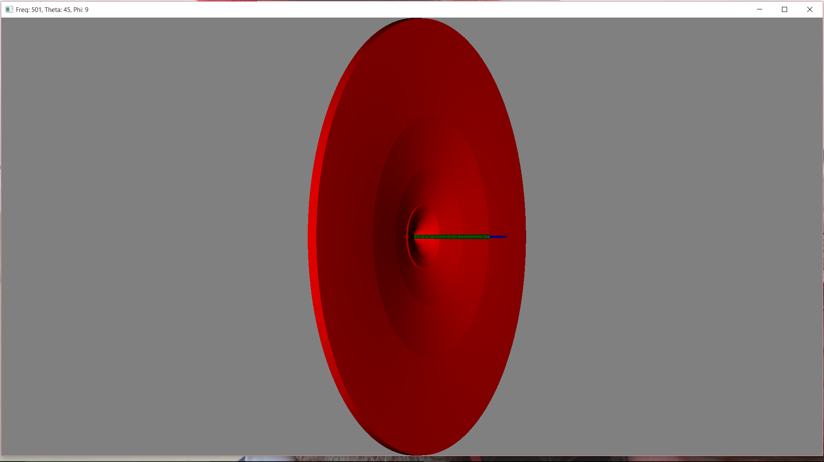

Figure B- Ideal Line Array Broadside Beampattern



Figure B- . Nested Conical Beams

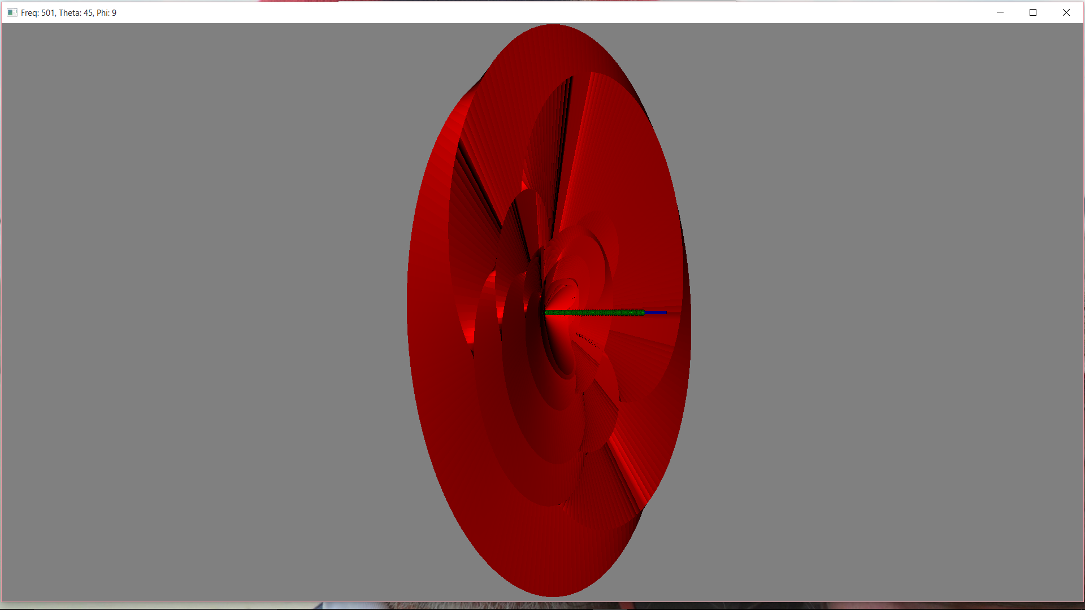

Figure B- . Distorted Broadside Beam



Figure B- . Near-Broadside Beams - Ideal and Distorted



Figure B- . Coverage Penalty vs. Frequency and Steer Direction

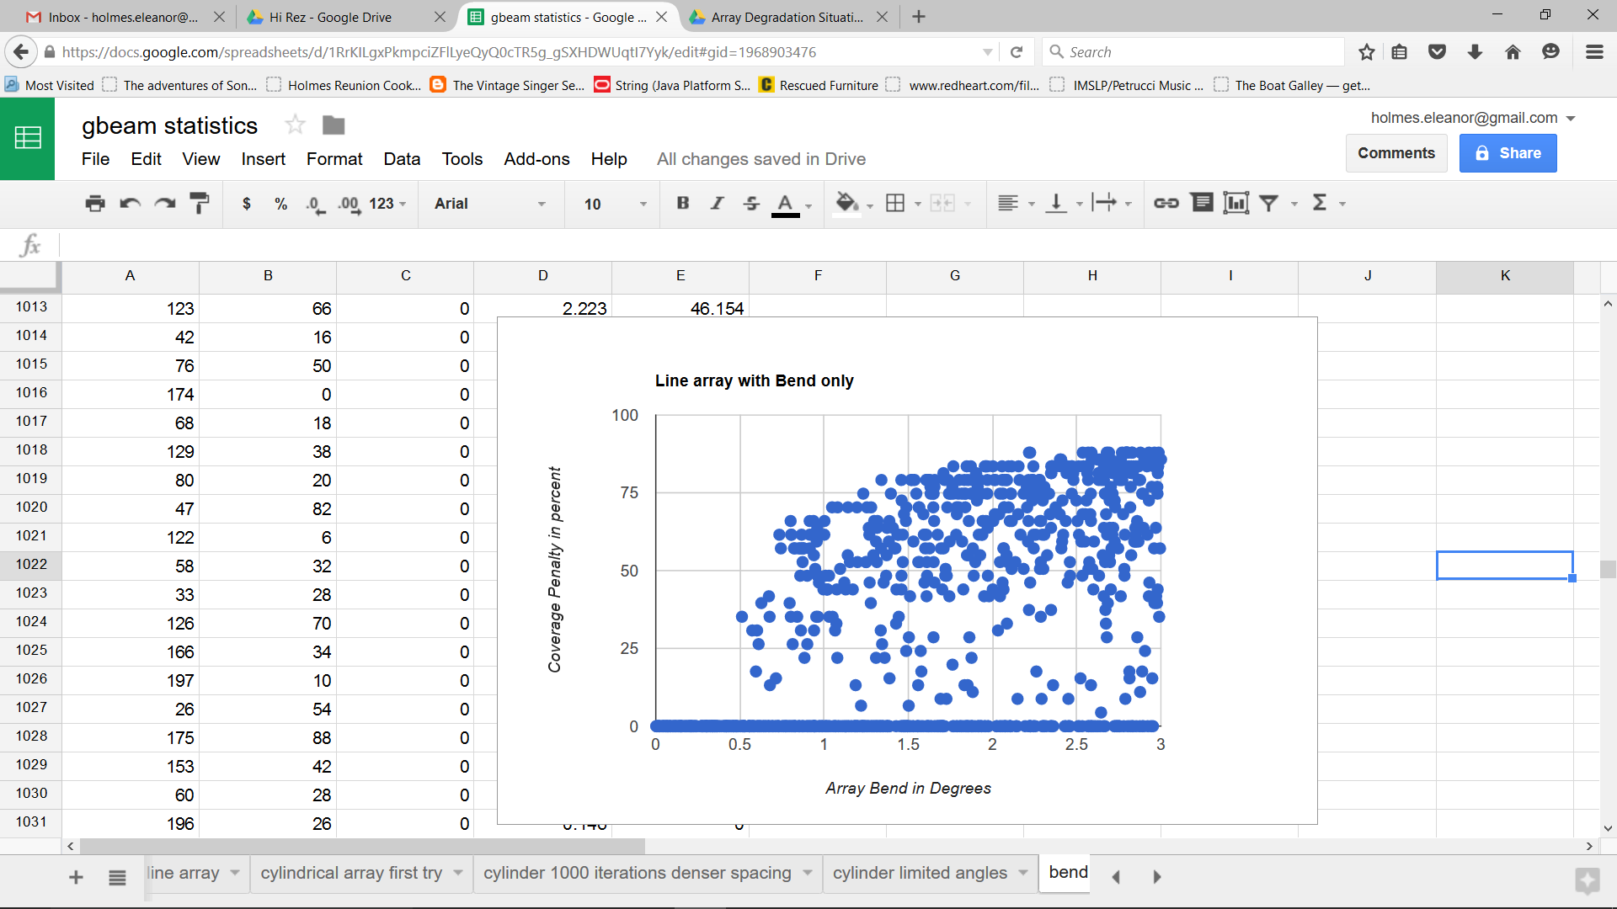

Figure B- . Coverage Penalty vs. Array Bend

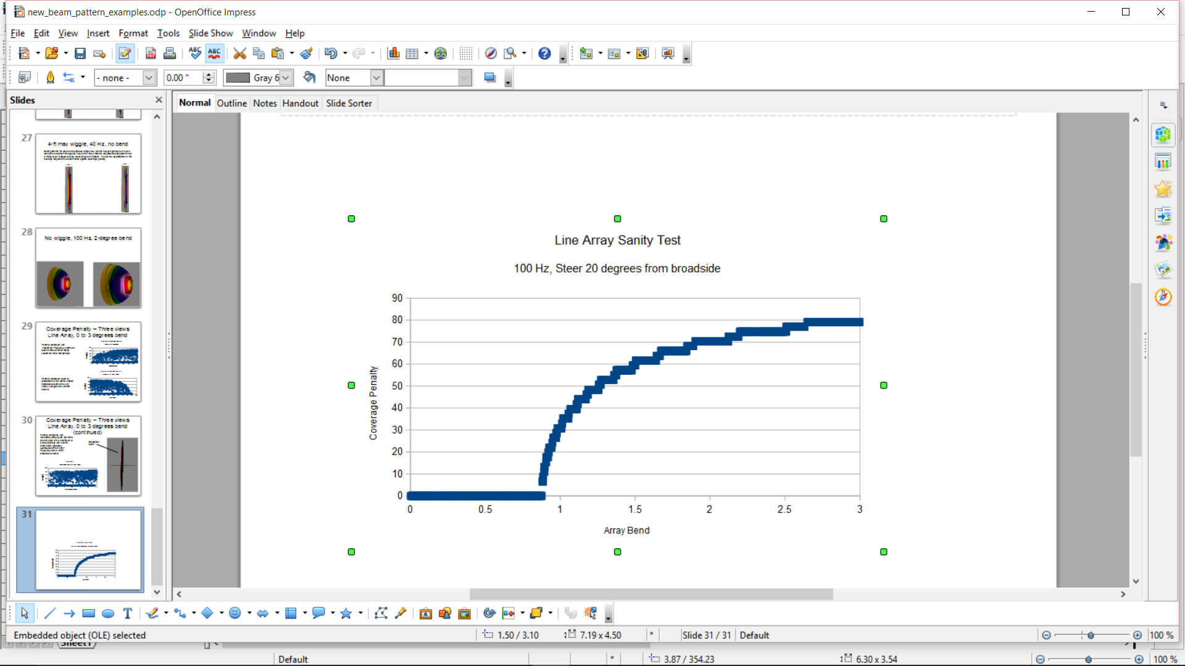

Figure B- . Sanity Check - Single Frequency, Single Steer Angle

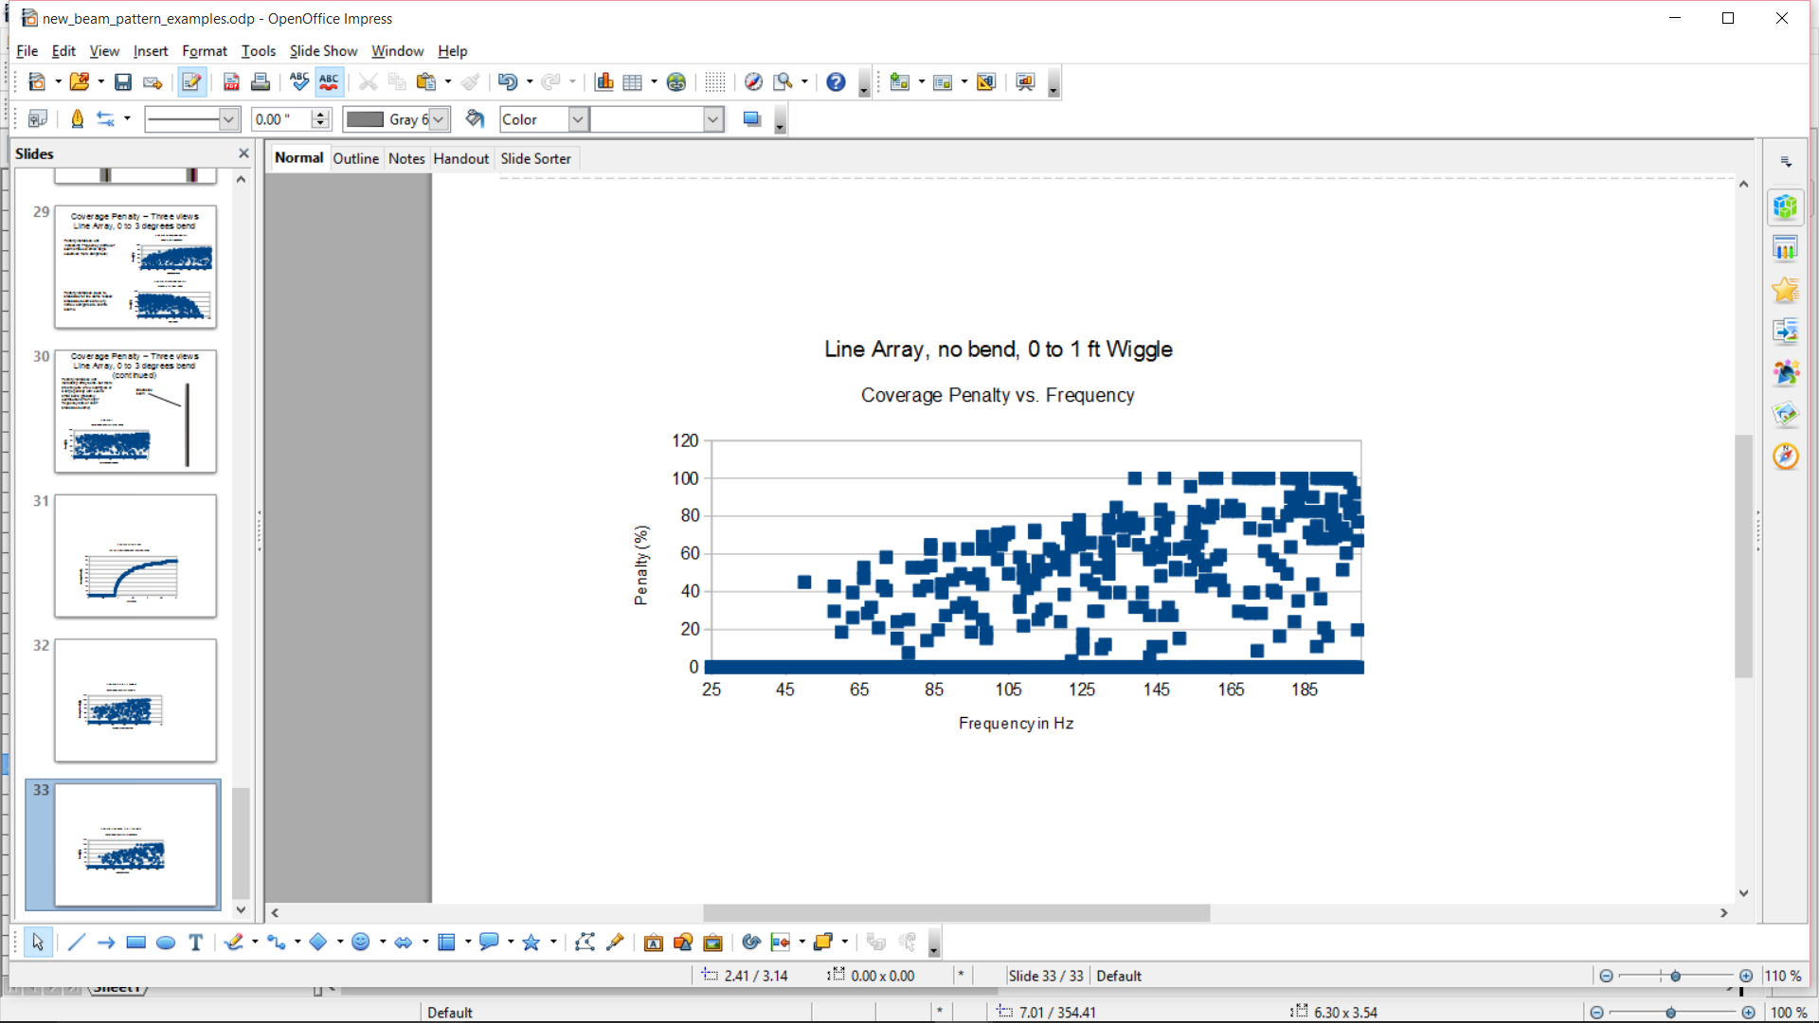

Figure B- . Wiggly Array Coverage Penalty vs. Frequency

# Expected Detection Range Study

We now look at the detection ranges we can expect from ideal and degraded arrays using a canonical threat and two sample array degradations.

The target, sensor and environmental parameters are as follows, providing about 12000 detection range samples:

Target

Passive frequencies

40 Hz @ 125 dB

225 Hz @ 120 dB

600 Hz @ 115 dB

Target Strength: 15 dB

Target depths: sampled at 60 ft, 600 ft, 1200 ft

Sensors

Towed Array Depths: 200ft, 800 ft

Active Cylinder frequencies:

1200 Hz

2400 Hz

4005 Hz

6000 Hz

7995 Hz

9990 Hz

Environments

For our first large-scale test, we created a 10x10 grid in the North Atlantic, eliminating all points on land, resulting in a sample of 90 locations. At each locationt, we selected four bearings: 000, 090, 180, and 270.

For additional environmental variability, we computed detection ranges for the months of January, April, August, and October.

This provides ducted, CZ, and shallow water environments, as well as more complex, sloping or mixed-propagation-type scenarios.

For each of the combinations of these parameters, we ran three levels of array degradation:

None – all elements available

Mild – 10% of elements out (just outside our tolerances, should not cause some mild detection degradation)

Severe – 40% of elements out (had better cause significant degradation)

The analysis consists of several steps, outlined in the paragraphs below.

## Step 1: DI degradations and Sensor Parameters

We first use the tools developed in this SBIR project to compute DI degradation for each passive frequency, as shown in Table B- 6

Table B- . Wide-Area Passive Run Sensor Parameter Degradations

|  |  |  |  |
| --- | --- | --- | --- |
| Frequency in Hz | DI | DI for 10% bad elements | DI for 40% bad elements |
| 40 | 10 | 9.6 | 7.7 |
| 225 | 12 | 11.5 | 9.5 |
| 600 | 16.4 | 16 | 13.7 |

For active arrays, we need more sensor parameters: DI degradation and beamwidths for each active frequency, as shown in Table B- 7. For active cases, we also reduce the source level by 10*log10(number of elements malfunctioning), or .5 dB for 10% malfunctioning elements and 2.2 dB for 40% malfunctioning elements.

After computing the various sensor parameters, we use existing TDA tools to build our active and passive sensors. The picture shown below in Figure B- 39 is a screen dump of the ideal 1200-Hz active sensor. Altogether, we built 18 active sensors, one for each frequency and each degradation (none, 10%, 40%), and 3 passive sensors, one for each degradation.

Table B- . Wide-Area Active Run Sensor Parameter Degradations

|  |  |  |  |  |  |  |
| --- | --- | --- | --- | --- | --- | --- |
| Frequency in Hz | DI (dB) | BW (deg) | DI for 10% bad elements | DI for 40% bad elements | BW for 10% bad elements | BW for 40% bad elements |
| 1200 | 14.4 | 49 | 14.15 | 13.1 | 50 | 57 |
| 2400 | 19.6 | 27 | 19.1 | 17.8 | 27.3 | 32 |
| 4005 | 23.4 | 18 | 23.2 | 16.5 | 18 | 21 |
| 6000 | 26.5 | 12 | 25.9 | 24.5 | 12.5 | 14.5 |
| 7995 | 26.5 | 12 | 26.2 | 24.3 | 12.7 | 14.6 |
| 9990 | 25.3 | 14 | 24.7 | 23.5 | 14.4 | 17.1 |

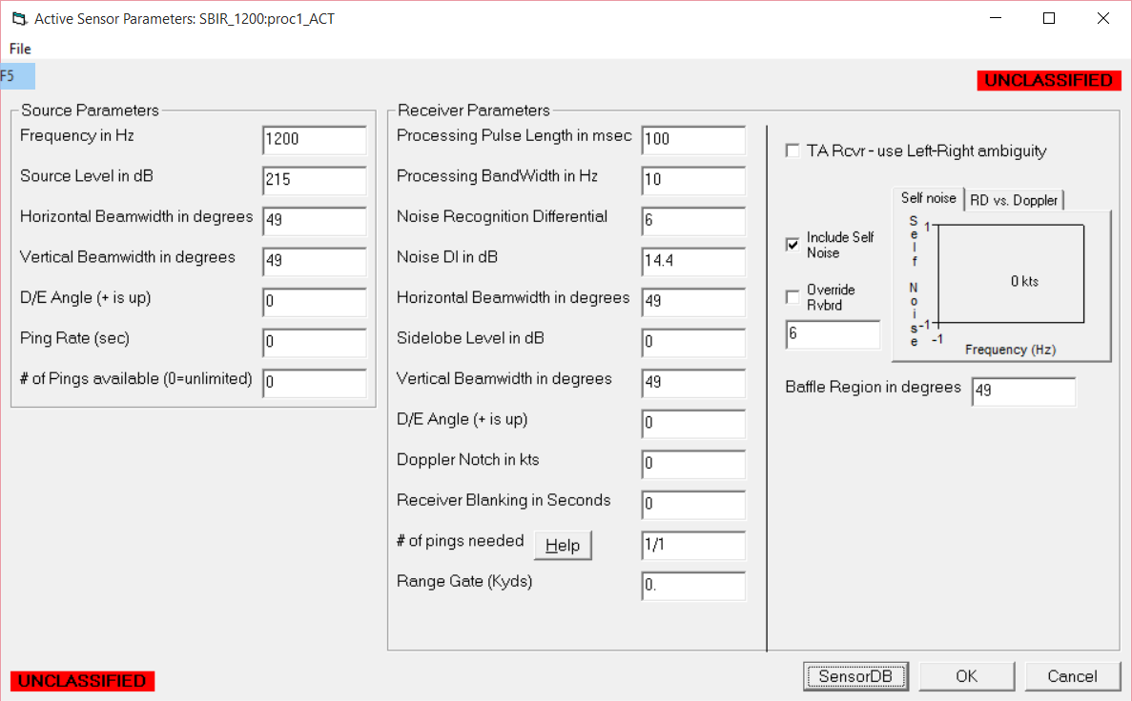

Figure B- . Active Sensor Parameters

## Step 2: Active and Passive sensor performance runs

For this study we chose an unclassified “Wide area analysis” tool that loops on locations, sensors, environments and threats, and generates performance predictions for all combinations. Two examples of displays available from this tool are below. In Figure B- 39 we display color-coded maximum ranges for each of the bearings at each point, for selected sensor/ threat/ environment combination. In Figure B- 40 we have averaged around the four bearings and display the average sensor performance, color-coded to indicate bearing-averaged detection range; these bearing-averaged detection ranges are what we will be using to generate statistics.

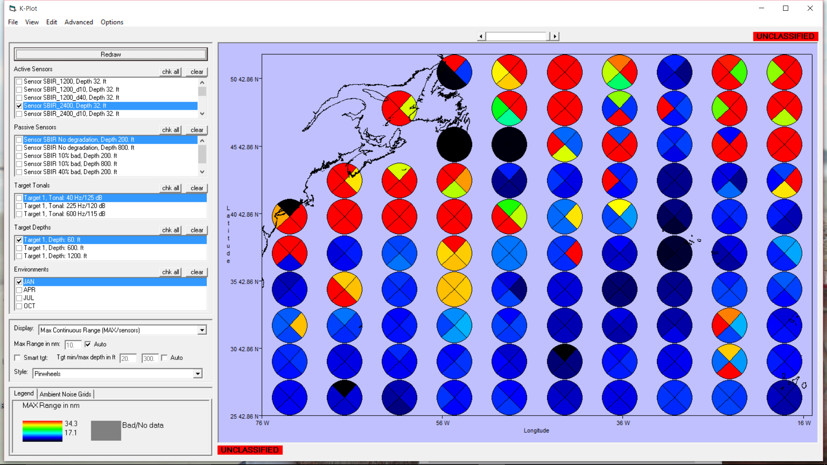

Figure B- . Pinwheel Display of Wide Area Detection Ranges - Atlantic



Figure B- . Block display of Wide Area Detection Ranges - Atlantic.

## Step 3: Performance Statistics

Our first output from the statistical study, Figure B- 41, shows the performance difference between an ideal array and the two degraded arrays as a function of detection range. This may sound a little redundant, but to interpret the plot, one simply selects a range on the X axis, and looks at the three lines on the curve. The top line is the for the ideal array, and matches the selected range. Ranges are binned, averaging all of the detection ranges within a 1-nm-wide bin. The red (second) line shows the average detection ranges for an array with 10% of its elements malfunctioning. The third (orange) is for the 40% degradation. As an example, when detection ranges are about 25 nm for the ideal sensor, the 40% degraded array expects only about 21 nm detection range, *on average*.

If we look at the worst case over all combinations in each range bin, we see a different picture, Figure B- 42, one that shows that even with only 10% of the elements malfunctioning, we can expect severe range degradation in some cases.

Finally, we computed the variance of the statistics, and displayed detection ranges at the one-sigma-below average levels, as shown in Figure B- 43.

The next plot, Figure B- 44, provides some insight that has been hidden by the binning process: where, in range, most detections take place. From this, we can see that overall, in the Atlantic Ocean, we have a lot of short range (probably direct path) detection ranges, and a group of larger bins near the CZ ranges around 35 nm. We can also see in the preceding displays of range degradation that the smallest penalties occur near these two groups of detection ranges. This is because both direct path detections and CZ detections do *not* behave like cylindrical spreading[4]. The ocean depth map (fifth plot below) shows large Atlantic areas, in dark blue, where CZ propagation is possible. For direct path and CZ detections, the slopes of Signal excess vs. range curves are very steep, meaning that a few dB less signal excess does not result in a large range change. At other ranges, transmission loss spreading is more likely to be cylindrical.

Inspection of the distribution of the range degradations is useful in determining how appropriate it is to use the variance (sigma). Three displays (Figure B- 46, Figure B- 47, and Figure B- 48), histograms of the binned ranges for 10%-degraded arrays, show that the distribution of these ranges is not very Gaussian, indicating that we should pay attention to other metrics, like worst case, to make sure we have captured most of the variability of the results; we can’t assume that only 15% of the results will fall below the one-sigma curve.

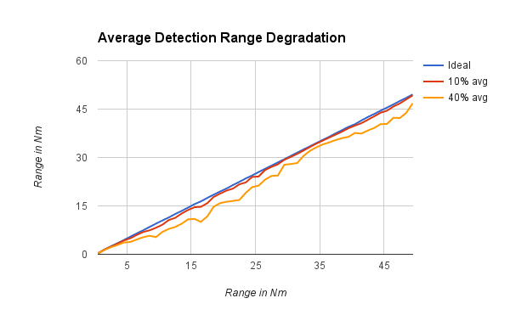

Figure B- . Average Detection Ranges - Atlantic

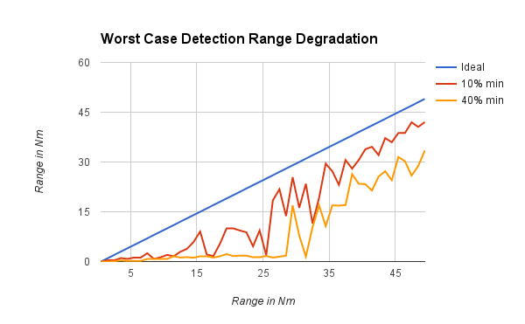

Figure B- . Worst-Case Detection Ranges - Atlantic



Figure B- . Average-minus-sigma Detection Ranges - Atlantic

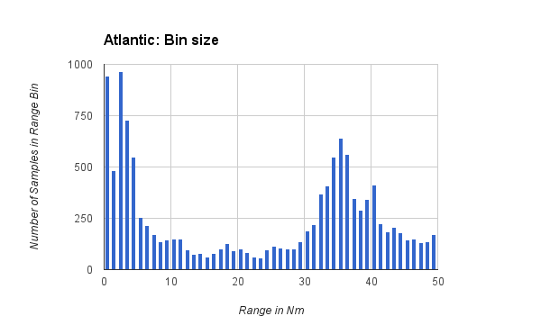

Figure B- . Detection Range Distribution - Atlantic

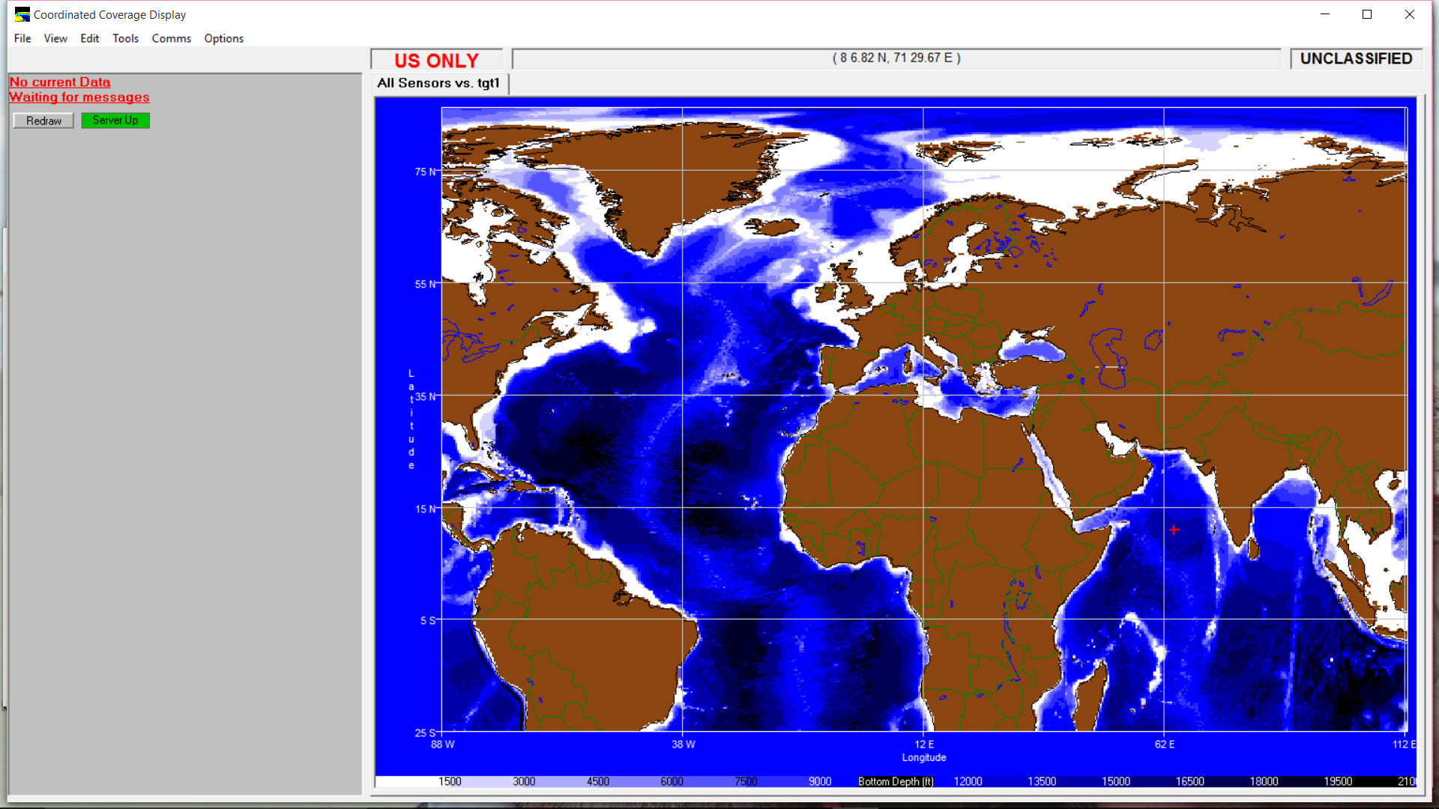

Figure B- . Ocean Bathymetry

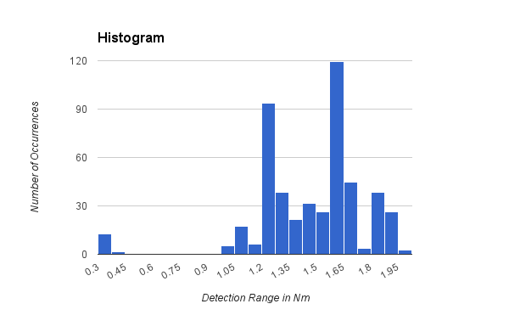

Figure B- . Histogram of Range Degradations - Atlantic

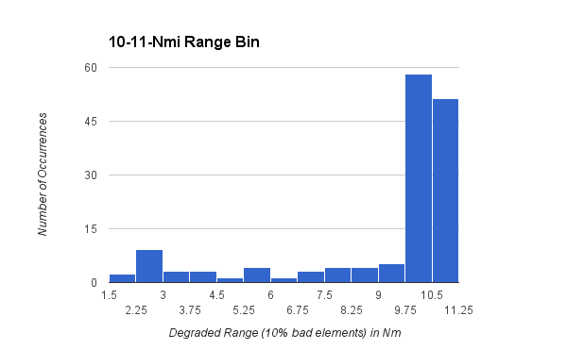

Figure B- . Histogram of Ranges (10% bad elements) for 10-11-nm Range Bin - Atlantic

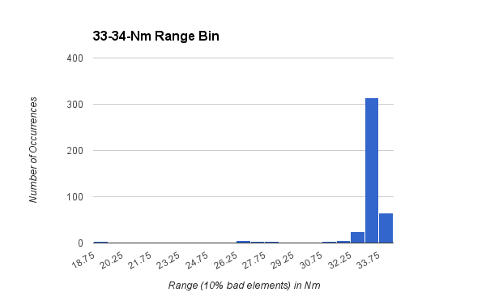

Figure B- . Histogram of Ranges (10% bad elements) for 33-34-nm Range bin - Atlantic

### Seasonal, Geographic and Other Trends

We next looked for trends: Is there a seasonal dependence, or a difference between active and passive sensors? The answer to the first question is “no”, as seen in the Figure B- 49 below. However, the following plot, Figure B- 50, appears to contradict our previous notion that active sensors would be affected more severely than passive sensors. In this plot, it is the passive sensors that suffer the more severe degradation, although the difference is not dramatic. We suspect the reason for this is the large number of times, during the active analysis, that we used the term “to be conservative, we will assume…”, leading to an over-conservative estimate of the effect of array degradation on performance degradation.

We next look for spatial tendencies, and compare detection range degradation in the Atlantic, Indian, Arctic (interesting currently due to its oil, as shown in Figure B- 51), and Pacific oceans . Sample detection ranges for the Arctic, Indian, and Pacific oceans are shown in Figure B- 52, Figure B- 53, and Figure B- 54. Because of half-channel conditions in the Arctic, we do not expect the same detection range distribution we see in oceans that support CZ propagation, and a histogram of detection ranges, shown in Figure B- 55, confirms that notion. This in turn leads us to expect more severe degradation in the predominantly cylindrical-spreading environment. However, when comparing the range degradation plots, we see very similar behavior in all four oceans (Figure B- 56).

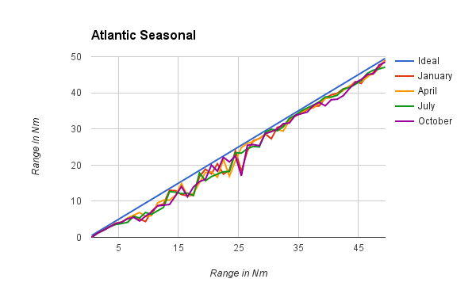

Figure B- . Seasonal Trends - Atlantic



Figure B- . Active vs. Passive - Atlantic



Figure B- . Importance of Arctic Ocean

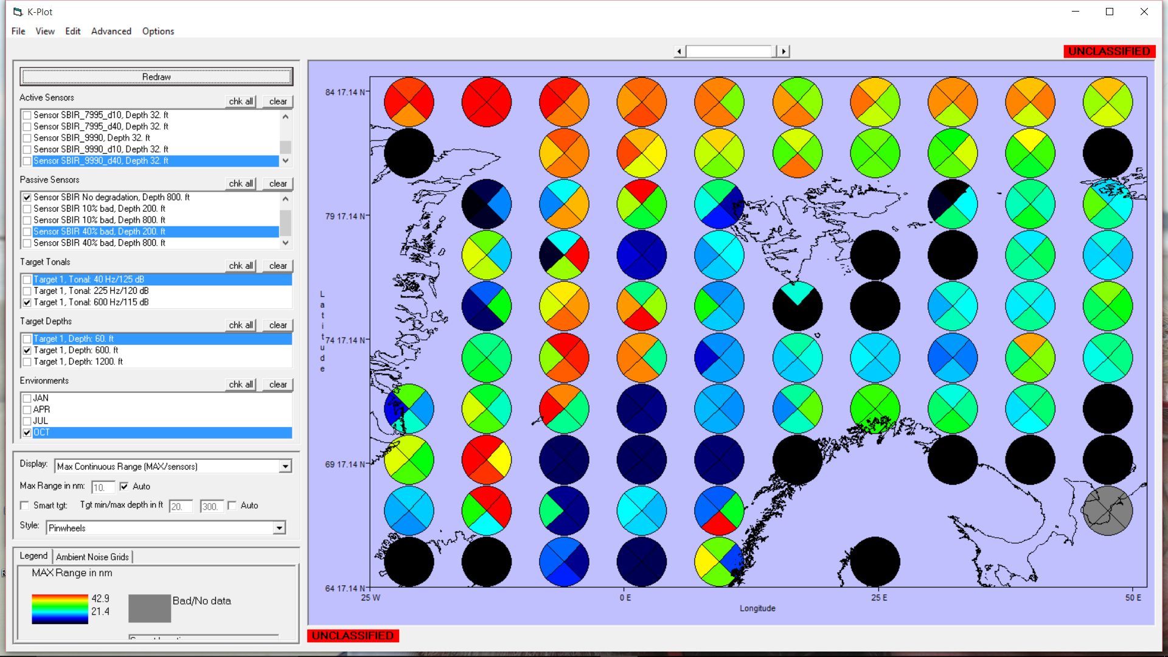

Figure B- .. Arctic Sample performance

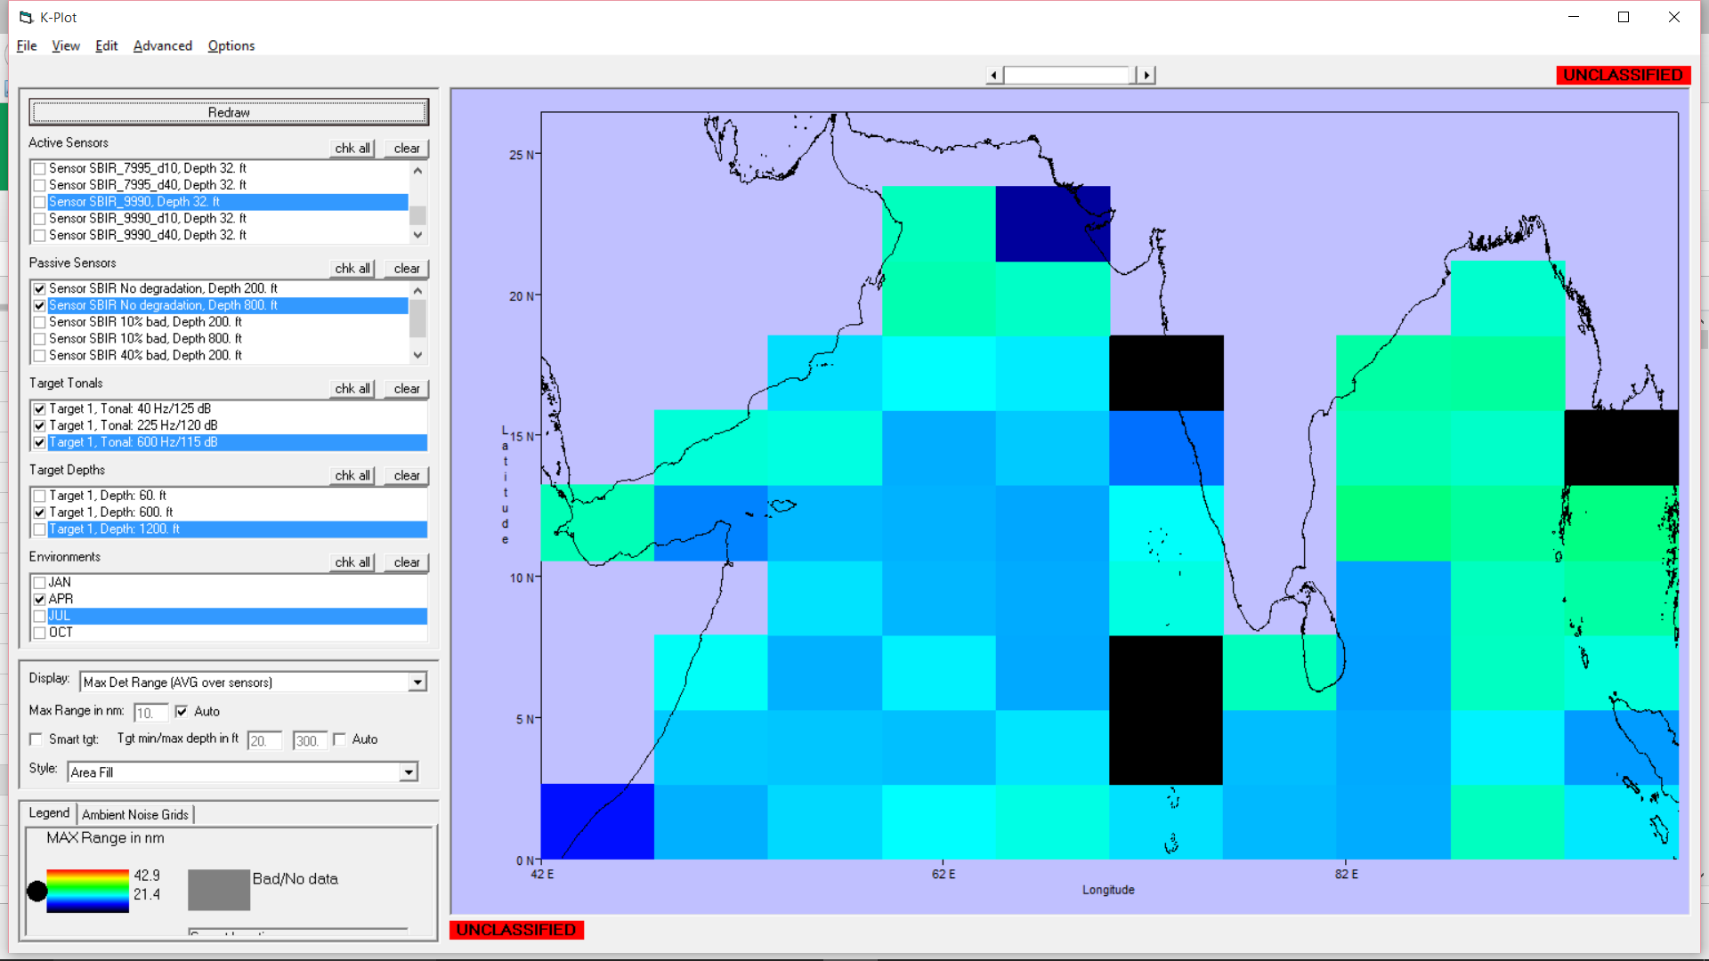

Figure B- . Indian Ocean Sample Performance

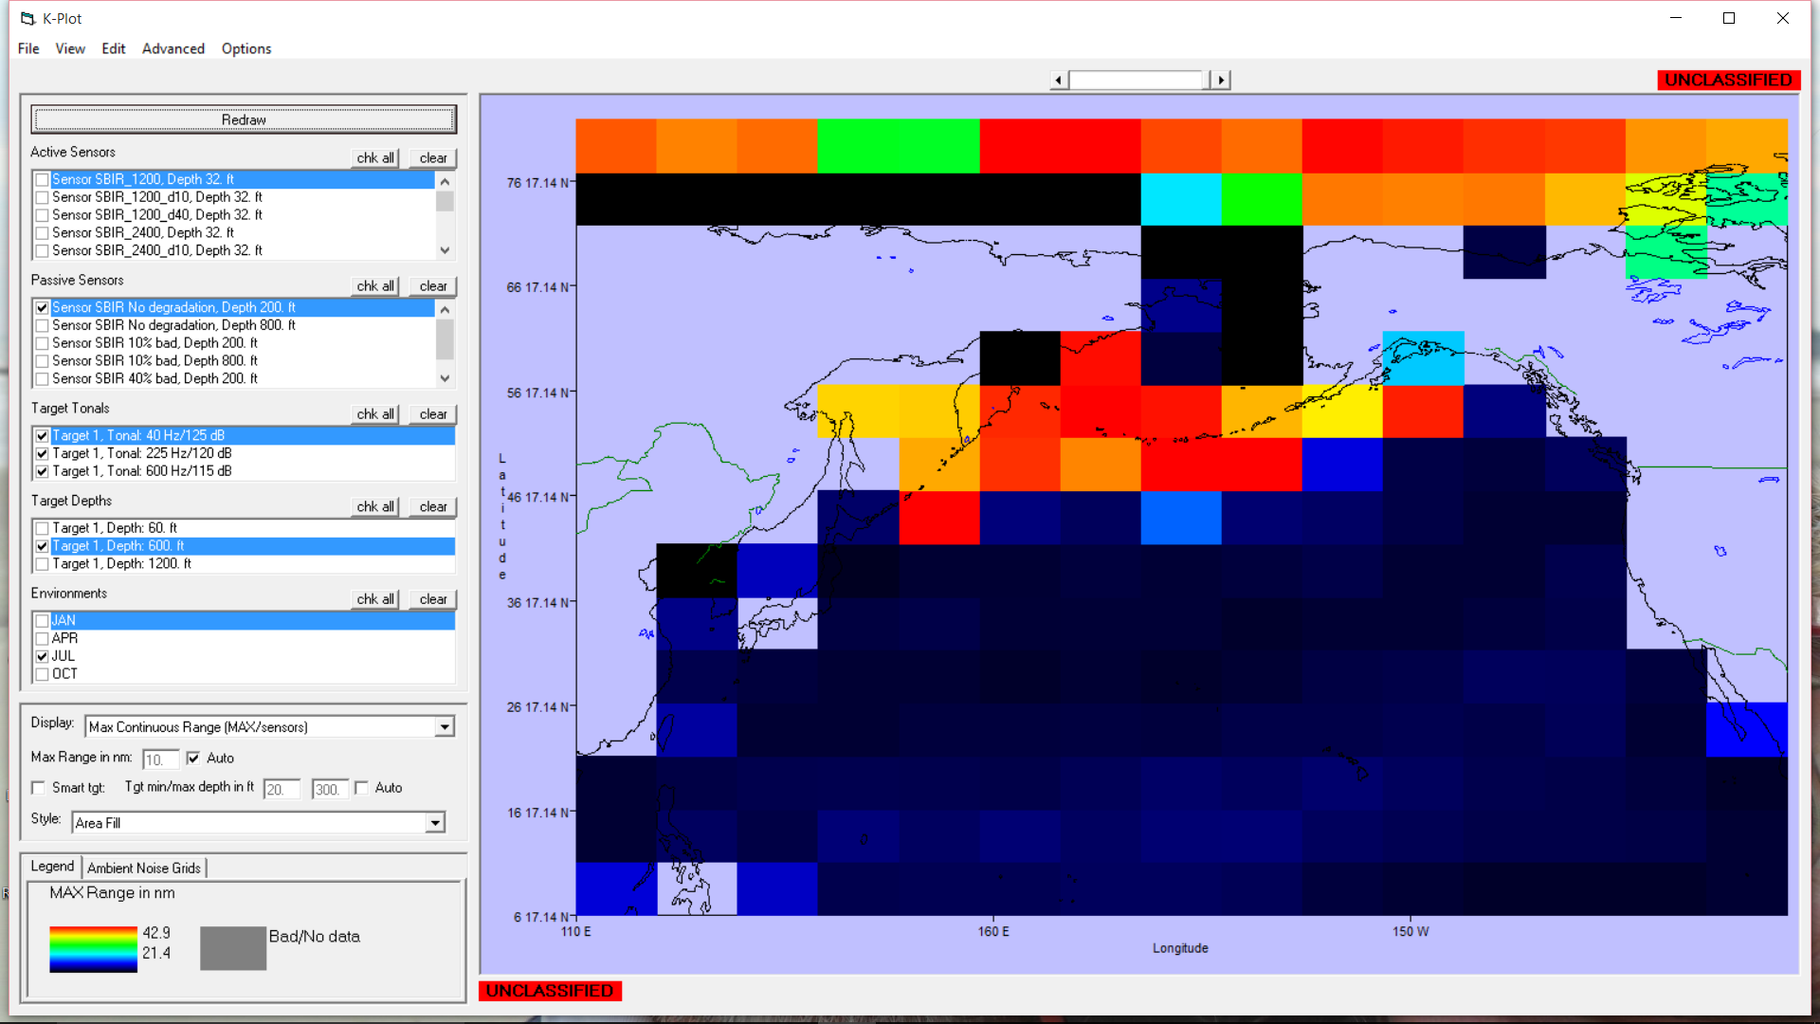

Figure B- . Pacific Ocean Sample Performance

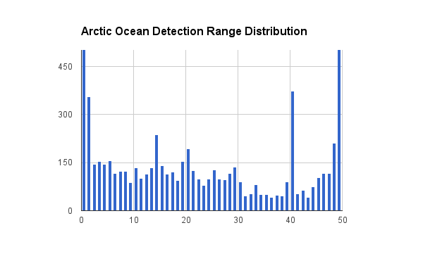

Figure B- .. Arctic Detection Range Distribution



Figure B- . Ocean Basin Range Degradation Comparison

### Behavior of Degradation Statistics

In this wide area analysis, we have noted non-gaussian characteristics for many of the distributions of expected detection ranges (and by extension, range degradations). Computing Skew and Kurtosis for the binned sets of detection ranges yields values far from the ideal for a Gaussian curve. Figure B- 57 shows the skew values for our Pacific ocean ranges. Negative numbers mean that the non-symmetry of the ranges is negative, which makes sense; the average degraded range is slightly smaller than the ideal range, and will *never* be more than the ideal range, forcing the skew into the negative direction. We can also note that the skew is worse for the 10% degraded array. This is also not surprising, because the degraded ranges for a 40%-degraded array is much farther from the ideal than for the 10%-degraded array, leaving more “room” to form a curve that is Gaussian.

Kurtosis is a measure of how heavy the tails of the distribution are. A small number for Kurtosis indicates that a curve is closer to Gaussian in the shape of the tails. Figure B- 58 shows the Kurtosis for the same Pacific Ocean case, followed by two histograms drawn from data where the Skew and Kurtosis are both low (close to Gaussian, Figure B- 59), and where they are both high (far from Gaussian, Figure B- 60). In both cases, we can easily see the left-side skew. And in both cases, we can see long tails, although it is not clear just from looking which curve is closer to Gaussian.

This means that the previous displays of the 1-sigma-down detection ranges do not necessarily capture 70% of the range sample data, as a Gaussian sample would allow. On the other hand, the “worst case” display captures 100% of the range samples, which is probably too strict.

Given the non-Gaussian nature of the detection range distributions, we wrote code to determine the range degradation that captures 85% of the range sample data (a little stricter than 1-sigma, a little more relaxed than 2-sigma, and have displayed that in the following Figures:

* Figure B- 61 - Pacific Ocean, Ideal vs. 10% Degradation and 40% Degradation
* Figure B- 62 - Pacific Ocean, same statistics using computed 1-sigma-down ranges

Surprisingly, the agreement between these two figures is good, indicating that the thresholds that we have defined previously are probably still valid.

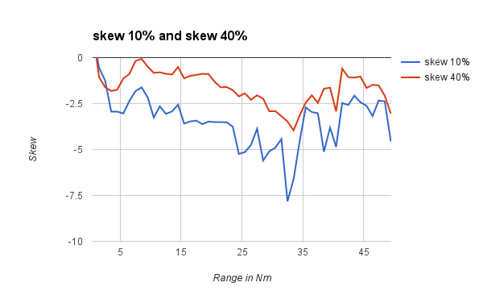

Figure B- . Skew values for Pacific Range Degradations

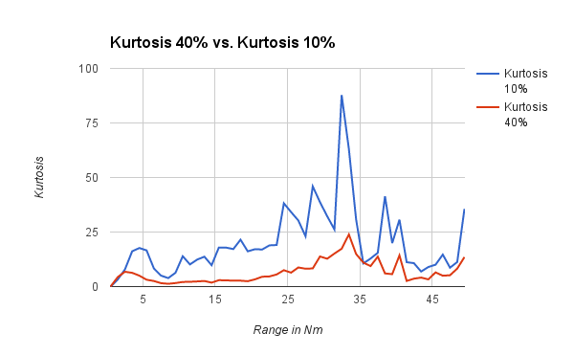

Figure B- . Kurtosis for Pacific Ocean Range

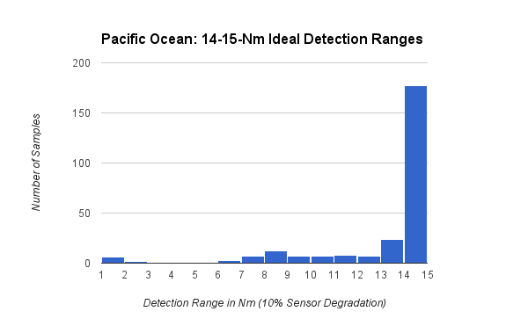

Figure B- . Range Distributions for 10% degraded array in 14-15-Nm Bin

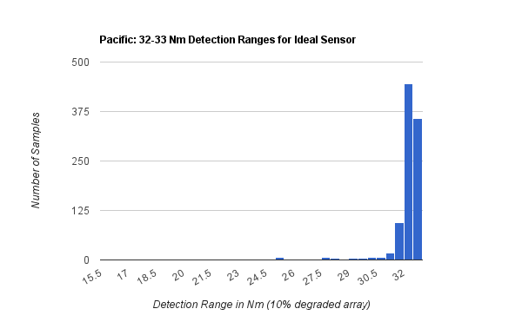

Figure B- . Range Distribution for 10% Degraded Array in 32-33-nm bin

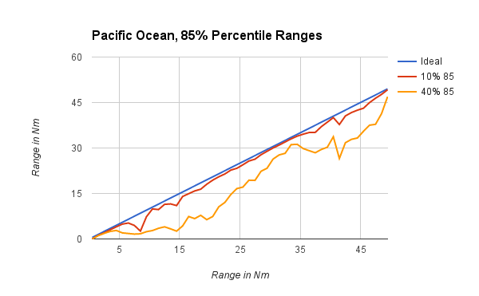

Figure B- . Ranges that Capture 85% of all data, Pacific Ocean

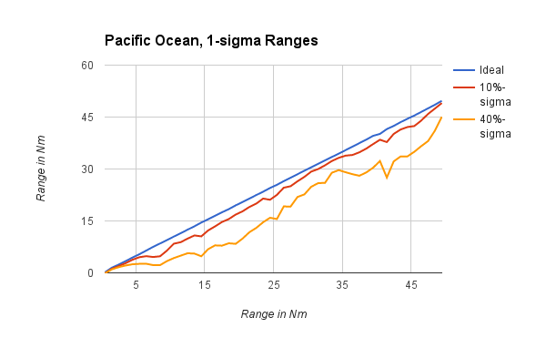

Figure B- . Pacific Ocean, 1-sigma Ranges

## 

1. Since we are using 1-sigma-down curves, this captures about 70% of the range samples.
2. For active sensors, there is a more complicated relationship: in noise-limited cases, signal excess is, dB for dB, degraded by the amount of DI degradation, but for reverberation-limited cases, there is little relationship between DI and SE, while there is a stronger relationship between beamwidth and SE, which is why we are also computing the beamwidth degradation.
3. A third line is shown in this Figure, at “FOM minus degradation”, which is not needed or relevant in this case.
4. The term “abrupt in” is common in describing the leading edge of a Convergence Zone.